FEDERAL STATE INSTITUTION

RUSSIAN RESEARCH CENTER “KURCHATOV INSTITUTE”,

NUCLEAR SAFETY INSTITUTE of the RUSSIAN ACADEMY OF SCIENCES

# **International Science and Technology Center**

PROJECT #2916

«DEVELOPMENT OF THE MODELS FOR NUCLEAR FUEL BEHAVIOR DURING ACTIVE PHASE OF CHERNOBYL ACCIDENT»

**FINAL REPORT**

(*FEBRUARY* *2005 – JULY 2007)*

|  |  |
| --- | --- |
| Document number:  **ISTC-KI-2916 Y3 01** | Date: **29/07/07** |

|  |  |  |  |  |
| --- | --- | --- | --- | --- |
|  | Name | Signature | Position | Date |
| Approved | А. Borovoi |  | Project Manager | 29/07/07 |

Moscow 2007

ABBREVIATIONS AND DEFINITIONS

|  |  |
| --- | --- |
| DB | DataBase |
| BWC | Bottom Water Communications |
| CH | Central Hall |
| Chernobyl NPP | Chernobyl Nuclear Power Plant |
| FA | Fuel Assembly |
| FE | Fuel Element |
| FCM | Fuel Containing Materials |
| IAEA | International Atomic Energy Agency |
| IBRAE | Nuclear Safety Institute of the Russian Academy of Sciences |
| LFCM | Lava-like Fuel Containing Materials |
| LHF | Large Horizontal Flow |
| LVF | Large Vertical Flow |
| MVF | Minor Vertical Flow |
| Model | Model of nuclear fuel behavior at the active phase of the Chernobyl accident |
| NSC | New Safe Confinement |
| OS | Object “Shelter” |
| Project | Project #2916 ”Development of the Models for Nuclear Fuel Behavior during Active Phase of Chernobyl Accident” |
| PSP | Pressure Suppression Pool |
| RRC ”KI”, KI | Federal State Institution Russian Research Center “Kurchatov Institute” |
| SChR | Self-sustaining Chain Reaction |
| SCP | Southern Cooling Pond |
| SDC | Steam-Distribution Corridor |
| SIP | Shelter implementation plan |
| SWC | Steam-Water Communications |
| “Д” (“D”) component | Lateral (water) biological shield |
| “Е” (“E”) component | Upper plate of biological shield |
| “Л” (“L”) component | Lateral (water) biological shield |
| “ОР” (“OR”) component | Lower plate of biological shield |

# INTRODUCTION

This Report is the Final Report under the ISTC Project No 2916“CHESS”: Development of the Models for Nuclear Fuel Behavior during Active Phase of Chernobyl Accident implemented jointly by RRC “Kurchatov Institute” (RRC KI) and Nuclear Safety Institute of the Russian Academy of Sciences (IBRAE RAS).

***The objective of the Project consists in the systematization of a huge body of data on Lava-like Fuel-Containing Materials (LFCM) collected over 20 years of investigations at the “Shelter”, the generation on its basis of a database and the development of models of the processes of lava generation and spreading during early post-accident days.***

First and foremost, the said objective is related to practical activities on elimination of the Chernobyl accident consequences.

At present works on transformation of the “Shelter” into an environmentally safe condition are being developed in Chernobyl under financial, technical and managerial support of the whole international community.

Measures on stabilization of building constructions have been already implemented. The present-day task is the construction of a New Safe Confinement (NSC) – an “Arch” that will cover the existing “Shelter”. By this the activities under the SIP (the Shelter Implementation Plan) shall be completed, however, the “Shelter”-transformation plans shall not terminate.

The removal of nuclear fuel and radioactive materials from the “Shelter” and their ultimate disposal shall be the following – the most challenging – step.

As known, a considerable portion of this fuel (~ 100 t) is incorporated into the lava generated during the accident.

It is at this phase that the outcomes of the ISTC “CHESS” Project may be a help in establishing a LFCM monitoring system, elaborating recommendations on prevention of eventual accidents, contributing to the development of optimum lava-removal technologies and thus reducing financial expenses and dose burden.

Secondly, the topicality of the Project objectives is due to the fact that the development of lava generation and spreading model will allow using the results of the huge and virtually unrepeatable “experiment” on nuclear fuel of the reactor of Unit 4 for solution of general nuclear-power-safety problems.

Fig. 1 illustrates the major phases of the work under the Project.

The work began with the generation of a database. After that it has become possible to perform calculations and develop models of lava generation and spreading.

The presentation of materials in this Report will follow the sequence demonstrated in the below diagram.

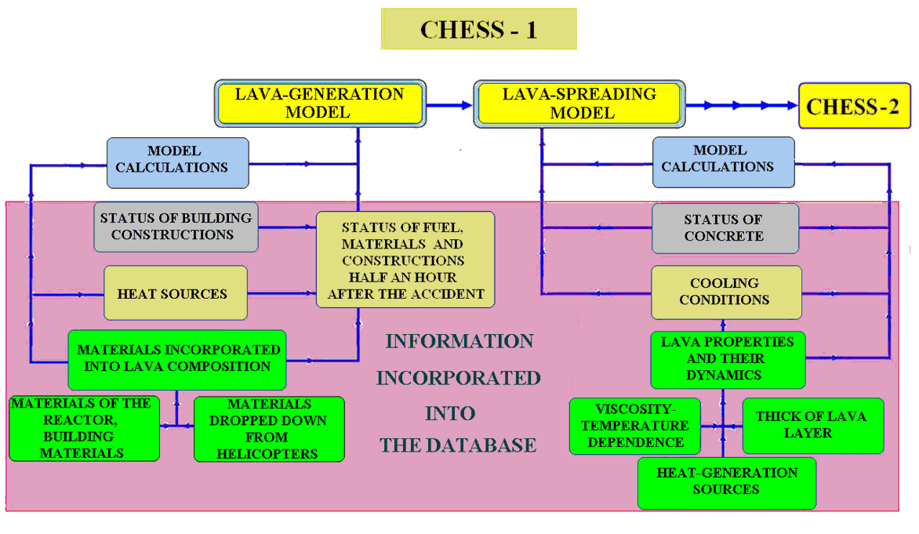

*Fig. 1. Sequence of implementation of major works under the Project*

2. lava-generation model

**2.1. Condition of Fuel, Materials and Constructions of the Reactor and the Whole Unit 4 Half an Hour after the Accident**

***2.1.1. General Statement of the Problem***

***The generation of a database and the reconstruction of the post-explosion condition of the destroyed power unit (by convention, the time of half an hour after the accident was chosen) have become the primary tasks for developing the lava-generation mode.***

Such a reconstruction necessitated maximum possible information on:

1. The before-accident status of the reactor and the whole power unit.
2. Their condition after the accident beginning.
3. Physico-chemical processes that went on during lava generation (including information on their heat sources).

Though the first-mentioned item involved no difficulties, the second item required long-continued investigations.

A huge body of experimental materials achieved during investigations at the “Shelter” in 1986 – 2005 performed by Kurchatov Institute, Radium Institute, IBRAE RAS, Chernobyl NPP, ISTC “Shelter” and many other organizations involved into elimination of the Chernobyl accident consequences was verified, analyzed and structured.

The data of publications, reports, survey certificates, construction drawings, etc. were used along with photo- and video- materials.

The information collection under Item 2 was completed in 2005. The outcomes were published in Ref. [1].

The most important results published at first under this Project are presented below.

###### A reconstruction of devastations in the reactor vault and the under-reactor room by the beginning of the second accident phase is presented in Fig. 2.

In the course of the accident the reactor basement («ОР» component) moved down and broken off. The “OP” fragment (*12* in Fig. 2) descended below the main part (*4*).

As the result, the reactor vault (Room No 504/2) became unified with Room No 305/2.

Later on the materials of ¼ ОР (*12*) became the lava components[1].

At the same time, the structures of ¾ ОР (*4*) were damaged to a considerably lesser extent despite appreciable damages visible in the break zone.

The constructions of “С” component (*2*) were crushed by the descended “ОР”.

Many BWC tubes were also crushed and pressed to the concrete plate of Room #305/2’s floor (*5*).

The major portion of serpentinite of the inter-compensatory gap spilled into the annular gap between the descended “ОР” component and semicircular western and eastern walls of Room #305/2 or was thrown by the explosion to the northern and the southern areas of that room.

*Fig. 2. Reactor vault and room #305/2 half an hour after the explosion*

*1. Serpentinite of the “ОР” component and the inter-compensatory gap*

*2. Crushed “С” component (“Cross”)*

*3. Fuel, fuel assemblies, fuel elements, process channels, graphite blocks, fragmented concrete*

*4. ¾ ОР*

*5. BWC tubes*

*6. Additional support*

*7. Reflector (channels and graphite blocks)*

*8. Reinforced-concrete plate (fragments of wall of separator box)*

*9. “Л” tank*

*10. Heat shielding lining of separator box’s wall*

*11. “Д” tank*

*12. ¼ ОР*

*13. Damaged wall*

*14. Sand of vault’s filling-up-origin*

*15. Debris of reinforced-concrete constructions*

*16. Fragment of reinforced-concrete construction*

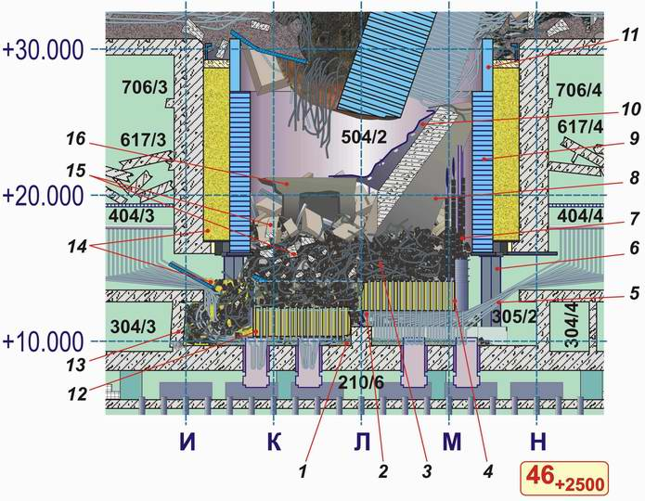

Sand from the area between “Л” tank (*14*) and the reactor vault walls spilled to the southern part of Room #305/2.

The area above “ОР” component was filled with graphite blocks, damaged fuel assemblies & fuel elements and fragments of process channels up to about +17.000 - +18.000 level marks (*3*).

On top large amounts of debris of building constructions are found above core fragments (*15*).

The issue on the amount of fuel remained in both the reactor vault and the under-reactor room No 305/2 was of paramount importance.

Such estimates were performed using several methods in Refs. [1 – 6].

***According to them, at the beginning of lava generation the unified space of rooms #305/2 and #504/2 housed (120 ± 45) t of fuel (U), the integral fuel amount in LFCM of all under-reactor room being (90 ± 30) t.***

***In our subsequent analysis average data will be used, e.g. 120 t and 90 t.***

***2.1.2. Materials Incorporated into the Lava***

In Ref. [2] the issue of composition and amount of materials incorporated into the lava is addressed in detail. The method of comparison of element composition of the lava with that of materials and constructions that, according to the data of investigators, were melted and might have generated the lava has been used.

In addition to fuel, the following materials are examined:

* zirconium;
* graphite;
* materials of “ОР” component;
* serpentinite mixture of the compensatory gap;
* steel blocks;
* BWC tubes and other communications of the reactor bottom;
* materials of “С” component;
* heat shielding and cooling system of building constructions;
* concrete of the under-reactor plate and walls of Room No 305/2;
* sand from the area between “Л” tank and walls of the reactor vault;
* plate floor.

Thorough analysis enabled identification of the composition of materials available in the reactor vault (Room No 504/2) and in the under-reactor room (No 305/2) at the beginning of the second accident phase at the initial lava‑generation instant and incorporated into its composition (Table 1).

Thereby necessary input data for description of lava-generation processes were achieved.

Table 1. Materials being in the reactor vault (Room No 504/2) and in the under-reactor room (No 305/2) at the beginning of the second accident phase

|  |  |  |
| --- | --- | --- |
| Material | Amount in Rooms No 504/2* and No 305/2, t | Incorporated into LFCM, t |
| Fuel (U) | 120 | 90 |
| Steel | 1300** | < 20*** |
| Serpentinite mixture | 580 | 160 |
| Concrete of the under-reactor plate | - | 130 |
| Concrete of building constructions penetrated into the reactor vault from upper level marks | 950 | 480 |
| Sand of the vault’s filling material | 300 | 280 |
| Zirconium | ? | 45 |
| Graphite | 750 | virtually no |

* within the reactor space boundaries;

** excepting materials of “С” composition and non-melted communications of the reactor bottom;

*** 330 t was melt and spread over under-reactor rooms.

***2.1.3. Heat Sources***

While simulating the processes of lava generation, the following three heat sources were accounted for:

* decay heat of fuel of Chernobyl NPP Unit  4;
* heat due to burning of graphite;
* heat due to zirconium-steam reaction.

To have an idea of the contribution of different heat sources, a plot of calculations using the model for one of lava-generation scenarios[2] is demonstrated below (Fig. 3).

*Fig.3. Contribution to the integral heat power going into lava generation from different heat sources*

*(for one of the lava-generation scenarios)*

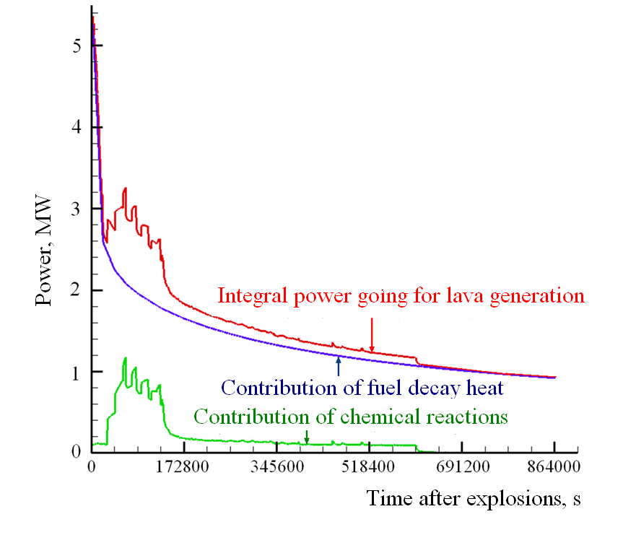

**2.2. Several Characteristic Conditions of Lava Generation**

***2.2.1. Water Delivery to the Reactor Vault***

Attempts at stopping heating of the core and preventing burning of graphite began immediately after the accident initiation. An attempt was made on delivering a maximum possible amount of water to the reactor.

To develop a model of the second accident phase progression (lava generation and spreading), the data on time and efficiency of such a cooling are undoubtedly necessary.

For this reason analysis of many publications addressing that subject was performed[3].

Despite the presence therein of some contradictory data, general vision of the event may be represented as follows:

* Water deliveries to the reactor began soon after the explosion between 2:00 a.m. and 3:00 a.m.
* Valves that impeded normal water flow were fully opened (manually) not until 4:00 a.m.
* According to evidences of eyewitnesses, only a minor portion of water penetrated into the destroyed core; its main flow passed via the reactor vault periphery and via auxiliary rooms. Finally, that water accumulated at bottom level marks.
* Water spread radioactive “mud”, flooded under-reactor rooms, shafts, underground communications and created hazard for operation of the power units 1 and 2. For those reasons water delivery was next stopped.   
  The duration of water-delivery period estimated in several publications at ~ 12 hours is likely overestimated. Most probably, the efficient water delivery lasted 7 hours at the most.

The above information suggests that water delivery to the destroyed reactor had no appreciable effects on the processes that went on deep in the wreckage within the reactor vault and in Room No 305/2.

***2.2.2. Temperatures of Materials during Lava Generation***

In the course of lava generation many materials both incorporated into its composition and immediately contacting its main flows played a part of specific “thermometers” via which temperature ranges of the processes that went on at that time may be restored.

First of all, the above said concerns ***molten metal***.

The database (Ref. [7], § 5.3) provides a detailed description of accumulations of solidified molten metal in rooms at bottom level marks of Unit 4. Several accumulations have a width of tens of centimeters. Constructions of the destroyed sector of “ОР” component were the major “source” of such a metal including: 10ХН1М-grade steel (total amount in “ОР” ~ 500 t), ОХ18Н10Т-grade steel (~ 200 t) and “black steel” (~ 230 t) [1].

The temperature of melting and spreading of those materials must have exceeded 15000С.

There were also metal “thermometers” within the lava itself. All types of LFCM contain metal globules of a regular shape and rather different diameter varying from a few microns to one millimeter.

Such globules are also evidences of the fact that the bottom boundary of lava-generation temperature exceeded 15000С.

***Chernobylit***

Chernobylit is a specific crystalline zirconium silicate with 10-12 % (by weight) admixture of uranium that formed during the active phase of the Chernobyl accident and is identified in all LFCM accumulations. Chernobylit cannot be generated at temperatures below 1600 °С.

***Molten Globules of Uranium Oxide***

Such globules are identified while performing microscopic investigations of LFCM. Microprobe analysis of lava in inversely-scattered electrons demonstrates that such globules contain an admixture of zirconium replacing uranium isomorphically in the amount of 5-6 % (by weight). In accordance with the state diagram of the ZrO2 – UO2 system, the melting temperature of oxide of such a composition equals (2500 – 2600) °С. While developing the LFCM-generation scenario, the indicated temperature was taken as a maximum-possible temperature that acted over a short period of time.

An additional estimate of both the effective temperature and the time of its impact on nuclear fuel was obtained via diffusion coefficients for cesium and strontium [1].

***2.2.3. Decomposition of Serpentinite***

Serpentinite (160 t) was one of the materials involved into the lava‑generation process.

The calculations took into account that, when heated up to a temperature above 500 °С, serpentinite decomposes into olivine-forsterite and silicon dioxide with the generation of water that evaporates:

Mg6(Si4O10)(OH)8 → Mg2SiO4 + SiO2 + 4Н2О 76,16% 10,84% 13%

Olivine-forsterite is a stable structure with melting temperature of 18900С.

The melting temperature of SiO2 equals 16100С.

**2.3. Lava-generation Model**

***2.3.1. Areas of Investigations***

In the course of 2005 – 2006 a scenario of lava generation during the Chernobyl accident was developed at RRC “Kurchatov Institute” and IBRAE RAS. Work was focused on the following basic lines:

* determining the main sequence of physical and chemical processes during lava generation; and
* generation of a high-quality heat model of lava spreading in Room No 305/2.

***2.3.2. Main Sequence of Physical and Chemical Lava-generation Processes Accepted in the Model***

The sequence of the Chernobyl’s lava-generation phases may be briefly described as follows (see e.g. Refs. [5], [7], [8]):

1. At a specific time instant an increase in neutron flux in the Unit 4 reactor core of Chernobyl NPP (the south-eastern section) took place that produced an increase in the number of fissions, heat release and a drastic increase in steam content in coolant that circulated in zirconium process channels of the graphite stack of the core[4].

The RBMK steam reactivity coefficient (an element of the integral reactive power coefficient) is positive. Intensification of the fission reaction could result in the generation of a larger amount of steam producing an increase in the K-factor leading in its turn to further intensification of the reaction, etc.

An increase in steam content in process channels brought to changes in cooling regime of fuel assemblies: zirconium walls of tubes of fuel elements began contacting not water but superheated water steam which cooling ability was by far below that of water.

2. Due to failure of cooling regime the temperature of fuel increased drastically that caused fuel dispersion and break of fuel element claddings and fuel channels.

3. Explosions that had destroyed the core allowed fuel fragments to interact with constructional materials: at first with zirconium and then with metal of “ОP” component, serpentinite filling, sand, concrete, etc. (Fig. 3 [1]).

Zirconium melting began as well as the dissolution of uranium dioxide therein with the generation of uranium-zirconium eutectic [9 - 11].

4. When uranium-zirconium eutectics contacted silicon dioxide (the major lava component), the following triple system was generated: UO2-SiO2-ZrO2. Minimum temperature of liquidus surface in that system was equal to the melting point of the triple eutectic and made up approximately 1500 оС (Fig. 4) [7].

*Fig.4. Approximate projection of liquidus surface of the triple system ‘UO2-SiO2-ZrO2’*

*F – field of primary crystallization of solid solutions based on U and Zr oxides with fluorite-type structure;*

*Т - field of primary crystallization of tetragonal ZrO2;*

*S - field of SiO2 crystallization (cristobalite).*

*The shaded area corresponds to possible composition of LFCM*

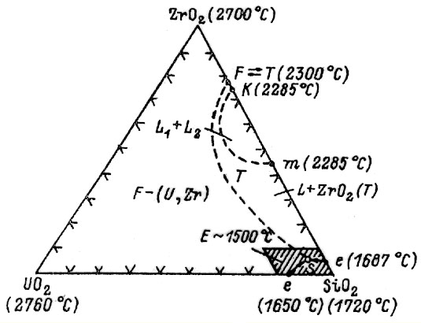

***It was in such a way that most of the lava, the so-called “brown ceramics” and “black ceramics” was generated.***

Due to interactions of irradiated fuel with constructional materials, LFCM ‑ in addition to uranium and zirconium, silicon and oxygen – also incorporated a considerable amount of other elements (element analysis of LFCM enabled identification of about two tens of such elements).

5. It is worth noting that the conditions for other paths of lava generation might have realized at individual locations of Room #305/2 as well.

Indeed, as demonstrated above, the temperatures might have reached a range of 1500оС ÷ 2600оС. The minimal value of indicated temperature is conditioned by melting of a large mass of metal (in ‘ОР’ component); the maximal value is confirmed by the presence in the silicate matrix of fuel globules with zirconium admixtures (‘ZrO2 – UO2’ system).

Analysis of both established and possible events that took or might have taken place at first after that accident reveals the possibility of existence of a variety of compositions of fuel with other materials which attained Room #305/2 and the reactor vault after the explosion. It would be reasonable suggesting several lava-generation “centers”, each of them having its own characteristic temperatures and generating lava of a specific composition.

In a case that silicon and other materials had been lacking, the ‘ZrO2–UO2’ system with the generation temperatures of 2500 – 2600°С could have acted.

UO2 dissolution in SiO2 proceeds very slowly [9] (eutectic in ‘UO2-SiO2’ binary system is generated at 13% relative concentration of uranium oxide and has the melting point of 1650 °С). At the same time addition of 10% of Al2O3 to melt results in a violent dissolution of fuel [12]. Addition of ZrO2 brings to similar results.

The possibility of realization of conditions providing melting of UO2 pellets (at 2850 °С and above) caused by poor heat removal at individual lava-generation “centers” should not be rejected as well.

On the other hand, at individual locations in case of “successful” range of materials and an “appropriate” heat regime the process of lava generation could have also started at a temperature not much above 1000°С.

6. While considering lava-generation processes, it should be remembered that in the under-reactor room lava is found not only in “the pure form” but also as a mixture with non-melted core fragments (UO2).

Such facts were established in investigations of samples of fuel-containing FCM from Room #305/2 performed in 1992–1993 [2].

In addition, visual observations allowed discovering core fragments immediately contacting lava formations.

Such facts are rather important from the nuclear safety standpoint because, according to calculations, in many cases the composition “lava + core fragments + water” is more hazardous than the “lava + water” composition due to the possibility of containing a considerably higher concentration of enriched uranium..

***2.3.3. Simulation of Heat Processes during Lava Generation***

Such simulation pursued the following two major objectives:

* first, to demonstrate that the selected sequence of physico-chemical processes (see the previous section) agrees with experimental data considering the time of lava spreading and its spatial distribution within the under-reactor room; and
* second, to obtain some input data enabling the generation of lava-spreading models for bottom rooms of the power unit.

To achieve the objectives put by, we have had to use information of a rather general character. There was no way of developing a detailed quantitative lava-generation model for lack of necessary data, such as the data on geometry of initially-generated “heap” of materials and constructions, trustworthy data on cooling conditions of the “heap”, fuel distribution therein, etc.

The results of numerical simulation included the following items:

* dynamics of burning-out of carbon and zirconium and dynamics of decomposition of serpentinite concrete;
* simulation of effective heat transfer in both air and melt via convective transfer and bubbling;
* dynamics of melt progression (namely, progression of the 2D interface boundary between the melt and constructional materials);
* determining 2D temperature fields corresponding to the dynamics of melt progression;
* determining variations in the melt volume agreed with the rate of carbon burning-out.

3. MAIN RESULTS ACHIEVED IN SIMULATION OF LAVA GENERATION

**3.1. Possibility of Existence of FCM Accumulations with High Uranium Concentration**

***3.1.1. What Follows from the Lava-generation Model***

Early attempts at describing physico-chemical processes of lava generation were based on the assumption of their rather similar running at close temperatures in the whole mass of materials being in Room No 305/2 and in the reactor vault (e.g. see Ref. [5]). Such an approach allowed establishing the most general mechanisms and obtaining general estimates of the character and the time of development of lava-generation processes.

The data acquired and analyzed in the course of implementation of this Project enabled an assumption that, along with main LFCM-generation processes, other – lesser-scaled – processes also took place involving the generation of FCM accumulations different from “pure lava”.

A series of data indicate definitely the possibility of existence in the under-reactor room of accumulations with average uranium concentration exceeding by far that in the lava: e.g. its mixture with core fragments.

***3.1.2. Indirect Evidences of the Existence of FCM Accumulations with High Uranium Concentration***

The hypothesis of existence in Room No 305/2 of a FCM accumulation with high uranium concentration (lava? a mixture of lava with non-melted core fragments?) was first expressed while attempting explaining the so-called “anomalous neutron event” of 1990.

The event consisted in a short-duration (~ 1.5 days) but a considerable (~ 60 times) increase in the counting rate of the “Finish”-system neutron sensor installed in Room No 304/3 close to the breach in the wall to Room No 305/2.

Throughout the indicated period actions were being conducted to discover the causes of such an anomalous behavior of Channel #50.

The whole counting route of Channel #50 of “Finish” system was fully checked, and no failure was detected.

Room #304/3 was examined from Room #318/2 via periscope. No changes in Room #304/3 were discovered.

Due to further increase in the counting rate in Channel #50 a decision was made on introduction – by two portions – of gadolinium-nitrate solution into Room #304/3. Once the second portion of solution had been introduced, the counting rate decreased during 24 hours and returned to the initial value.

The most detailed and weighty investigation of the causes of that anomalous event in Room #304/3 (June 1990) was performed by a special commission of the Nuclear Safety Institute of the Russian Academy of Sciences [13].

After checking of all assumptions only one of them still aroused suspicion: a considerable increase in neutron generation (in extreme case –initiation of Self-sustaining Chain Reaction (SChR)) within a hypothetical FCM accumulation located in Room #305/2 close to the breach in wall leading to Room #304/3. If so, the sensor responded to scattered neutron radiation that first increased and next – after flooding of the room with gadolinium solution – was absorbed intensively. Specialists of the Physics & Power Engineering Institute (FEI) came to the same conclusion as well [14].

The calculations demonstrated that in order for the effective neutron multiplication factor Кeff to be considerably increased in such an accumulation while flooded by water, the FCM volume must be equal to several cubic meters, and uranium concentration therein (at medium burnup) must exceed that in LFCM by 4 to 5 times [15].

For example, the accumulation may represent a mixture of lava with non-molten core fragments.

Later on a thorough analysis of the data available (see below), as well as the results of measurements performed in 1999 – 2000 along three new itineraries in the breach area within the southeastern quadrant of Room #305/2 [16] confirmed the presence of a large localized FCM massive with higher neutron activity. The massive is situated in the area of +9.000 level mark. One more similar-type accumulation is expected close to Room #307/3’s wall in the area of +9.000 - +10.000 level marks north of the above massive (Fig. 5).

As for the available materials, the results of core-sample analyses [17], the distribution of heat flows in Room #305/2 achieved as early as 1988 [18] and observations of neutron fluxes during periods of abnormally high atmospheric precipitations [2]

*Fig.5. Expected location of areas containing FCM with high uranium concentration*

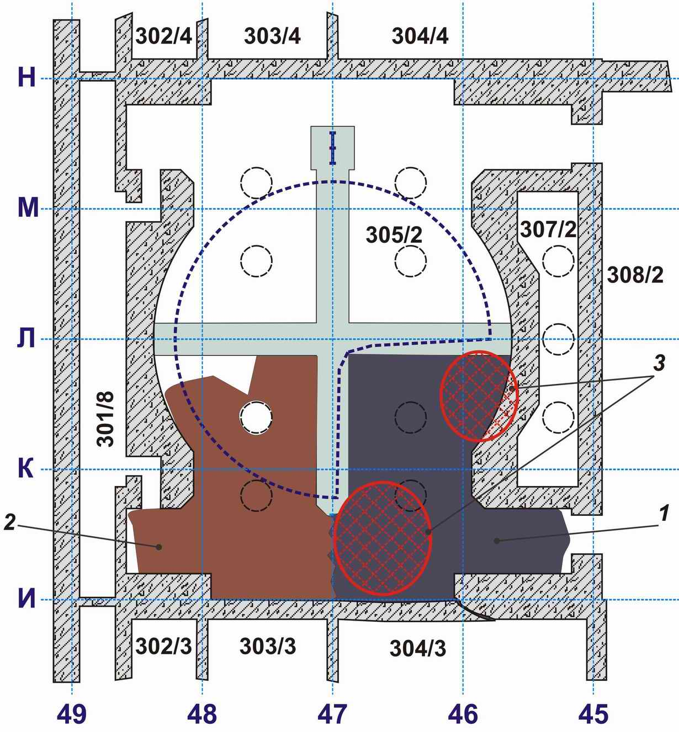

*1 – Mostly black LFCM*

*2 – Mostly brown LFCM*

*3 – FCM areas with high fuel concentration*

***3.1.3. Several Conclusions***

At present the integrity of heat and neutron measurements indicates the existence of two such hypothetical accumulations.

One of them, located close to the break in the wall between Rooms No 305/2 and No 304/3 might have been the cause of the “anomalous neutron event” recorded in 1990.

An increase in criticality of these accumulations is due to water inflow/outflow to/from their locations. Unfortunately, there is no way of estimating exactly their hazard at the present-day level of our knowledge. Thus at present on needs to be in readiness on taking preventive safety measures including introduction into such accumulations of special substances – neutron absorbers (Refs. [19]). After establishment of the “Arch” due to a drastic decrease in water amount penetrating into the “Shelter” variations in neutron fields related to the accumulations in question may become imperceptible. This does not mean, however, that they potential hazard may be ignored. During works inside the “Shelter” all necessary measures aimed at preventing any hypothetical incidents must be undertaken.

**3.2.** **Layout of LFCM Accumulations in the Under-reactor Room**

As an important outcome of the work under the Project in 2006, a “map” showing the layout of lava-like FCM in Room #305/2 may be presented.

The generation of such a “map” has become possible after both processing of the results of analyses of core materials taken from bore holes drilled into this room and measurements using these bore holes.

To that end, Room #305/2 was conventionally broken into sectors through tracing of characteristic sections. The coordinates of sections were selected on the information-density basis (drilled bore holes, samples taken, in-hole measurements) (Fig. 6).

Using the whole of available verified information LFCM spreading boundaries were determined for each section.

Example of individual section are demonstrated in Fig. 7. Extended information on sections is found in Chapter 4.1.1 of the database [7].

*Fig. 6. Room #305/2. LFCM at +9.700 level mark. Location of sections*

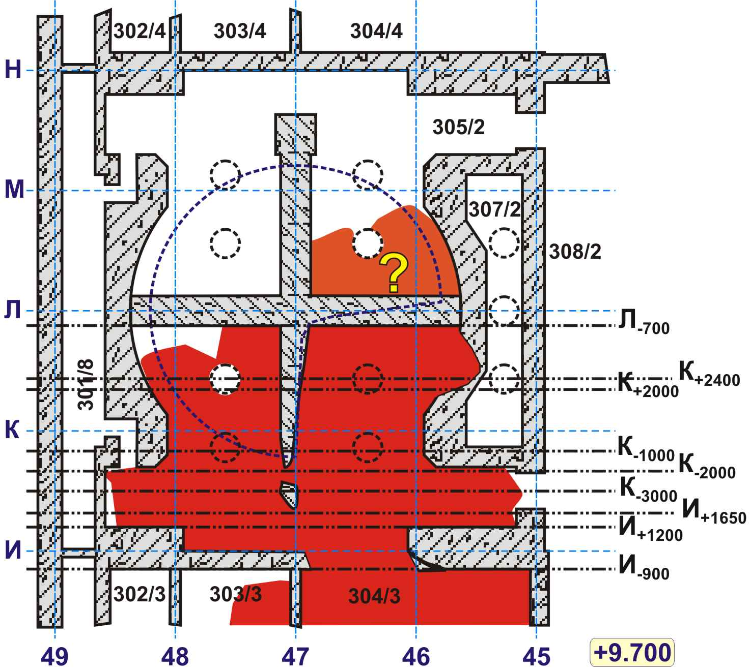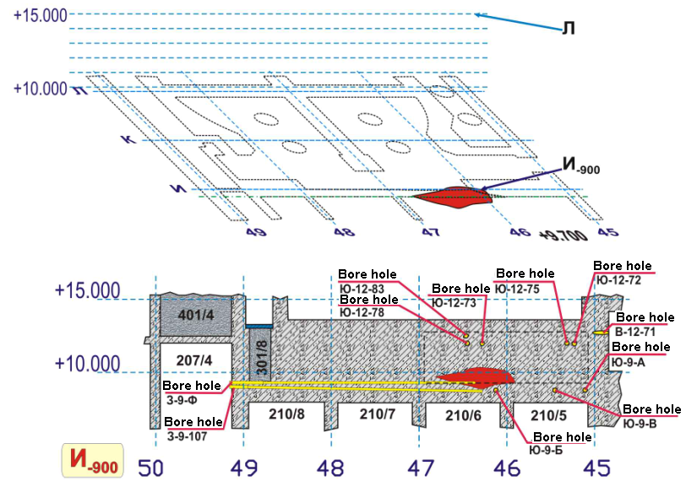

*Fig.7. Separating wall between Room #305/2 and Room #304/3. LFCM. Section through row ‘И-900’*

**3.3. Evaluation of the Countermeasures Taken at the Active Accident Phase Based on the KI‑IBRAE Model**

***3.3.1. General Statements***

This chapter has not for goal either critic or disapproval of the decisions taken to localize the Chernobyl accident in the course of its active phase[5].

It is obvious that under conditions of virtually no information on the processes that went on in the destroyed reactor making of optimum decisions involved major difficulties, and ‑ as it turned out at a later time ‑ many countermeasures were excessive or even useless.

The Project goal has been an attempt at both reconstructing the situation that existed at that time and explaining real effects of the taken countermeasures on the processes that went on in the destroyed Unit 4 based on the present-day knowledge and using the KI‑IBRAE model. For convenience of discussion the data of Table 2 (taken from Ref. [21]) summarizing the main countermeasures taken at the active accident phase will be used.

Table 2. Main countermeasures taken at the active accident phase

|  |  |  |
| --- | --- | --- |
| Date | Hours | Description |
| **Saturday, April 26** | **~ 01** | **Accident. Reactor collapse.** |
| Saturday, April 26 | 01:30 -  -06:30 | Extinguishing of fires (there were more than 30 sources of combustion caused by explosions in the reactor and release of hot core fragments). |
| Saturday, April 26 | 02 | Onset of water delivery to the reactor to cool fuel and prevent burning of graphite |
| Saturday, April 26 | Morning – day-time | Disconnection of pumps that delivered water to the reactor (bottom level marks of all power units became flooded with radioactive water). |
| Saturday, April 26 | Day-time - evening | The accident scale was realized for the first time. |
| Saturday, April 26 | Night | At the Governmental Commission meeting a decision was taken on the start of dropping of materials into the destroyed reactor for accident localization purposes. |
| Sunday, April 27 | ~ 10:00 | Onset of dropping of various materials into the reactor from helicopters. |
| Sunday, April 27 | Night | Boron carbide is dropped down. |
| Thursday, May 1 | The whole day | Decision on start of reactor cooling with nitrogen to prevent the “China syndrome”[6] - burning-through of floors with very hot fuel. |
| Friday, May 2 | By the end of the day |  |
| Saturday May 3 and Sunday May 4 | Throughout the night | Valves are opened to drain radioactive water from the PSP of Unit 4.  The Governmental Commission took a decision on construction of an under-foundation plate under the Unit 4 reactor compartment. |
| Monday, May5 |  | The nitrogen-delivery system to the PSP is assembled.  Onset of delivering construction equipment and necessary materials to build the under-foundation plate. |
| Tuesday, May 6 | ~01:00 | Arrival of cars with liquid nitrogen. Shortly thereafter delivery of gaseous nitrogen to the second floor of PSP. Failure of cooling attempts. |
| **Tuesday, May 6** |  | **The release intensity (Ci/day) decreased by three orders of magnitude.**  **End of the active accident phase.** |
| June, 28 |  | Completion of construction of the under-foundation plate under the reactor to prevent the “China Syndrome” development. |

***3.3.2. Whether or Not a Part of the Reactor Stack Survived after the Explosions***

Immediately after the accident survival in the reactor vault of a fragment of the core (possibly, of its major part) was expected. Such a view persisted for quite a long time and was deemed true up to the spring of 1988.

In conditions of no reliable information such a concept was reasonable for it represented the conservative standpoint (maximum nuclear hazard).

In May 1988, thanks to the bore holes drilled, it was found out for the first time that the reactor vault contained no undamaged structure of fuel and graphite. Further investigations using boreholes and next by means of robots as well as direct visual observations confirmed total destruction of the core.

It may be assumed that immediately following the explosions a minor (~ 10%) part of the reactor survived yet and was definitively destroyed (graphite burned down, fuel and zirconium were incorporated into lava, etc.) at a later time during the lava-generation process.

***Such a hypothesis does not contradict the KI‑IBRAE model and the reconstruction data characterizing the status of destroyed Unit 4 half an hour after the explosions that have been discussed in Chapter 2.1.2* (*Figs. 3).***

***3.3.3. Efficiency of the Measures on Water Delivery to the Reactor***

The efficiency of the countermeasure on water delivery to the destroyed reactor has been discussed above in Chapter 2.2.1, and, as noted, according to evidences of eyewitnesses, only a minor portion of that water might have attained the core.

Several hours later water pumps were stopped.

***Inefficiency of the said measure may be also confirmed indirectly by calculations performed for lava-generation-simulation purposes.***

The effect of water was not taken into account in those calculations. At the same time, a good agreement between the calculated data and the observed parameters (lava composition, time of its generation, heat conditions, character of temperature fields, etc.) indicates that the effects of all main factors have been adequately accounted for in the model.

***3.3.4. Possibility of the Self-Sustaining Chain Reaction in the Course of the Active Accident Phase***

Such a suggestion was made at the very first meeting of the Governmental Commission (on the evening of April 26), which from that point on repeatedly asked the specialists concerned about the possibility of SChR within Unit 4.

On the evening of 26.04.1986 Academician V.А. Legasov specially arrived upon the Unit 4 wreckage to measure neutron fluxes. Unfortunately, his attempts were unsuccessful.

Specialists of the Ministry-of-Defense institutes, Radium Institute and other institutions performed regular aerosol samplings above the collapsed reactor and close to it for purposes of identifying both the composition and intensity of radionuclides released. A special purpose of the investigations consisted in discovering an increase in concentration of short-lived isotopes, which might have evidenced the initiation of SChR.

Instability of results due to complexity of the processes and virtual impossibility of repeating the conditions of measurement was reported. However, as judged from release of short-lived radionuclides, no SChR indices were discovered.

***The heat model of lava generation is incapable of providing a general answer to the question on the possibility of SChR initiation in the destroyed reactor.***

***However from this model it follows that the power released by the generated critical assembly must have been considerably below the integral power of other heat sources, such as:***

***- decay heat;***

***- graphite burning; and***

***- zirconium-steam reaction (see Chapter 2.1.3 and Fig.3).***

Otherwise it has been hard to achieve a satisfactory agreement between the calculated data and the observed parameters.

During the active accident phase (up to May 6) the assembly must have been fully destroyed.

The suggestions expressed sometimes that an increase in release out of Unit 4 during May 2-5 was due to “restart of operation” of a part of intact core have been confirmed neither by available facts nor by calculated models.

***3.3.5. On Materials Dropped down from Helicopters for Accident-localization Purposes***

Early expectations on total isolation of the destroyed core, diminishing of radioactive release and reduction of both nuclear and heat hazard thanks to materials dropped down from helicopters were not realized.

As demonstrated in many publications, most of dropped down materials did not penetrate into the reactor vault at all (see Ref. [20]).

In accordance with the KI‑IBRAE model, half an hour after the explosions the reactor vault above the core wreckage contained fragments of concrete structures that had dropped therein from the central hall. Those and other materials listed in Table 1 were enough to generate the observed amount lava of necessary composition.

***If any dropped-down materials had been involved into the lava-generation process, their impact would have been insignificant.***

***3.2.6. The “China Syndrome” Development***

The KI ‑IBRAE model enables a detailed tracing of the processes of melting and gradual descending of materials heated up to a high temperature as well as of burning by them of concrete floors, i.e. of the “China Syndrome” development process.

According to the model, and in a case that all basic conditions of lava generation and spreading are taken into consideration, the burning-through hazard must have only existed with respect to the concrete floor slab between Room #305/2 and the SDC.

Such a hazard did partly realize indeed.

*Thus from the viewpoint of the present-day knowledge and in accordance with the KI‑IBRAE model, complex measures on prevention of Unit 4 slab fusion and penetration of fuel into groundwater were excessive.*

It should be realized, however, that it was the post-explosion geometry of devastations that “saved” the damaged power unit from catastrophic development of the “China Syndrome”.

If the fragment (one fourth) of ‘OP’ component (which melting took up the most of the energy) had not been located on the path of lava generation and spreading-down of scorching lava masses and if the path via steam-dumping valves had been opened, the construction of the under-reactor plate might have been necessary.

4. LAVA-SPREADING MODEL

**4.1. Lava-spreading Geometry**

The paths of lava spreading, the rooms housing LFCM accumulations and their characteristics are described in detail in Ref. [7].

In this Section only a generalized pattern of progression of major lava flows is provided because the main purpose of ***the computer simulation was the establishment of general lava-spreading mechanisms conditioned by its own parameters and interactions with surrounding materials.***

***4.1.1. Horizontal Flow***

The “Large Horizontal Flow” (LHF) (Fig. 8) passes via several rooms at the level mark of 9.000 m.

It flowed out of Room No 305/2 via the breach in the wall to Room No 304/3 and spread over the whole its floor. Next via the open door of Room No 304/3 the LHF penetrated into the Corridor No 301/5 and separated into two sub-flows: the western sub-flow and the eastern sub-flow.

The western sub-flow penetrated into Room No 303/3 (via the torn off door). Further path of the western sub-flow has not been discovered due to a thick layer of concrete that penetrated into rooms of Unit 4 in the course of the “Shelter” construction. The eastern sub-flow penetrated into the Room No 301/6, turned south and, having passed ~15 m, attained the row ‘Г’.

From Room No 301/6 via vertical penetrations LFCM flowed down to the level mark of 6 m (Room No 217/2) and formed the so-called “Elephant’s Foot” (Fig.8), “stalactites” and “the Drop”.

Minor lava amount (as compared to the whole mass) penetrated from Room No 217/2 down to the level mark 0 m – into Room No 017/2.

To the north, the horizontal lava flow likely terminated its spreading over Room No 301/6 between the rows ‘Ж’ and ‘И’.

LFCM also penetrated into Room No 307/2, however, only limited data are available on them.

Information on LFCM of the “horizontal flow” is summarized in Table 3.

Table 3. Data on LFCM of the “horizontal flow” (at the level mark +9.00 m and in its leaks down to +6.00 m and 0.00 m) [7]

|  |  |  |  |  |
| --- | --- | --- | --- | --- |
| Room | Brief description of FCM accumulation | FCM volume, m3 | Mass of fuel (U), t | Comment |
| 304/3 | FCM layer on the room floor of 0.6 ÷1 m thick | 50 ÷ 70 | 6 ± 2 | FCM volume in the breach is taken into account |
| 303/3 | FCM on the floor under concrete | 2 ÷ 7 | 0,5 ± 0,3 |  |
| 301/5 | ‘Open’ FCM and FCM under concrete | 8 ÷ 30 | 2,0±1,5 |  |
| 301/6 | FCM on the floor under concrete | 8 ÷ 30 | 2,0±1,5 |  |
| 217/2 | "Elephant’s Foot", "Stalactites", "The Drop" | 2 ÷ 4 | 0,4 ± 0,2 |  |
| 017/2 | Individual FCM fragments on “fresh” concrete | minor |  | Presence of FCM under concrete is possible |

The total volume of FCM in the “horizontal flow” and on bottom floors makes up (70 ÷ 140) m3**.** The value of **100 m3** was taken for calculations. The amount of fuel contained in FCM equals (11 ± 4) t. For calculations the value of **11 t** was taken.

At a later time, in fall 1986, several lava flows were covered with concrete that penetrated there during construction of the “Shelter” .

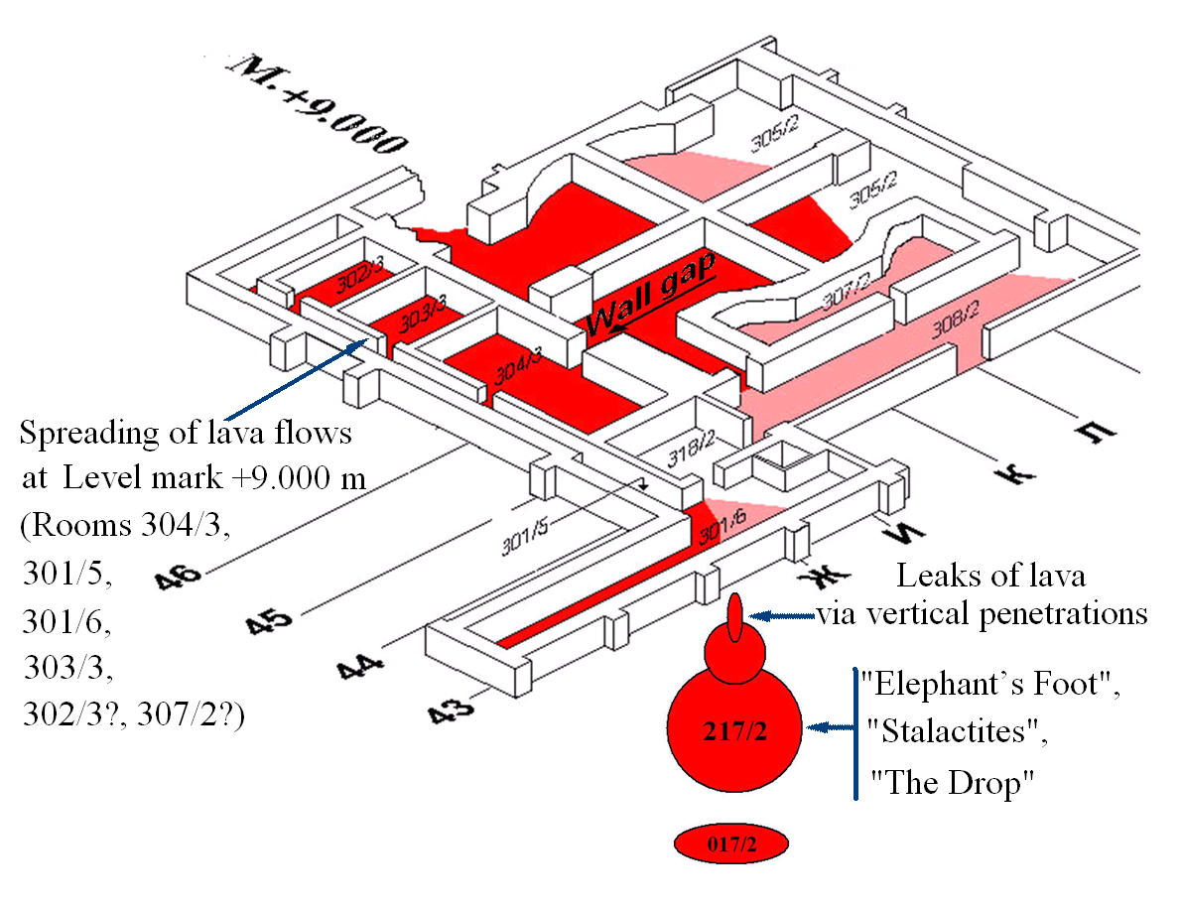

*Fig. 8. Large horizontal flow. Scheme of lava spreading*

Lava of the LHF consists of “black ceramics”.

While comparing the radionuclide composition of samples of ceramics taken from the LHF (Rooms NoNo 304/3, 301/5, 217/2, 017/2) (Ref. [7]), a conclusion may be drawn up on the invariability of its composition – within experimental errors – in the course of spreading.

***4.1.2. Vertical Flows***

While spreading, molten metal and lava-like FCM generated in Room No 305/2 used the path that had been provided for water and steam for a design-basis accident and penetrated into lower level marks. The said path goes through steam-dumping valves on the floor of the under-reactor room, steam-dumping headers and tubes of the CDC and PSP.

It was molten metal that penetrated first into the SDC rooms: its solidified accumulations are found under virtually all lava accumulations.

Lava, having penetrated via the steam-dumping system, generated two vertical flows: the “large vertical flow” and the “minor vertical flow” (Fig. 9).

*Fig. 9. Vertical distribution of lava over steam-dumping valves and pipes.*

*Large Vertical Flow (LVF): Room No 305/2→ Room No 210/7→*

*Room No 012/15→*

*Room No 012/7.*

*Minor Vertical Flow (MVF): Room No 305/2→ Room No 210/6*

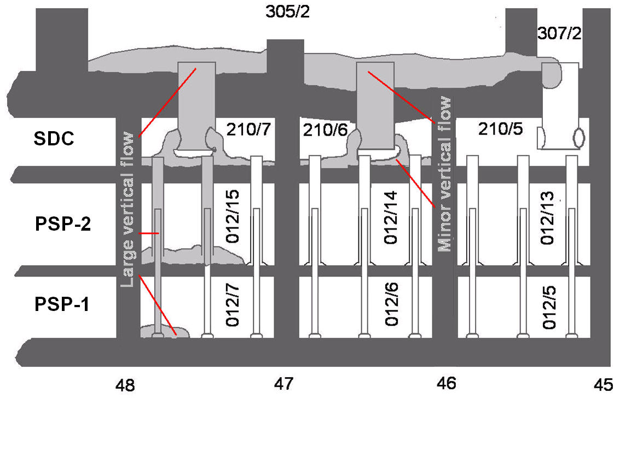

Two types of lava are found in the SDC: “black ceramics” and “brown ceramics”.

In Room No 210/7 a solidified “falls” of brown ceramics issuing from the first duct of the 4th steam-dumping valve was formed also containing large “drops” and “jets” of metal. The second duct contains a solidified “jet” of coal-black ceramics. The third duct comprises a chocolate-brown solidified mass.

In Room No 210/6 ducts of the steam-dumping valve are filled with black lava containing a variety of small-sized fragments of metal constructions.

Most important data on LFCM located in rooms wherein solidification of LVF and MVF took place is summarized in Table 4.

Table 4. Data on LFCM forming the “large vertical flow” and the “minor vertical flow” (level marks: +6.00, +3.00 and 0.00) [7]

|  |  |  |  |  |
| --- | --- | --- | --- | --- |
| Room, level mark | Brief characteristic of FCM accumulation | LFCM volume, m3 | Fuel mass (U), t | Comments |
| 210/7 (6.00).  SDC | Solidified lava (mostly brown ceramics) and metal from the 4th steam-dumping valve. | 13 ÷ 28 | 3.7 ÷10.4 | LFCM volume in the valve is taken into account |
| 210/6 (6.00).  SDC | Solidified lava (mostly black ceramics) and metal from the 3rd and the 4th steam-dumping valves. | 17 ÷ 30 | 2.4 ÷ 6.2 | LFCM volume in the valves is taken into account |
| 210/5 (6.00).  SDC | Solidified metal on the room’s floor | - | - | No FCM has been discovered |
| Total in SDC (expert evaluation) | | | (11.4 ± 5.3) |  |
| 012/15 (3.00)  PSP -2 | “Pile” on the second floor of PSP | 23 ± 6 | 5.2 ± 2 | Fuel in steam-dumping pipes is taken into account |
| 012/14 (3.00)  PSP -2 | Lava within four pipes located in the ‘Л’-row area  Lava under a concrete layer along the axis 46+1000 between the rows ‘К-М’ | Up to ~ 1.4  ( ? )  Up to ~ 20  ( ? ) | ( ? )  ( ? ) |  |
| Total in PSP-2 (expert evaluation) ‑ (8 ± 3) | | | | |
| 012/7 (0.00)  PSP-1 | “Pile” on the first floor of PSP | 2.5±0.5 | 1.1±0.7 | Fuel in steam-dumping pipes is taken into account |
| 012/6 (0.00)  PSP-1 | Lava within pipes | Up to ~ 0.1 (?) | (?) |  |
| Total in PSP-1 (expert evaluation) ‑ (0.9 ± 0.3) | | | | |

**4.2. Main Parameters Influencing the Character of Lava Spreading**

***4.2.1. Heat Characteristics***

The decay heat (Qdec) was the only heat source for both the horizontal and the vertical flows of lava in the course of its spreading over under-reactor rooms.

***Volumetric heat-power density***

To estimate the order of volumetric heat-power density, let us use the calculated data for Qdec (Fig. 3) and characteristics of the black ceramics of Ref. [7].

Let us take for estimates the Qdec value 1 day and 10 days after the beginning of the accident.

Taking account of the release of volatile components, these values make up ~ 90 kW/t and 46 kW/t (U), respectively, i.e. differ from each other by ~ 2 times.

The density of lava equals: (2.69 ± 0.17)⋅103 kg/m3.

At uranium concentration of ~ 4%, 1 m3 of lava contains ~108 kg of uranium that enables estimation of volumetric heat-power density ‘*qv’* at:

* ~ 10000 W/m3 one day after the beginning of the accident; and
* ~ 5000 W/m3 10 days after the beginning of the accident (i.e. by ~ 2 times less).

# ***Initial Temperatures of Lava Spreading***

***Horizontal Flow***

Studying of samples of concrete taken on the surface of walls in Room No 304/3 near the breach to Room No 305/2 has allowed establishing that they contain a considerably larger amount of 125Sb (by 4 times!) as compared to ‘standard’ fuel composition.

Because the boiling point of oxide and metal forms of antimony makes up 1456°С and 1637°С, respectively, one may suggest that by the instant of lava penetration to Room No 304/3 via the breach **its temperature equaled 1500°С at a minimum.**

Having penetrated into Room No 304/3, the lava flow covered several metal constructions.

However the said constructions have no indices of melting. This means that the lava temperature at the locations of its contact with metal **could not have much exceeded 1500°С.**

***Vertical Flow***

It was molten metal that penetrated first into the SDC from steam-distribution valves. Thus the initial temperature of the flow was above **1500°С.**

The external appearance of lava found in SDC, PSP-2 and PSP-1 indicates that, having penetrated into lower level marks of Unit 4, it cooled down rapidly.

Solidified lava flows issuing from ducts of steam-dumping valves as well as the “piles” formed in rooms of PSP-2 and PSP-1 are evidence of high viscosity of last portions of flowing LFCM and thus of its temperature **< 1000 °С** (see the following chapter).

***4.2.2. Lava Viscosity***

At present experimental data on viscosity of Chernobyl-origin lavas are only available for a narrow temperature range.

Accordingly, while generating a model of their spreading, the analogy method was used.

By element composition (save for, naturally, uranium and zirconium), macro- and microstructure the Chernobyl lavas are in many respects similar to natural volcanic lavas (see Tables 5 and 6).

Table 5. Average oxide composition of Chernobyl lavas

|  |  |  |  |  |  |  |  |  |  |  |  |  |  |  |
| --- | --- | --- | --- | --- | --- | --- | --- | --- | --- | --- | --- | --- | --- | --- |
| LFCM type | Main oxides, mass % | | | | | | | | | | | | | |
| SiO2 | Al2O3 | Fe2O3 | FeO | MgO | CaO | Na2O | TiO2 | ZrO2 | BaO | UO2 | MnO | CrO | NiO |
| Black ceramics  No 304/3 | 70.6 | 7.4 | 0.3 | 0.2 | 3.9 | 6.7 | 6.2 | 0.21 | 5.8 | 0.13 | 4.3 | 1.9 | 0.27 | 1.2 ×  10-3 |
| Black ceramics  No 217/2 | 66.6 | 8.7 | 0.5 | 0.3 | 3.8 | 8.5 | 5.6 | 0.27 | 5.8 | 0.15 | 5.0 | 3.8 | 0.29 | 0.19 |
| Black ceramics  No 210/6 | 62.1 | 7.2 | 3.5 | 2.1 | 5.1 | 6.0 | 5.2 | 0.19 | 5.5 | 0.18 | 5.8 | 0.40 | 0.35 | 0.39 |

Table 6. Average chemical composition of several volcanic lavas

|  |  |  |  |  |  |  |  |  |  |  |  |
| --- | --- | --- | --- | --- | --- | --- | --- | --- | --- | --- | --- |
| Type of volcanic lava | Oxides, mass % | | | | | | | | | | |
| SiO2 | Al2O3 | Fe2O3 | FeO | MgO | CaO | Na2O | K2O | TiO2 | P2O5 | MnO |
| Basalt | 48,5 | 14,3 | 3,1 | 8,5 | 8,8 | 10,4 | 2,3 | 0,8 | 2,1 | 0,3 | 0,2 |
| Andesite | 54,1 | 17,2 | 3,5 | 5,5 | 4,4 | 7,9 | 3,7 | 1,1 | 1,3 | 0,3 | 0,1 |
| Dacite | 63,6 | 16,7 | 2,2 | 3,0 | 2,1 | 5,5 | 4,0 | 1,4 | 0,6 | 0,2 | 0,1 |
| Phonolite | 56,9 | 20,2 | 2,3 | 1,8 | 0,6 | 1,9 | 8,7 | 5,4 | 0,6 | 0,2 | 0,2 |
| Trachyte | 60,2 | 17,8 | 2,6 | 1,8 | 1,3 | 2,9 | 5,4 | 6,5 | 0,6 | 0,2 | 0,2 |
| Rhyolite | 73,1 | 12,0 | 2,1 | 1,6 | 0,2 | 0,8 | 4,3 | 4,8 | 0,3 | 0,1 | 0,1 |

Investigations of natural lava allow concluding that the viscosity of lava is mostly determined by concentration of silicon dioxide (SiO2) due to not only its basic position in the element composition but also to decisive braking role of groups of ‘Si’ and ‘О’ in inter-displacement of layers of the melt [21].

Based on experimental data, in Ref. [22] estimates of viscosity of natural lavas depending on concentration therein of different components for temperatures within (1250 – 1450) С were achieved.

Application of these equations to LFCM allows estimating their viscosity with the order-of-magnitude accuracy (Table 7 and Fig.10).

Table 7. Results of dynamic-viscosity calculations for LFCM of the “Shelter” rooms

|  |  |  |  |  |  |
| --- | --- | --- | --- | --- | --- |
| LFCM type | Dynamic viscosity,  Pa ∙ s | | | | |
| 1250 °С | 1300 °С | 1350 °С | 1400 °С | 1450 °С |
| Black ceramics Room No 304/3 | 1.18 | 1.11 | 0.68 | 0.46 | 0.22 |
| Black ceramics Room No 217/2 | 1.80 | 1.36 | 0.81 | 0.54 | 0.28 |
| Black ceramics Room No 210/6 | 1.34 | 1.04 | 0.61 | 0.40 | 0.22 |
| Brown ceramics Room No 210/7 | 1.50 | 0.96 | 0.57 | 0.38 | 0.19 |

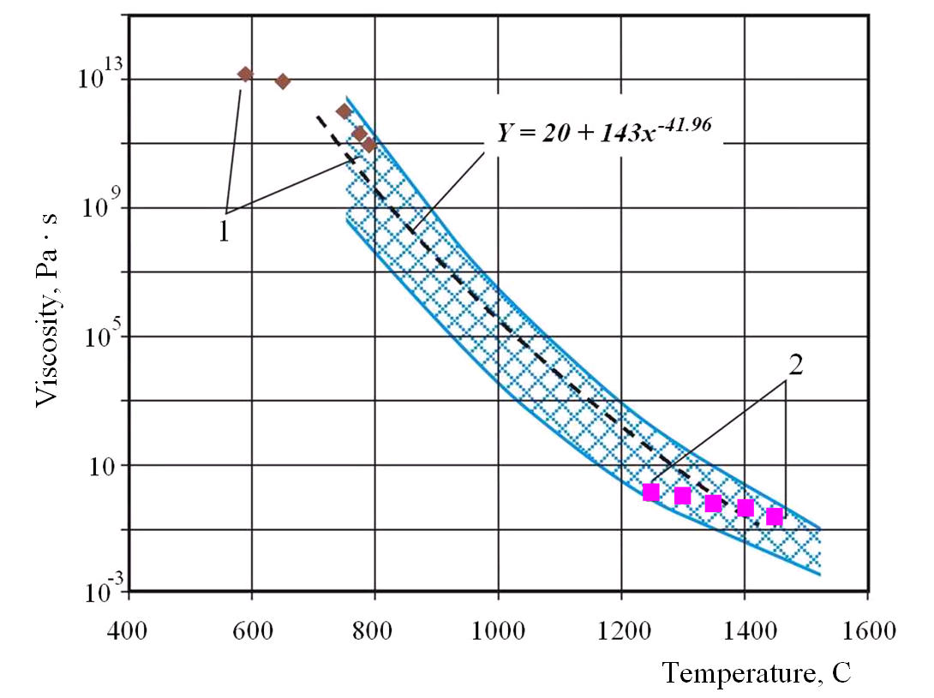

*Fig.10. Dependence of dynamic viscosity of LFCM on temperature*

*1 – Experimental data for brown lavas*

*2 – Results of calculation (Table 7)*

*The shaded area indicates possible errors of estimates.*

**4.3. Lava – Concrete Interactions**

Lava masses in the course of spreading as well as while cooling down after stopping interacted with concrete in intense way. This statement is confirmed by the results of investigations, such as: analyses of core samples taken from bore holes and data achieved using robots (for more detail see Ref. [7]).

According to the samples taken, lava penetrated into de-structured concrete on the floor of Rooms No No 304/3, 301/5 etc down to tens of centimeters.

While simulating LFCM spreading, adequate selection of lava‑concrete interaction parameters was of major importance.

Those parameters were to describe the following processes (for more detail see Ref. [23]):

* At first in the course of heating concrete is de-watered (it contains (200—250) kg/m3 of water). At (100 -150)°С concrete loses free water, next – at about 180°С water loss due to decomposition of gel starts. In the course of these processes concrete loses (30 – 40)% of water. According to experiments, ~ 100 l of water per 1 m3 is removed from concrete up to 500°С.
* Water release continuous at further temperature increase, СО2 is released as well, and de-structuring of concrete takes place.

Portland cement decomposes at ~ 500°С; quartz transforms at ~ 570°С; decomposition of limestone begins at ~ 800°С.

In the course of decomposition of ‘portlandid’ at (500—700)°С an additional portion of water (~75 l) is removed from concrete. Water release out of concrete terminates at ~ 800°С.

* Melting of concrete begins at (1150 – 1200) С. At (1300 – 1400)°С concrete represents a melt.

5.MAJOR OUTCOMES ACHIEVED IN SIMULATION OF LAVA SPREADING

**5.1. Main Parameters of Lava-spreading Simulation**

To simulate lava spreading, a mathematical model of multi-component medium was developed based on nonstationary Navier-Stokes equations within natural variables for incompressible liquid together with the energy equation. The model development was based on the following publications [11, 24 – 28].

Parametric dependences were obtained to determine the time of lava spreading and the rate of its cooling. The parameters considered included:

- the time elapsed after the accident (2, 3, 5, 7 days);

- different uranium content in the lava (4% or 8%);

- different thick of the layer of spreading lava (0.3, 0.5, 1.0 m); and

- different initial LFCM temperature (1800, 1900, 2000K).

Interactions of lava with concrete were accounted for, and the depth of both concrete fusing and de-structuring depending on the properties of spreading lava was determined[7].

Parameters with low variation probability and those with insufficient information on variations were neglected, such as: changes in lava composition with spreading (no relevant experimental data), distinctions in concrete composition in rooms “flooded” with lava (unimportant parameter), etc. Temperature of the ambient medium was not varied either.

**5.2. Results Important for “Shelter”-transformation Activities**

The most important results were achieved with regard to the horizontal lava flow.

They concern the boundaries of lava spreading in the rooms (or in their fragments) for which no experimental information is available as well as estimates of lava amount in rooms and in the whole horizontal flow.

The condition of concrete structures affected by high-temperature lava is also of major interest.

***5.2.1. Lava-spreading Boundaries in Rooms at the Level Mark 9.000 m***

As follows from Section 4 of this Report, at the level mark of 9.000 m the condition of LFCM and concrete in Room No 304/3, where lava surface was not concreted, has been studied in a rather detailed way.

In the corridor No 301/5 both parameters of the lava layer and the depth of concrete de-structuring were determined at a few number of points by means of holes and robots, most of the lava surface being covered with a layer of “fresh concrete”.

There are virtually no exact data on the lava being under a layer of concrete in Rooms NoNo 301/6, 303/3, 302/3.

Investigations of the lava in Rooms No 217/3 and No 017/2 indicate both a considerable distance (~ 25 m) of LFCM flow spreading and its virtually invariable element composition.

Thus there are no direct data on lava-spreading boundaries for some ‘concreted’ rooms.

In such a case computer simulation may be helpful. A good agreement of the results of performed calculations with all available experimental data allows making conclusions – to a considerable degree of trustworthiness – on the character of lava-flow spreading over rooms at the level mark 9.000 m.

The following experimental values were taken for calculations:

-lava layer thick by the inlet of the lava flow to Room No 304/3 (the breach – burn-through in the wall) ~ 1 m (see Ref. [7]);

-temperature at the lava flow inlet ~ 16000С (see § 4).

The calculated depth of concrete de-structuring makes up (30 – 40) cm that is in a good agreement with the observed values.

The average thick of the lava layer in the corridors No 301/5, No 301/6 and in Room No 303/3 (taking account of burned concrete) equals (0.3 - 0.5) m. In such a case the calculated depth of concrete de-structuring (10 – 15) cm is in a good agreement with the observed one.

Fuel content in the lava is 4%.

According to the results of computer simulation, the time of cooling of 0.5 m thick layer of the melt down to ~1000 K, at which the process of lava spreading virtually terminates, makes up about 20 hours. Crust of a rather large thick (0.1 m) is generated during 5 to 6 hours.

The model confirms that rooms at the level mark of 9.000 m are filled with solidified LFCM (see Table 8).

Table 8. Geometric parameters of the layer of solidified lava in rooms at the level mark of 9.000 m

|  |  |  |
| --- | --- | --- |
| Room | Possible area of spreading  (m2) | Average thick of the lava layer (taking into account burning of the floor)  (m) |
| 304/3 | 70 | 0.85 |
| 301/5 | 48 | 0.5 |
| 303/3 | 15 | 0.3 |
| 301/6 | 54 | 0.3 |

***5.2.2. Estimates of the Lava Amount in Rooms and in the Whole Horizontal Flow***

Such estimates may be made on the basis of the data of Table 8 and compared with those performed by experts (see Ref. [2]).

The results are generalized in Table 9.

Table 9. Estimates of the amount of fuel in the large horizontal flow (according to the KI‑IBRAE model and expert evaluations [2])

|  |  |  |  |  |
| --- | --- | --- | --- | --- |
| Room | Estimates based on the KI‑IBRAE model | | Expert evaluations [2] | |
| LFCM volume,  m3 | Amount of fuel (U), t | LFCM volume,  m3 | Amount of fuel (U), t |
| 304/3 | 60 | 6.4 | 50 ÷ 70 | 6 ± 2 |
| 301/5 | 24 | 2.5 | 8 ÷ 30 | 2,0±1,5 |
| 303/3 | 4.5 | 0.47 | 2 ÷ 7 | 0,5 ± 0,3 |
| 301/6 | 16 | 1.7 | 8 ÷ 30 | 2,0±1,5 |
| Fuel total | 104 | 11 | 105±35 (taking account of the volume of lava in the “Elephant’s Foot”) | 11 ± 4 (taking account of 0.4 t in the “Elephant’s Foot”) |

Table 9 demonstrates a good agreement between model calculations and previous estimates.

The model also allows fully excluding from consideration the options suggesting a considerably smaller volume of lava in the horizontal flow and an appreciably lesser amount of fuel contained therein as compared to the data of Table 9.

In such a case spreading of the lava over rooms at the level mark 9.000 m and at a distance of ~ 25 m must have been impossible due to cooling down of the lava.

6. CONCLUSION

**6.1. Database**

The work under the Project required the generation of a database on location and condition of nuclear fuel in Unit 4 of Chernobyl NPP both before and after the accident.

Its development was based on a database generated within the framework of the French-German Initiative – “Fuel of Unit 4” as well as on a large body of data especially collected and processed under this Project.

As a result, the database has integrated the information achieved over 20 years of investigations at the “Shelter” and included more than 6000 individual records.

Later on the database developed may and should be used while planning and conducting any works related to LFCM handling inside the “Shelter”.

**6.2. Layout of LFCM Accumulations in the Under-reactor Room**

The generation of a “map” showing the layout of lava-like FCM in Room No 305/2 has been an important outcome achieved in the course of work under the Project in 2006. This has become possible after processing of the results of numerous analyses of core samples taken from bore holes and measurements performed using these bore holes.

**6.3. FCM Accumulations with High Uranium Concentration**

The developed lava-generation model has revealed the possibility of presence of fuel accumulations with high uranium concentration at depth of the under-reactor Room No 305/2.

To date the integrity of heat and neutron measurements indicates the presence of two such hypothetical accumulations.

Increase in criticality of the said accumulations is due to inflow/outflow of water in their locations. There is, unfortunately, no way of estimating exactly their hazard at the present-day level of our knowledge. Thus one should be ready all the time to undertake preventive safety measures including injection of neutron absorbers into such accumulations.

After establishment of the “Arch” variations of neutron fields caused by these accumulations may become undetectable due to a drastic decrease in the amount of water penetrating into the “Shelter”. This, however, does not mean that their potential hazard may be neglected, and thus in the course of works inside the “Shelter” all necessary measures must be undertaken to prevent critical incidents.

**6.4. Evaluation of the Countermeasures Taken at the Active Accident Phase**

Within the frames of the Project an investigation aimed at evaluating the efficiency of several countermeasures taken at the active accident phase (such as: water delivery to the destroyed reactor; drop of different materials into Unit 4 wreckage from helicopters; construction of a special cooled plate under Unit 4 to prevent the “China Syndrome” development and some others) was performed.

At the level of the present-day knowledge and using the KI‑IBRAE model an attempt was made on reconstructing the situation and establishing real effect of countermeasures on the processes that went on within the destroyed power unit.

**6.5. Results Achieved while Simulating Lava Generation**

Most important results were achieved with regard to the horizontal flow.

They concern the boundaries of lava spreading in individual rooms (or their fragments) with lacking experimental information as well as estimates of the amount of lava in rooms and in the whole horizontal flow.

The KI‑IBRAE model confirms that rooms at the level mark 9.000 m are filled with solidified LFCM (see Table 8).

Table 8. Geometric parameters of the layer of solidified lava in rooms at 9.000 m level mark

|  |  |  |
| --- | --- | --- |
| Room | Possible area of spreading  (m2) | Average thick of the lava layer (taking into account burning of the floor)  (m) |
| 304/3 | 70 | 0.85 |
| 301/5 | 48 | 0.5 |
| 303/3 | 15 | 0.3 |
| 301/6 | 54 | 0.3 |

Estimates of the amount of lava in rooms and in the whole horizontal lava flow based on the KI‑IBRAE model and previous investigations are summarized in Table 9.

Table 9. Estimates of the amount of fuel in the large horizontal flow (according to the KI‑IBRAE model and expert evaluations [2])

|  |  |  |  |  |
| --- | --- | --- | --- | --- |
| Room | Estimates based on the KI‑IBRAE model | | Expert evaluations [2] | |
| LFCM volume,  m3 | Amount of fuel (U), t | LFCM volume,  m3 | Amount of fuel (U), t |
| 304/3 | 60 | 6.4 | 50 ÷ 70 | 6 ± 2 |
| 301/5 | 24 | 2.5 | 8 ÷ 30 | 2,0±1,5 |
| 303/3 | 4.5 | 0.47 | 2 ÷ 7 | 0,5 ± 0,3 |
| 301/6 | 16 | 1.7 | 8 ÷ 30 | 2,0±1,5 |
| Fuel total | 104 | 11 | 105±35 (taking account of the lava volume in the “Elephant’s Foot”) | 11 ± 4 (taking account of 0.4 t in the “Elephant’s Foot”) |

The data of Table 9 demonstrate a good agreement between model calculations and previous estimates.

The model also allows fully excluding from consideration the options suggesting a considerably smaller volume of lava in the horizontal flow and an appreciably lesser amount of fuel contained therein as compared to the data of Table 9.

In such a hypothetical case spreading of the lava over rooms at +9.000 m level mark and at a distance up to ~ 25 m must have been impossible due to lava cooling.

**6.6. Areas of Further Investigations**

After spreading, in the course of 20 years 1200 t of solidified lava inside the “Shelter” have been under the impact of external (humidity, temperature) and internal (its own radioactive emanation) factors and have degraded gradually.

As intended presently, many more decades will pass prior to removal of the lava out of the new confinement and its ultimate disposal.

Thus at the following step one should develop and justify models of the lava behavior and degradation for a protracted period of time (up to its removal ‑ ≤ 100 years) that is the content of the KI proposal for a new ISTC Project “CHESS – 2”.

Based on the models developed, recommendations on optimum establishment of barriers to prevent nuclear and radiation hazard at the Chernobyl NPP during storage and removal of the lava may be proposed.

The development of such-type models may be of interest for the whole category of hypothetical accidents accompanied with corium generation.

Just as in case of Chernobyl, works on corium removal and disposal might begin not immediately after an accident and thus would require a protracted period of time. In such a case the model generated might be useful for the development of corium retention devices for PWR, BWR and VVER power projects.

The Project “CHESS-2” shall answer a series of specific questions.

After the end of the active accident phase 20 years have elapsed. What processes have occurred with the “lava” during the period indicated? What processes will take place in the future during the time of awaiting removal of “lava” for several more decades under new-confinement conditions?

What physical and chemical processes and what external and internal mechanisms may have effect on degradation of the lava? What is the role of self-irradiation?

Whether or not the Chernobyl’s lava will transform into fine fuel dust over the period in question? Whether or not soluble uranium compounds will be generated on its basis; and what will be the radiation hazard in the course of removal?

What countermeasures may be taken in case of hazard, and what safety barriers may be recommended for use under the “Shelter” conditions?

What general recommendations on safe protracted storage of corium may be proposed?

The interfaces between the Projects “CHESS” and “CHESS-2” and their main objectives are demonstrated in the below diagram.

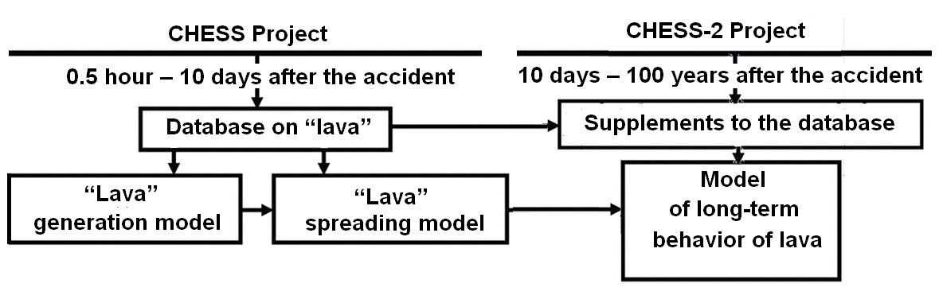

The use of the “CHESS” Project database in “CHESS–2” Project is intended.

In addition, the database will be substantially supplemented with new sections addressing possible radiation and chemical mechanisms of lava degradation.

REFERENCES

1. Bogatov, S., Borovoi, A., Gavrilov, S., Lagunenko, A. and Pazukhin, E. (2005) *Half an Hour after the Beginning of the Accident*, OKPRINT, Moscow, P. 22 (in Russian).

2. *The "Shelter" Current Safety Analysis and Forecast Estimates for the Situation Development* (2001) Responsible Executive: A.A. Borovoi, ISTC "Shelter" Report, n°3836, Chernobyl, P. 337 (in Russian).

3. Anderson, Е. B., Bogatov, S.А,Borovoi, А.А., *et al*. (1993) *Lava-like Fuel Containing Masses of the "Shelter"*, Preprint of the Ukrainian National Academy ISTC “Shelter” n°93-17, Kiev, P. 44 (in Russian).

4. *Project 1: “ Safety Status of the Chernobyl NPP’s "Object Shelter", Subproject n°3: “Nuclear Fuel and Radioactive Waste”* under a Special Agreement with IPSN and GRS of April 23, 1998. Work Report of IHTEM of RRC "KI" for the 3rd Half-yearly Milestone (October 30, 1999), Responsible Executive: Borovoi, А.А., P. 30 (in Russian).

5. Pazukhin, E.M. (1999) *Lava-like Fuel Containing Masses of the Chernobyl NPP Unit 4: Topography, Physical & Chemical Properties, Generation Scenario and Environmental Effects*, Doctoral Thesis, Chernobyl, P. 293 (in Russian).

6. Borovoi, А.А. (2006) Nuclear fuel in the “Shelter”, *J. Atomnaya Energiya (Atomic Energy),* **100 (4)**, pp. 259 – 267 (in Russian).

7. Bogatov, S.А., Borovoi, А.А., Gavrilov, S.L., *et al*. (2007) *Database on the Location and Status of Nuclear Fuel at Unit 4 of Chernobyl NPP before and after the Accident*, Preprint of RRC Kurchatov Institute #130-11/2 of 01.02.2007, P. 146 (in Russian).

8. Pazukhin, E.М. and Krasnov, V.А. (2004) Concerning a major engineering fault committed while designing RBMK-1000 and the necessity of an important correction of the scenario of the 1986-accident active phase, *Chernobyl Problems*, **15**, pp. 93 – 102 (in Russian).

9. Arutyunyan, R.V., Bolshov, L.А., Vasiliev, А.V. and Strizhov, V.F. (1992) Physical models of severe accidents at nuclear power plants, in: *N. N. Ponomarev-Stepnoy* (eds.), Nauka, Moscow, P. 232 (in Russian)

10. Veschunov, М.S. (1991) Kinetics of UO2‑Zr interactions at high temperatures, *J. Atomnaya Energija*, **70(2)**, p. 127 (in Russian).

11. Hofmunn, P. and Kerwin-Pack, D. (1984) UO2‑Zr interaction, *J. Nucl. Mater.*, **124**, р. 80.

12. Kabakchi**, S. А. and Bulgakova, G. P. (1997) *Radiation Chemistry in the Nuclear Fuel Cycle*, Manual of D.I. Mendeleev Chemico-Technological Institute, P.** 180 (in Russian).

13. *Findings of Expert Commission Concerning the Causes of Abnormal Event in Room #304/3 of the “Shelter” in June 1990* (1992), IBRAE RAS, Moscow, P.67 (in Russian).

14. Frolov, V.V. (1992) *A New Hypothesis on the Genesis of Abnormal Event in the Shelter in June 1990*, FEI Letter of 15.07.92, outgoing #57-07/117 (in Russian).

15. Borovoi, А. А. (2003) *The “Shelter” Nuclear Safety Evaluation and Consequences of a Hypothetical Nuclear Incident at the “Shelter”*, Preprint of IAE-6283/3, Moscow, P. 36 (in Russian).

16. Vysotskiy, E.D., Lagunenko, А.S., Shevchenko, V.G., *at al*. (2000) *Development of Methods and Procedures of Control over Subcriticality of Fuel-containing Materials, Experimental Investigation of the Efficiency of Early Detection Criteria and Technologies of Local Suppression of Subcritical Anomalies*, ISTC “Shelter” Report #3810, Chernobyl, P. 129 (in Russian).

17. *Bore* *Holes in the "Shelter": Generalized Data (Diagram Manuel)* (1998) Report of the ISTC “Shelter” Nuclear & Radiation Safety Department, #09/05-66 of 09.06.98, Chernobyl, P. 117 (in Russian).

18. *Results of Heat and Radiation Measurements at the Shelter over 1988-1989* (1989) Report of ISTC “Shelter” of Ukrainian National Academy #1379, P. 47 (in Russian).

19. *Development of Engineering Proposals on the Methods Influencing Subcriticality of Nuclear-hazardous Materials of the “Shelter”* (1997) ISTC “Shelter” Report, responsible executive: Borovoi A.A., Chernobyl, P. 131 (in Russian).

20. Borovoi, А.А., Pazukhin, E.М. and Strizhov, V.F. (2007) *Efficiency of Measures on Elimination of the Chernobyl Accident Consequences (Active Accident Phase)*, Preprint of RRC “Kurchatov Institute”, ИАЭ-6471/11, Moscow, P. 38 (in Russian).

21. Sheludiakov, P.N. (1980) *Composition, Structure and Viscosity of Homogeneous Silicate Melts*, Nauka Publishers, Alma-Ata (in Russian).

22. Kudinova, I.V.and Dodis, G.М. (1998) Investigation of viscosity of melts from basalt rocks, in *Bulletin of Kirghiz State University, Part 3*, Bishkek (in Russian).

23. Milovanov, А.F., Solomonov, V.V. and Larionova, Z.М. (2000) *High-temperature Heating of Reinforced-concrete Floors in the Course of the Chernobyl NPP Accident*, Energoatomizdat, Moscow, P. 75 (in Russian).

24. Chudanov, V., *et al.,* (1998) Current Status and Validation of CONV2D&3D code, *Proc. OECD/CSNI Workshop on In–vessel Core Debris Retention and Coolability*, Germany, Garching, 223-234.

25. Chudanov V.V., Aksenova A.E. and Pervichko V.A. (2003) *Proc. of IAEA Technical Meeting on Use of Computational Fluid Dynamics (CFD) Codes for Safety Analysis of Nuclear Reactor Systems, Including Containment, University of Pisa, Italy, 11-14 November, 2002*. (CD-disk (Session 7). Summary report IAEA-TECDOC-1379, p.14, 2003.

26. Chudanov V.V., Aksenova A.E., Pervichko V.A. (2005) 3D unified CFD approach to modeling of bubble phenomena. *Proc. 11th International Topical Meeting on Nuclear Reactor Thermal-Hydraulics (NURETH-11) Popes’ Palace Conference Center, Avignon, France, October 2-6, 2005*.

27. Chudanov V. (1999) Integrated approach to solution of problems of computational heat- hydrodynamics in complex areas, in: *Proceedings of the Russian Academy of Sciences,* **6**, pp.126-135 (in Russian).

28. Gronager, J.E., Suo-Anttila, A.J., Bradley, D.R. and Brockmann, J.E. (1986) TURC1: Large Scale Metallic Melt-Concrete Interaction Experiments and Analysis. *NUREG/CR-4420, SANd85-0707 R5, R7.*

1. The effects of materials dropped down from helicopters on the lava composition are neglected. According to performed investigations (e.g. Refs. [1], [2]), virtually no such materials penetrated into the reactor vault.
2. According to this scenario, burning of graphite lasts for 7 days. The initial time is half an hour after the accident beginning.
3. Among them:

   Memoirs by V.G. Smagin, Shift Supervisor at Unit #4, published in: Medvedev, G. (1989) The Chernobyl’s Writing-book*,* *Russian Literary Monthly Journal "Novyi Mir"*, **6**, pp. 3-108 (in Russian);

   Andreev, V. (1996) We worked in knee-deep water, *Daily Newspaper “Vseukrainskiye Vedomosti*”, April 25, 1996 (in Russian);

   Popov, N.N. (2003) *The Chernobyl Tragedy Pages*, Kiev (in Russian), and many others.
4. The causes of such a burst are not discussed: there are many versions of the Chernobyl catastrophe, and their analysis is beyond the scope of this paper.
5. Such disapprovals are expressed quite often. It is worthy of note that, if absolutely speculative publications are rejected, the rest of publications in most cases neglect specific conditions under which decisions on localization of the accident were made.
6. The “China Syndrome” ‑ the name of a popular feature film – means gradual burning-through of floors with glowing fuel down to its penetration into groundwater.
7. The following boundary conditions were used in calculations:

   * At the upper lava boundary thermal radiation was preset in the shape of σ (T4 – Tbound4), where: Tbound = 400;
   * At the lower boundary, type III boundary condition (convective heat exchange) was preset = 10×(T-300) or radiation condition.

   The properties of materials involved into interactions were selected as follows:

   * 1. Thermal conductivity of high-density concrete with granite gravel may be calculated through the formula up to the temperature of ~1000К λ = 1.3 – 0.000T.
     2. Heat capacity of the same concrete is: c = 481 + 0.84T.
     3. Densities of lava and concrete were taken equal, i.e. 2.33×103 kg/m3’.
     4. Because thermal conductivity of lava is unknown, that of re-melted oxide SiO2 was taken as the evaluation thermal conductivity. The available data allowed estimating thermal conductivity at a level of 2.5–3 W/mK that corresponded to its thermal conductivity at t=1000K.
     5. Heat capacity of lava was calculated as that of a mixture of uranium dioxide and silicates.

  