**FEDERAL STATE INSTITUTION**

**RUSSIAN RESEARCH CENTER “KURCHATOV INSTITUTE”**

**NUCLEAR SAFETY INSTITUTE of RUSSIAN ACADEMY OF SCIENCE**

## PROJECT № 2916

**REVIEW AND EVALUATION OF THE EXISTING MODELS**

**OF THE CHERNOBYL ACCIDENT**

**(PHASE 2)**

# Moscow

**2005**

# Abstract

Some source data necessary for generation of a model of the Chernobyl accident Phase 2 progression are addressed. The second phase of the accident, which began after Unit 4 destruction by explosion(s), represents a many-day process of nuclear fuel – constructional material interactions, corium generation and spreading.

The existing models are discussed including “The 1986’s Model”, “The Flying-Reactor Model” and “The E. Pasukhin’s, *et al*. model”.

Figs.4. Tables. 2. Refs. 14.

**1. Introduction**

As the result of the Chernobyl NPP Unit 4 accident shielding barriers and safety systems protecting the environment against radionuclides contained in irradiated fuel were destroyed. The release of activity from the damaged reactor at a level of millions of curies lasted for 10 days from 26.04.86 till 06.05.86 (see Fig.1); next it decreased by thousands of times and after that continued further its gradual decrease.

This period of time is known in scientific publications as “the active accident phase”.

Fig.1. Dynamics of release at the accident active phase. Error: ±50% (the authors’ estimate [1])

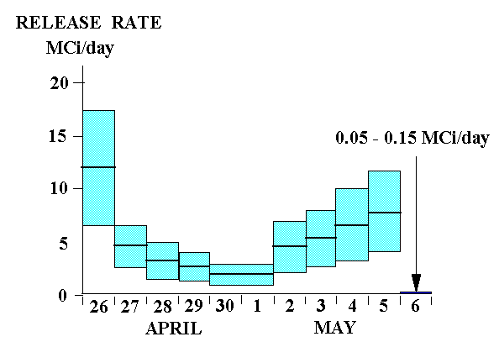

***This study mainly addresses the period of time after Unit 4 destruction by explosion(s), when a many-day process of nuclear fuel ‑ constructional material interactions, corium generation and spreading began.***

As distinct from the first phase with rapid (second-duration) processes, which resulted in fuel degradation and destruction of the reactor itself and Unit 4 constructions, the period under consideration is often designated as the “second accident phase”.

Since the early post-explosion hours, attempts have been undertaken on generating models of further behavior of the rest of Unit 4’s nuclear fuel.

Unfortunately, at first such models used very limited measurement and observation data. As a consequence, many decisions taken on their basis turned out to be far from optimal at a later time.

Hasty conclusions based on only few measurements and intuitive ideas were also made quite often at that time.

One typical example is cited below.

In the daytime of April 26 the very first data of radiation field measurements around Unit 4 were received at “Kurchatov Institute”. Those data were horrifying: most often the matter concerned thousands of Roentgen per hour! Based on those data, a suggestion was put forward (and even reported to the Governmental Commission) on release of an appreciable portion of nuclear fuel – tens of percent – to the Chernobyl NPP’s site. No calculation of radiation fields from a unit of quantity of irradiated fuel was performed.

However already on April 27 (i.e. one day later) by far more complete experimental on-site dose rate data were obtained, and calculations of the doses created by 1 g of fuel having been in the reactor by the accident instant were fulfilled. The first-type data turned out to be considerably lower, as compared to the measurements of April 26 (Fig. 2); by contrast, the calculation data were very large.

Their comparison allowed concluding that the release of fuel had equaled only tenths of percent of the whole fuel load[1].

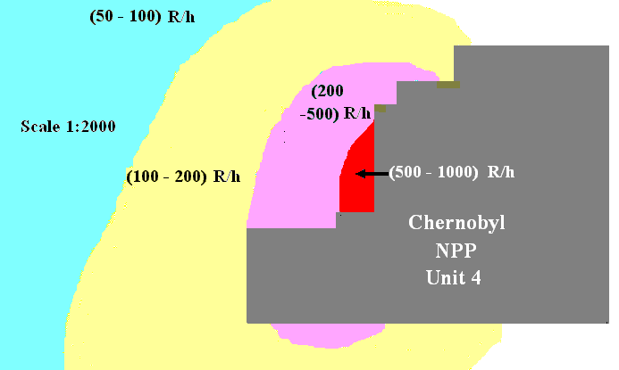

Fig. 2. Radiation fields (exposure dose rate values) around the destroyed Unit 4 of Chernobyl NPP after the accident

Let us consider one more example.

During the first post-accident days the following possibility was actively discussed: a conglomerate of molten nuclear fuel would gradually burn through concrete plates of floors, next would go down and finally would attain the ground[2]. Enormous contamination of ground waters was predicted. A comparison of “a scorching iron thrown into snow” was even contrived.

However that model did not consider at all (or considered incompletely) specific chemical and physical processes, which ‑ as the result of interactions between fuel and constructional materials ‑ had led to the generation of a special-type “lava”. Under such conditions the amount of Fuel Containing Materials (FCM) considerably increased, specific heating rate decreased, whereas cooling conditions improved. If a comparison of “an iron thrown into snow” were used further, one would assume dissolution of the iron material in the generating water.

At a later time, by the fall of 1986, the survey teams obtained some proofs that, though the floor-burning-through process had already begun (partial melting of the reactor basement’s structures and destruction of the plate between the subreactor compartment and the steam-distribution corridor, 9.0 m level mark), it did not lead to destruction of the basement plate.

The above examples confirm that the generation of a credible nuclear fuel behavior model at the second accident phase necessitates a considerable experimental data body.

One needs using information that may be – though rather conventionally – subdivided into the following categories:

***Mechanical data*** – describing spatial arrangement of materials and constructions in the reactor vault and subreactor compartments before the accident and after the occurred destructions;

***Chemical data***– characterizing the amount and composition of materials involved into interfaces with fuel including the materials, which had attained the reactor vault at the second accident phase; and

***Heat data***– describing heat sources and the dynamics of their behavior along with heat transfer conditions in the damaged reactor during the second phase.

Such data were obtained during investigations of 1986 – 2005 at both the destroyed Unit 4 and its confining “Object Shelter”. The most of data came to light by 1991.

As evidenced by this review, ignorance or failure to take account of such information led to major faults.

**2. The First Model of 1986**

At the very first meeting of the special Governmental Commission by the night of April 26 a decision was taken on dropping some materials down from helicopters into the open reactor vault for purposes of the accident localization. At a later time, after consultations, the list of those materials was defined more exactly [2]. Some of them (boron compounds, in particular, B4C) consisted of neutron absorbers and must have ensured nuclear safety. Other-type materials (clay, sand, dolomite) were to create a filtering layer and diminish radiation release. It was also expected that dolomite (MgCa)(CO3)2, after reaching high-temperature areas, would disintegrate forming carbon dioxide. That could have ensured "gas covering", i.e. could have deprived burning graphite of oxygen.

Finally, the last component (lead) was to take up the released heat, melt and prevent the “China syndrome” development.

Table 1 contains some characteristics of dropped down materials. The dynamics of material dropping down before May 2, 1986, is illustrated in Figure 3.

Table 1

Description of dry and liquid materials dropped into the reactor wreck by 18.06.1986

|  |  |  |
| --- | --- | --- |
| Material | Chemical formula | Mass  (t) |
| Boron carbide | B4 C | ~40 |
| Dolomite | MgCa(CO3 )2 | ~1200* |
| Marble aggregate, clay, sand, etc. | - | ~3500** |
| Lead (grit +ingots, etc.) | Pb | ~6700*** |
| Three-sodium phosphate (solution) | Na3PO4 | ~2500 |
| Solutions (dust-suppressing compositions) | Latex SKS-65gp, “barda” (waste of pulp-and paper industry), liquid glass, polyvinyl alcohol, caoutchouc SKTN, etc. | ~2700 |
| Total |  | ~16600 |

* during the active phase ~ 600 t of materials were dropped;

** about 1800 t of clay and sand were dropped during the active phase;

*** in the course of the first five post-accident days 2400 t of lead were dropped;

By 29.06.1986 1890 t of zeolite were additionally dropped.

Figure 3. – Dynamics of material dropping down

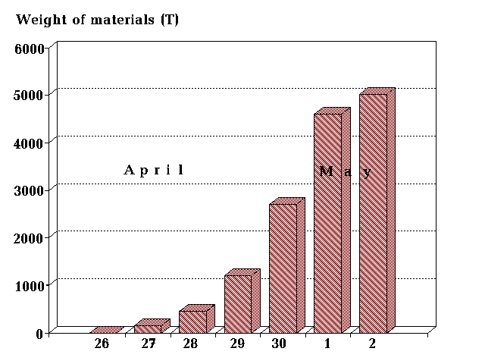

The effects of those materials on the processes in destroyed fuel were used as a basis of the first model (more precisely, of the first description) of the accident active phase progression. The model was reported by the USSR’s delegation at the IAEA Post-accident Review Meeting [1].

*“At the first phase of the accident a release of dispersed fuel from destroyed reactor occurred. Radionuclide composition of the release at that phase approximately corresponded to their concentrations in irradiated fuel but was enriched with volatile nuclides of iodine, tellurium, cesium and noble gases.*

*During the second phase (April 26 through May 2, 1986) the release rate beyond the damaged unit decreased thanks to the undertaken measures on graphite burning stopping and release filtration...*

*The third accident phase characterized by a rapid increase in fission product release rate beyond the reactor unit...That was due to fuel heating in the core up to 17000С and more due to decay heat.*

For the final – the fourth – accident phase (after May 6) a rapid release decrease was typical”.

More detailed description of the model under consideration can be found in several subsequent publications.

The main processes were explained in that model by the effects of dropped down materials. In the authors’ opinion, at first the cooling process took place due to absorption by lead of a portion of released heat. Next covering of the reactor vault with loose materials caused release decrease. Simultaneously, due to a decrease in heat pick-up by airflow, fuel temperature increased. At the active phase end a “break of radioactivity” through the layer of materials of the covering occurred, i.e. the release increase; after that the release decreased drastically. It seemed then that the above-described dynamics of release had explained entirely the observed situation.

However that – quite orderly and logic in 1986 ‑ model was completely refused already in the course of the first years of systematic investigations inside the “Shelter”.

According to those investigations, the main assumption of the reactor vault filling with a thick layer of dropped down materials – used as a basis of the initial four-phase model – turned out to be untrue*.*

Some indications for that fact were already available in 1986. For example, on some photos of the Central Hall (CH) it can be clearly seen that CH is literally filled with dropped down materials, which formed many-meter “hills” (see e.g. Reference [3] and Fig. 4). At a later time that fact was confirmed by survey teams, which had penetrated into CH after a long preparative period. Nevertheless, the possibility of location of a portion of dropped down materials in the reactor vault still must not be ruled out.

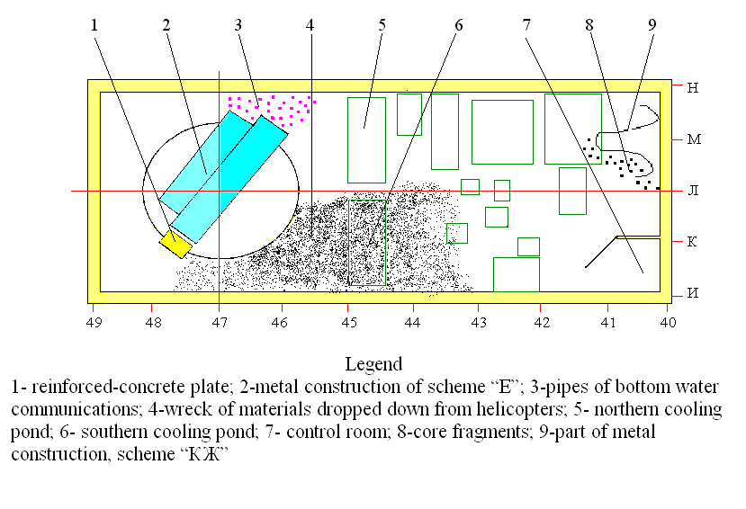

*Figure 4. - Central Hall of Unit 4 after the accident (scheme)*

In the mid-1988s the investigators managed to observe directly the reactor vault contents using optical devices and TV cameras [4]. Virtually no dropped down materials were found therein. However, one may also argue: when dropped down materials had reached high-temperature areas, they melted and spread over bottom reactor rooms. Such a process could have occurred indeed, for large amounts of solidified lava-like fuel-containing masses were discovered on bottom floors.

In such a situation lead could have been a proper indicator of the fact that not only reactor constructions, concrete, etc. formed the Unit 4 “lavas”, but also materials dropped down from helicopters. However so far virtually no lead has been discovered in the “lava” despite the fact that thousands of tons of that material were dropped down.

Table 2 [3] comprises data on lead contents in different types of Lava-like Fuel-Containing Materials (LFCM).

Table 4. Lead contents in LFCM samples

|  |  |  |  |  |
| --- | --- | --- | --- | --- |
| LFCM type | Coal-black ceramics | Chocolate-brown ceramics | Slag from piles in PSP* | Pumice from PSP* |
| Pb  (weight %) | (6.5 - 110)  ×10-3 | (12-240)  ×10-3 | (1.1 ±0.1)  ×10-2 | (1.2 ± 0.2)  ×10-2 |

*PSP – Pressure Suppression Pool

If the total LFCM mass is estimated today at ~ 1200 t, the integral amount of lead in the “lava” is <3 t of almost 7 thousand t dropped down from helicopters (i.e., approximately the 5×10-4th fraction!). Thus virtually no lead reached the reactor vault. Consequently, if other components of the dropped materials had reached the reactor vault, their amount could not have been significant enough to have a decisive effect on the release behavior.

Such are the known-by-now facts.

What factors did impede the pilots to fulfill their task?

Most likely, both the risk of colliding with the 150-m ventilation duct and enormously radioactive smoke column did not favor successful “bombing”. One more reason is also conceivable: the scheme “E” released by explosion rose almost vertically and –together with the pulled out jumble of pipes – created a specific “shield” that threw the dropping down materials to CH.

There was a bright luminous spot in CH nearby the reactor vault (hot graphite?). In Fig.3 its location is indicated by figure "4". That spot could have been recognized as the vault opening, and the pilots could have directed the dropping materials to that spot. Such a version is discussed in detail in a study by А. Sich [5].

# So far the data on dropped down materials have been published more than once (see e.g., References [4], [6] and [7]). Nevertheless, the model based on crucial effects of those materials on fuel behavior in the destroyed reactor (see, e.g., Ref. [8]) is still used and appears from time to time in various articles and reviews (e.g., Reference [9]).

Thus, despite undoubtedly heroic efforts of the pilots, their attempts on reactor filling with dropped down materials failed.

Whether their efforts were useless?

There are opinions that they were even harmful. For example, a viewpoint is known that, as a result of dropping tens of thousands of tons of materials onto Unit 4, damaged constructions could have been destroyed further. That could have produced negative effects on stability of the “Object Shelter” at a later time.

We would like, however, to point out positive effects of the measure under consideration (recall that only the technical side of the problem is addressed here).

Boron-containing materials attained CH, wherein large amounts of reactor core fragments and fuel dust had been thrown in. After covering reactor fuel, they diminished its nuclear hazard (most likely, transferred the fuel it to a “nuclear-safe” condition). In many locations sand, clay and dolomite had covered radioactive debris with a thick layer that facilitated subsequent works of the “Object Shelter” builders, operational personnel and investigators. A minor portion of materials could have reached the reactor vault and could have been involved into lava-generation processes.

1. **The “Flying-Reactor” Model**

That model was proposed first by E. Purvis III while working at ISTC “Shelter” (1990) [10]. Being contradictory to many established facts, that model would not deserve our special consideration, if peculiar circumstances were not concerned. Unfortunately, some “magic words” used repeatedly in the study by E. Purvis (such as: as “air-blast”, “reactor flying to the central hall”, “nuclear runaway”, “nuclear explosion”, “solar temperatures”, etc.) have inspired a number of his followers (K. Checherov, *et al*.) for further speculations. Some of them are still discussed today, mainly in mass media (see e.g., Ref. [11]).

For these reasons let us consider the E. Purvis’s model in more detail.

A quotation from the study by E. Purvis is given below.

*“The accident at Unit 4 of Chernobyl Nuclear Power Plant began between 1:23 and 1:24 of April 26, 1986. The fuel fragmentation process caused by rapid increase in reactor power level was the initiating event for a series of subsequent destructive phases.*

Fuel fragmentation and interfaces of the generated fragments with coolant produced an air-blast that, in its turn, led to destruction at about the same instant of virtually all bottom crossover joints of fuel channels.

*Via the generated breaches coolant was released from the primary circuit to the reactor core and produced intense steam generation therein. That resulted in steam explosion and lifting of the whole core - graphite moderator stack, fuel channels, fuel, reactor upper head (upper biological shielding) and refueling machine – up to at least 14 m above the reactor compartment flooring.*

*Due to loss of the whole coolant in the core, nuclear runaway led to an explosion (expansion of gas-like fuel) in air above the reactor vault at the indicated level mark.*

*It was that explosion that destroyed the core and many constructions surrounding the reactor. The same explosion threw fuel, graphite and other core fragments onto the roofs of the nearby buildings and the area surrounding the reactor compartment”.*

# Let us consider several – far from all ‑ speculative, in our opinion, statements of the model in question.

*“Fuel fragmentation and interfaces of the generated fragments with coolant produced an air-blast that, in its turn, led to destruction at about the same instant of virtually all bottom crossover joints of fuel channels”.*

This is the author’s crucial statement to which he recurs again and again.

Indeed, interactions of fragmented fuel with water could have resulted in air-blast initiation.

But why did that air-blast emerge simultaneously in every of 1659 fuel channels?

According to the available calculations (see Reference [12] and other publications), emergency increase of neutron flux lasted for only few seconds and was very non-uniform over the reactor core volume. Consequently, fuel channels must have dropped non-simultaneously.

*“That resulted in steam explosion and lifting of the whole core - graphite moderator stack, fuel channels, fuel, reactor upper head (upper biological shielding) and refueling machine – up to at least 14 m above the reactor compartment flooring.*

*Due to loss of the whole coolant in the core, nuclear runaway led to an explosion (expansion of gas-like fuel) in air above the reactor vault at the indicated level mark”.*

Question #1. Why did steam release from 1659 channels occur synchronously providing for vertical motion of the reactor in the vault (otherwise the reactor must have been jammed)? Such a phenomenon seems to be a real wonder.

Question #2. While “catapulting to air" (the author’s expression), graphite blocks under conditions of lower head "*ОР*” lacking must have been spilled down from zirconium fuel channels welded to the upper reactor head, having been literally “stringed” to those channels. Consequently, the author’s suggestion on “a single whole” that “catapulted to air” seems fantastic.

There is also another way of looking at the issue of graphite and other reactor materials.

In the author’s opinion, the whole core had flown out quite uprightly and had reached the central hall wherein nuclear explosion took place. E. Purvis III and his followers estimated the maximum temperature of the resulting heating up of the core materials at: ~ 7000 °С (such a temperature was enough to produce uranium dioxide evaporation) and 400000С (!), respectively.

In both cases all materials – fuel, metal and graphite – must have been evaporated.

The questions are: What material did burn in the reactor vault later on?

What materials 1200 t of lava were generated of in the Unit 4 bottom rooms? and

What is the explanation of the fact that ~ 95% of fuel was found within the “Object Shelter” a later time?

# Question #3.

Let us address now the Chernobyl’s hot particles.

Those particles were investigated by tens of research institutions, and a unique opinion was elaborated that the release had consisted of two main components.

The first component comprised volatile radioactive substances released by aerosols (volatile fraction). It was namely the volatile fraction containing iodine radionuclides, 137Cs and 134Cs that produced radioactive contamination of large territories.

The second component of the release consisted of radionuclides with high boiling point. They were also released in the aerosol form, however, not independently, but as components of uranium matrix wherein they had been generated during normal operation of the reactor. Those were the so-called “fuel particles” deposited mainly within the Chernobyl area. Tens of radionuclides, including 90Sr, isotopes of plutonium and other transuranic elements, were identified in those particles.

If “solar temperatures” had been available during the explosion, other-type specific “explosive” particles (e.g. purely plutonium or purely uranium particles) would have been generated. The “explosive”-type particles have been much studied by nuclear explosion investigators.

The fact is that during a nuclear explosion the process of fractioning of refractory non-volatile fission products takes place in the generating hot particles.

However in the Chernobyl’s case no “explosive” particles have been discovered.

The only exceptions are purely ruthenium particles really observed in different studies. However such particles fall into the “volatile fraction” category. They did not contain ruthenium metal (with the evaporation temperature of 4100°С) but ruthenium oxide easily sublimating at temperatures below 1000С. That was ruthenium oxide that deposited on particles of graphite and dust released from Unit 4.

Though the model by E. Purvis III and his followers contains many other enigmatic statements, we will not address them further in this study.

In our opinion, the authors have generated a rather impressive model of the Chernobyl accident:

… The reactor, moving first under the “liquid-propellant-jet-engine” mode, next under the “nuclear-jet-engine” mode and ejecting jets of water and plasma, leaves easily the reactor vault, soars up as a whole, flies and, finally, evaporates under the central hall’s roof at solar temperatures…

It only remains to regret that this model has nothing to do with the reality. Thus its predictions concerning fuel distribution after the explosion are useless for our further work.

There are many other models of the Chernobyl accident progression, however, they are mainly dealing with the first accident phase. Individual fragments of the developed models will be addressed in out future studies.

**4. The E. Pazukhin’s model**

The behavior of fuel at the 2nd accident phase has been studied most completely and consecutively in works of E.M. Pazukhin (see Ref. [13], references therein and Ref. [14] by S.A. Bogatov).

They contain the very first description of main post-accident mechanical, chemical and heat processes in the destroyed reactor complying with the factual data ‑ observations, measurements, and analyses of samples of fuel-containing and constructional materials.

The developed model describing the generation of ~ 1200 m3 of lava of real chemical composition did not involve considerable quantities of dropped down materials.

The fuel decay heat phenomenon (with a minor addition of energy from graphite burning and zirconium oxidation) was quite sufficient for the author to explain the processes of lava generation and spreading over the subreactor rooms. The duration of processes till lava surface cooling down 7000С - 8000С and below and the release cessation was estimated in the model at three days.

Though such estimate should not be considered as a quite accurate one for lack of knowledge of heat transfer processes at each phase of lava generation and motion, its order of magnitude coincides with the active accident phase duration.

The logic of this model will be used in our subsequent investigations.

# REFERENCES

**1. USSR State Committee on the Utilisation of Atomic Energy** (1986), in: “*The Accident at the Chernobyl NPP and its Consequences*” IAEA Post Accident Review Meeting, Vienna, 25-29 August 1986.

**2. Diachenko А.А.** (1996)

The Governmental Commission, in: “*Chernobyl: Catastrophe, Feat, Lessons and Conclusions*”, Inter-Vesy, Moscow, pp.183-193 (in Russian).

**3. The "Shelter" Current Safety Analysis and Forecast Estimates for the Situation Development** (2001) Responsible Executive: A.A. Borovoi, ISTC "Shelter" Report, arch. n°3836, Chernobyl, P. 337.

**4. Borovoi А.А.** (1990)

*Post- Accident Management of Destroyed Fuel from Chernobyl: Analytical Report*, IAEA, Work Material, 1990, pp. 1 - 99.

**5. Sich A. R.** (1994)

Chernobyl Accident Management Actions, *Nuclear Safety*, Vol.35, #1, January-June 1994, pp.1-22.

**6. Borovoi, А.А., Ibragimov, G.D., Ogorodnik, S.S., *et al*.** (1990)

*Actual Status of Chernobyl NPP Unit 4 and Nuclear Fuel Stored Therein*, Kurchatov IAE Preprint, P. 72 (in Russian).

**7. Belayev S., Borovoy, A., Demin V., *et al*.** (1991)

The Chernobyl source term, in: *Proceedings of a seminar of comparative assessment of the environmental impact of radionuclides released during three major nuclear accidents: Kryshtym, Windscale, Chernobyl*. Luxembourg, EUR 13574 report, pp. 71- 91.

**8. Maslov, V.P., Miasnokov, V.P. and Danilov, V.P.** (1987)

*Mathematical Simulation of the Damaged Chernobyl NPP’s Unit*, Nauka, Moscow, P. 144 (in Russian).

**9. Sivintsev, Yu. V. and Khrukev, А. А.** (1995)

Dynamics of radionuclide release from the damaged unit of Chernobyl NPP in 1986, *J. Atomnaya Energija*, **83**, #2, pp. 213—245 (in Russian).

**10. E. Purvis ІІІ** (1995)

*The Chernobyl Accident Scenario: a Version of April 1995*, ISTC Report, Chernobyl, P. 146 (in Russian)

**11. Versions of explosion at Chernobyl NPP ‑ an interview with K. Checherov,** “*Trud*” *Daily Paper*, February 11, 1998 (in Russian)

**Kiselev, А.N. and Checherov, K.P.** (2001)

A model of the processes of Chernobyl NPP Unit 4 destruction, *J. Atomnaya Energija,* **91**, #6, pp.425-433 (in Russian)

**12. «Chernobyl accident causes: overview of studies over the decade»** (1996)

*IAEA International Conference One Decade After Chernobyl: Nuclear Safety Aspects*, Vienna, April 1-3, 1996.

**13.Pazukhin, E.M.** (1994)

Lava-like Fuel Containing Masses of the Chernobyl NPP Unit 4: Topography, Physical & Chemical Properties, Generation Scenario, *J. Radiokhimia*, **36(2)**, 1994, pp. 97-142 (in Russian).

**14. Bogatov S.A.** (1996)

Interactions between Damaged Fuel of the Chernobyl NPP Unit 4 and Constructional Materials: Quantitative Estimates, in: Collection of Papers “*The Shelter: 10 Years on – Principal Results of Investigations*”, The Ukraine National Academy, Chernobyl, pp. 112-127 (in Russian).

1. According to calculations, if 0.3% of the whole of fuel had been released to the NPP’s site, the mean-over-NPP-site dose rate 1 m from the earth surface by May 6, 1986 would have been 50 R/h.
2. That effect was called “The China Syndrome” after the same-title movie.