# 1st Annual Report on the ISTC Project #2936

## Task 1: Modelling of melt formation and onset of melt relocation

### SVECHA/MELT code development

Single rod advanced mechanistic SVECHA/QUENCH code [1] was developed in IBRAE for detailed description of the fuel rod behaviour under severe accident conditions. Fuel rod is divided into a number of meshes along axial and radial directions. One axial mesh contains *UO2*fuel pellet, gap and the multilayered oxidized *Zr* cladding, Fig. 1. Code consists of the several coupled modules simulating physical effects during severe accident: cladding deformation; fuel rod heat conduction**;** cladding oxidation and hydrogen absorption and release; pellet-oxide dissolution; boron carbide oxidation; gas mixture dynamics.

Deformation module simulates deformation and failure of the fuel rod multilayered cladding with consideration of oxidation influence on cladding mechanical properties. Heat conduction module simulates two-dimensional temperature evolution inside the cylindrical rod with accounting of multilayered cladding structure and heat sources due to oxidation and hydrogen absorption. Cladding oxidation (hydrogen absorption) module simulates oxidation kinetics up to the metal *Zr* melting with consideration of mechanical effects and temperature gradients and cladding hydrogen absorption and release. Dissolution module simulates zirconium dioxide *ZrO2* and uranium dioxide *UO2* dissolution kinetics in the conditions of the metal *Zr* melting. *B4C* oxidation module simulates boron carbide pellet oxidation in steam flow. Gas mixture dynamics module calculates chemical composition (*Ar*, *O2*, *HO2*, *H2* and some additional species in the case of *B4C* oxidation), channel gas mixture temperature and velocity distribution.

**Work Performance**

* SVECHA/QUENCH code models set were slightly reduced to eliminate some second order approximation models unused in the melt formation and relocation modelling. Model of the fuel rod cladding through wall cracks surfaces oxidation and model for detailed description of the heat release due to *Zr* cladding oxidation were eliminated.
* SVECHA/QUENCH code main driver program structure was optimized. The algorithm of inter - modules data exchange was modified to have an opportunity to switch off each single effect module of the code. Initialization of the arguments becomes more flexible for new arguments introduction.
* New version for the calculations restart procedure (allows performing new calculations on the basis of pre-calculated results, starting from the user defined time moment) was developed. Restart data writing – reading was modified so that the restart data file becomes more useful for debugging and flexible in the case of new arguments appearance.
* Modified version of the SVECHA/QUENCH code was validated against the experimental data base. This modified version is chosen as the basis for development of the new SVECHA/MELT code. Improved model for simultaneous dissolution of the fuel rod cladding oxide scale *ZrO2* and *UO2* pellet by molten *Zr* and *U-Zr-O* mixture oxidation and its release from a cladding breach should be implemented in the SVECHA/MELT code.

**Axial Mesh**

**Pellet**

**Gap**

**Cladding**

Fig. 1. Schematic presentation of the mesh structure of the SVECHA/QUENCH code

### Improvement and implementation in the SVECHA/MELT code of the models for dissolution of ZrO2 and UO2 by molten Zircaloy and U-Zr-O melt oxidation

The default value of the temperature criterion in the SA codes for liquefaction and relocation of core materials is 2800 K, corresponding to liquefaction of the ceramic phase mixture at the eutectic point in the UO2-ZrO2 phase diagram. Nevertheless, poor representations of the observed relocation of core debris in the bundle degradation tests (e.g. Phebus FP tests) are produced by the codes when this default criterion is used. Much better representations of relocation are obtained in code predictions by artificially reducing the “melting point” of fuel to 2500-2600 K to simulate the effects of non-equilibrium material interactions in the Zr-U-O system. Such a “trick” is needed to obtain an adequate simulation of both: i) thermal evolutions in the bundle and in the shroud; and ii) the final state of the bundle degradation.

However, these changes in the temperature criterion for core material liquefaction and relocation are not substantiated by the equilibrium phase diagram of the ternary Zr-U-O system. In such a situation a mechanistic consideration of the effect of non-equilibrium material interactions becomes especially important, since it allows physically grounded interpretation of the bundle test observations.

Indeed, an additional analysis of the new model for Zr-O melt oxidation [2] shows that melt oxidation under non-equilibrium conditions characterised by the temperature difference between solid and liquid phases, can proceed after the attainment of the melt saturation and results in the ceramic phase precipitation in the bulk of the melt. Depending on test conditions, the precipitation process can be accompanied with the peripheral oxide layer growth or dissolution. This model prediction was successfully confirmed by the new FZK tests, in which such dissolution behaviour at a late stage of (ZrO2 crucible - Zr melt) interactions was investigated [2].

The important model prediction deduced for the binary Zr-O system concerning the enhanced dissolution of the ceramic phase by saturated melts and ceramic phase precipitation under non-equilibrium conditions can also be extended to the case of UO2 dissolution. It was anticipated that the dissolution of UO2 by the melt can strongly be increased under conditions of different temperatures in the fuel pellet and surrounding U-Zr-O melt. In this case the fuel dissolution is not anymore restricted by the melt saturation limit and actively proceeds in the oversaturated melt. This process (along with the melt oxidation by steam) leads to the enhanced oversaturation of the melt and to an increased rate of (U,Zr)O2-x ceramic phase precipitation. Therefore, a relatively quick transformation of UO2 phase into the mixed (U,Zr)O2-x ceramic phase (owing to dissolution and precipitation) can be predicted by this mechanism.

**Work Performance**

* Currently the model is extended to the general case considering temperature difference between the melt and two solid phases (the pellet and peripheral oxide layer surrounding the melt) in the course of their non-equilibrium interactions, therefore, it allows self-consistent treatment of UO2 dissolution and melt oxidation accompanied with growth of the peripheral ceramic layer (crust) and bulk ceramic precipitates.
* The new melt oxidation – fuel dissolution model is implemented in the SVECHA/MELT code.
* Being applied to the conditions of the Phebus FP tests, the model allows interpretation of the post-test microstructure observations of the molten pool in the lower zone of the FP test bundle. From the model calculations one can deduce that the observed homogeneous corium microstructure can be explained by precipitation of mixed ceramic (U,Zr)O2-x phase which accompanies the growth of the peripheral oxide crust (with a composition similar to that of the corium in the central zone). This occurs in the course of enhanced dissolution of fuel rods by (over)saturated melt and simultaneous vigorous melt oxidation in the molten pool at relatively low temperature (2500-2600 K), if non-equilibrium conditions characterised by temperature difference between solid and liquid phases are sustained, Fig. 1. A possible reason for such non-equilibrium conditions in FP tests can be connected either with the fission heat released in the fuel pellet or with the oxidation heat released in the oxide crust. Quantitative analysis of these heat sources and induced temperature gradients is recommended for the future investigation.

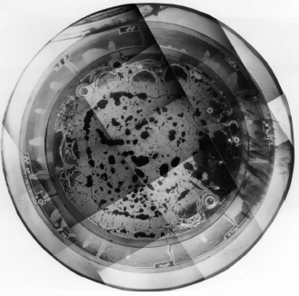

**Post-test macrograph of (U,Zr)O2 ceramic corium (molten pool)**



**Evolution of molten pool layers during transient**

Ceramic crust

Ceramicphaseprecipitation

Fig. 1. Conversion of large molten pool into ceramic phase at T < 2300°C due to oxidation/dissolution. Calculation with the SVECHA/MELT code. Temperature scenario from the Phebus FPT1 test.

### 

### 3. Cladding oxide shell failure criteria of SVECHA/MELT code

Analyses of results of integral tests on the severe accident behaviour of the fuel bundles under the loss of coolant conditions show that the external oxide scale failure strongly influences the accident progression. It is usually assumed in the codes that molten zirconium will be held in place between fuel and the shell of zirconium dioxide until a temperature criterion is reached. Currently, the temperature criterion is a user defined parameter, which is recommended in MELCOR as:

Tclad = 2400 K;

in ICARE2 as:

Tclad = 2700 K, if oxide shell thickness δZrO2> 250 µm

and

Tclad= 2600K, if δZrO2< 250 µm;

in ATHLET as:

Tclad = 2450 K, if oxide shell thickness δZrO2> 300 µm

and

Tclad = 2250K, if δZrO2< 300 µm.

Therefore, the temperature criterion is generally well above the melting point of the Zircaloy cladding. There is, then, time for hydrogen production by steam reaction with molten zirconium.

Once retention of the molten zirconium is no longer possible, a complex alloy of Zr-U-O will flow down fuel rods and be susceptible to steam oxidation.

This problem can be resolved by application of a more advanced mechanistic criterion for the clad rupture. Analyses of the available experimental data on the oxide scale failure at high temperatures obtained in FZK [3] and modelling of this phenomenon with the help of the code SVECHA/QUENCH (S/Q) revealed the following two modes of the oxide scale failure:

1. Outer oxide scale formed during the initial stage of an accident is partially dissolved by molten Zircaloy and hydrostatic pressure of molten Zircaloy destroys the thinned oxide layer. This mechanism is characteristic for the high heat up rate (> 5 K/s) scenario (Fig. 2).
2. Outer oxide scale continues to grow after melting of Zircaloy metal phases. Owing to the volumetric expansion of oxide, the free volume unoccupied by the melt (gap volume between pellet and cladding) decreases and finally disappears, leading to the oxide scale failure induced by the incompressible molten Zircaloy pressure. This mechanism is characteristic mainly for the low heat up rate (< 5 K/s) scenario (Fig. 3).

S/Q code simulations show that evolution of the oxide scale under interaction with molten Zircaloy depends on the oxide scale and metal phase thickness, oxygen content in molten Zircaloy and the oxygen flux at the cladding surface. The oxygen flux should strongly influence the oxidation kinetics: the decrease of the steam flow in the gas mixture can lead to the transformation of the oxidation kinetics from “corrosion” (oxidation) to “erosion” (dissolution) and vice versa. Hence, timing to the oxide scale failure depends on erosion/corrosion kinetics and the mechanical damages of the oxide scale accumulated in the previous stages of an accident.

**Work Performance**

* Despite failure mechanism is the result of mutual interaction of oxidation/dissolution and deformation behaviour, in the first order approximation a simplified approach can be accepted. Breaching in the first case (dissolution mechanism) occurs when oxide shell becomes very thin (in comparison with the initial thickness), whereas breaching of the oxide shell in the second case (volumetric expansion mechanism) occurs very soon after closure of the pellet-cladding gap. This allows significant simplification of the failure criterion by the following assumptions: the outer oxide scale fails if either the oxide scale thickness equals to zero (in the first case), or the free gap equals to zero (in the second case), Fig. 3. Therefore, only simulation of the erosion/corrosion kinetics may be used to predict the oxide failure under interaction with molten Zircaloy within the simplified approach of the system codes.
* The new cladding oxide shell failure criterion was implemented in the SVECHA/MELT code.
* The code with the newly implemented cladding oxide shell failure criterion was applied to the conditions of the Phebus FP tests. Using the standard high-temperature criteria for oxide shell failure (e.g., T ≥ 2600 K), one can make a conclusion that the fuel rod geometry in the upper zone of the bundle will mostly remain intact after melting of the metal cladding; whereas application of the advanced SVECHA/MELTcriterion allowed a conclusion that oxide shell failure at high elevations may occur already during temperature escalation phase just after metal α-Zr(O) melting, leading to formation of local molten pools above the upper space grid of the bundle.

Local molten pool formation prevents metallic melt from complete oxidation owing to a high value of the volume to surface ratio in this melt configuration, on the one hand, and provides an enhanced fuel pellets dissolution by the melt during the subsequent degradation phase, on the other hand.

|  |  |
| --- | --- |
|  |  |
| Fig. 2. FZK test 32SK: pre-oxidation time 2 min. at 1400°C, 8 °C/s heat-up rate, failure temperature 2030°C [3]. | Fig. 3. FZK test 36SK: pre-oxidation time 2 min. at 1400°C, 4 °C/s heat-up rate, failure temperature 2100°C [3]. |

**Erosion**

**Corrosion**

**Cladding temperature**

**Axial elevation**

**Zr(O) melting temperature**

**Fuel rod**

**Pellet**

**ZrO2**

**Zr(O)**

**Solidified melt**

### Melt

## Gap

Fig. 3. Scheme of the SVECHA/MELT mechanisms for the oxide shell failure at high temperature.

### References:

1. A.V. Berdyshev, A.V. Boldyrev, A.V. Palagin, V.E. Shestak, M.S. Veshchunov, “SVECHA/QUENCH Code for The Modeling of Reflooding Phenomena in Severe Accidents Conditions”, - Proceedings of the Ninth International Topical Meeting on Nuclear Reactor Thermal Hydraulics (NURETH-9),paper Log_19 (CD-ROM edition), San Francisco, California, USA 1999.
2. M.S. Veshchunov, J. Stuckert, A.V. Berdyshev, *Modelling of Zr-O and U-Zr-O Melts Oxidation and New Crucible tests*, Report FZKA 6792, SAM-COLOSS-P040, Karlsruhe, Germany, December 2002.
3. P. Hofmann, J. Stuckert, A. Miassoedov, M.S. Veshchunov, A.V. Berdyshev, A.V. Boldyrev, ZrO2 Dissolution by Molten Zircaloy and Cladding Oxide Shell Failure. New Experimental Results and Modelling, - Report FZKA 6383, INV-CIT(98)-P026, Karlsruhe, Germany, 1999.

## Task 6: Mathematical model and numerical module of molten pool

### Adaptation of an existing three-dimensional CONV code

Adaptation of an existing three-dimensional CONV code [AKS, 00] is carried out in view of conditions of the LIVE project for simulation of three-dimensional flows in the Boussinesq approximation for buoyancy on Cartesian grids with a local refinement near domain with singularities of flows.

For designing a computing grid in domain representing the experimental facility LIVE the developed automatic process engineering of grid generation using CAD models (see fig. 1) is applied [CHU, 99; CHU, 05].

|  |  |
| --- | --- |
| Common dimensions of facility | E-F section. Heater. |
|  |  |
| Figure 1: Sketch of the LIVE facility constructed by means of AutoCAD. | |

For construction of calculated grids (structured orthogonal grids and also Cartesian grids with local refinement near to solid-state domain boundaries) the specially developed preprocessing supplied by the user-friendly interface is used to build calculated grid and to set boundary conditions [CHU, 00].

For modeling thermal and hydrodynamics in incompressible fluids the Navier-Stokes equations in the primitive variables in the Boussinesq approximation for buoyancy together with the convection/diffusion equation for temperature are used:



Criterion of applicability is the inequality , where  is sound velocity in a liquid,  is thermal expansion coefficient.

### Implementation of the algebraic turbulent models in CONV code

For the modeling of 3D turbulent single-phase flows the developed approximated model of turbulent viscosity is applied [RAS, 95]:

,

where f(Ra) is a function of Rayleigh number calibrated by numerical calculations of natural convection in а cavity with walls of different temperature (see figure 2).

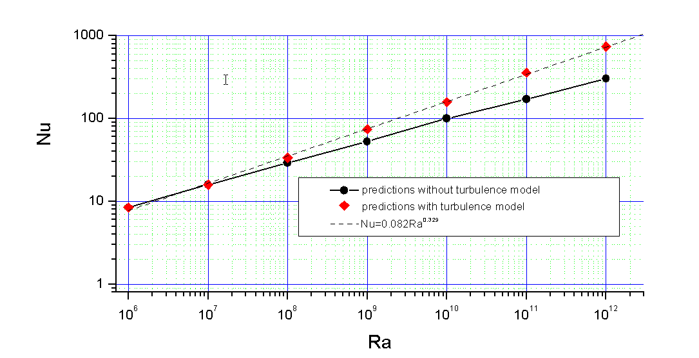

Figure 2:

Other notes in model: **  - turbulent viscosity,  – local Reynolds number,  - critical Reynolds number, Ra- Rayleigh number.



is turbulent Prandtl number. Richardson number estimated by prof. Kondratenko (IBRAE) as .

Under extremely high Ra number there has to be а change in approximating model accounting stable and unstable temperature layers. For this purpose Polykov’s data may be used [POL, 89].

Moreover the possibility of application Baldwin-Lomax of eddy viscosity (B-L) is realized which was formulated for use when properties of a boundary layer as (is thickness of shift layer), ( is high-speed thickness) and ( is a velocity of boundary layer edge) are difficult to define. Such situation frequently arises at modeling of the separate flows in particular for flows with shock waves.

B-L model is two-layer model with  defined by the separate expression in each layer.

The eddy viscosity is defined by the equation

,

where  is the smallest value of  for which .

For inner layer (value of  in inner layer) is calculated as follows:

,

.

- dimensionless sub-layer scale distance .

Here  is friction velocity, is mass density,  is surface shear;  is kinematic molecular viscosity (sub-index  denotes of wall value).

For outer layer (value of  in outer layer) is calculated as follows:

,

where

, ,

where  is value of  at which  reaches the maximum value.



Closure coefficients for B-L model look like

.

 is Klebanoff’s intermettency function with  replaced by *ymax/Ckleb* and *w* is the magnitude of vorticity vector [WIL, 04].

Model was applied to wall-bounded flows, i.e. to flows with a solid boundary. The no-slip boundary condition was enforced for wall-bounded flows. At first examines two internal flows, viz. channel flow and pipe flow. Then external flows were considered, i.e. boundary layer growing in a semi-infinite medium.

1. For solving of computational fluid dynamics problems in the domain of arbitrary shapes the effective finite-volume numerical algorithm for the heat and mass transfer equations (i.e. Navier-Stokes equations with energy equation) in the primitive variables is developed.

The numerical technique is based on the developed algorithms with small scheme diffusion, for which the discrete approximations are constructed using finite-volume methods and fully staggered grids.

* Decomposition on physical processes is used to construct operator-splitting schemes. The momentum equation operators are splitting on two parts. The first part is associated with the velocity transport by convection/diffusion, whereas the second part deals with pressure gradient. The numerical implementation of the constructed scheme is performed as the predictor-corrector procedure. To supply momentum equations by pressure correction is allowed to transform it to the well-known Poisson equation and velocity correction equation.
* The energy equation is decomposed into two parts associated with the enthalpy transfer and temperature diffusion. Semi-implicit scheme is used for solving of unsteady equation of temperature diffusion.

 (1)

(2)

(3)

Here , where  and  is the diffusive transport operator  or where .

To implement the scheme (1)-(3) one can subtract the equation (1) from (2) and obtain so-called stabilising correction equation with regard 

 (4).

Let us express  from the (4) and substitute it into the incompressibility constraint (1) taking into account that  at the boundary  and denoting  we derive the Poisson equation to evaluate the pressure correction :



* For solving of transfer equation the developed regularized non-linear monotonic operator-splitting scheme is applied.
* To deal with irregular computing areas the fictitious domain method (FDM) is used [AKS, 98].
* For solving of the pressure correction equation the Fast Transformation Fourier method is used [CHU, 02].
* The elaborated technique has a high degree of efficiency and today allows CFD calculations to be carried out on a grid with a total number of 107 nodes using a PC with P4-2.0GHz processor and 1.5Gb-RAM. For simulation of the single-phase flows fast actions of 10-5 second per node and time step are possible.

### Validation of algorithms, methods and software

Algorithms, methods and software, elaborated on basis of the above computational methods and schemes are validated during project on a wide class of experimental and benchmark tests.

* + Verification against data on convection of fluid between two rigid walls of different temperatures was performed. Heat transfer in this case is governed by the fluid flow in vertical boundary layers adjacent to the walls, ascending near hot boundary and descending near cool wall. Heat transfer is defined by Ra number based on temperature difference. Two data sets were used for verification. The first set considers laminar flow regime at rather low values of Rayleigh number  (benchmark Davis), the second set deals with transitional and turbulent flow regimes in range of Rayleigh numbers from  up to (Jacob correlation).
  + Verification against data on Benard convection to verify code predictions in a region of unstable stratification has been performed against data on convection between two rigid horizontal surfaces. Bottom surface is heated while upper is cooled. Heat transfer is governed by Rayleigh number based on temperature difference between horizontal plates.
  + Verification against data obtained in experiments on melting of pure gallium was used for verification of code capabilities to solve consistently heat transfer problem and melting/solidification. This problem is a standard test for the problem of melting (solidification) for convection/conduction heat transfer.
  + Verification against Mayinger experiments obtained for volumetric heated rectangular or semi-cylindrical geometry in range of modified Rayleigh numbers -  is performed.

The preliminary numerical simulation of circular heating used in experimental facility LIVE is carried out.

A comparison of a uniform heat with circular used in experimental facility LIVE under an identical common power is carried out. The qualitative picture is shown at figure 3. Nu vs Ra at the different heating is presented at figure 4. Ratio equals 1.2. Comparison is done with correlations presented by M. Sonnenkalb [SON, 94].

|  |  |
| --- | --- |
| Uniform heat: Ra=109 | Circular heat: Ra=109 |
|  |  |
| Figure 3: comparison of a uniform heat with circular used in experimental facility LIVE under an identical common power. | |



Figure 4: Nu vs Ra at the different heating.

### The model for calculation of flows with a variable density without of Boussinesq approximation

The model for calculation of flows with a variable density without of Boussinesq approximation is included in CONV code.

For calculation of flows with a variable density without of Boussinesq approximation the Navier-Stokes equations with a variable density in the primitive variables are applied:

.

For solving of presented equations the finite-volume numerical algorithm for the heat and mass transfer equations (i.e. Navier-Stokes equations with energy equation) in the primitive variables is developed.

The numerical technique is based on the developed algorithms with small scheme diffusion, for which the discrete approximations are constructed using finite-volume methods and fully staggered grids.

* Decomposition on physical processes is used to construct operator-splitting schemes. The momentum equation operators are splitting on two parts. The first part is associated with the velocity transport by convection/diffusion, whereas the second part deals with pressure gradient. Douglas-Rachford operator-slitting technique is employed to construct semi-implicit scheme for time-dependent equations of hydrodynamics. The numerical implementation of the constructed scheme is performed as the predictor-corrector procedure. To supply momentum equations by pressure correction is allowed to transform it to the well-known Poisson equation and velocity correction equation.
* Fully implicit scheme is used for solving of unsteady equation of temperature diffusion.
* For solving of transfer equation the developed regularized non-linear monotonic operator-splitting scheme is used.
* To deal with irregular computing areas the fictitious domain method (FDM) is used [AKS, 98].

The modified predictor-corrector procedure for the Douglas-Rachford scheme seems like this





Here , where  and  is the diffusive transport operator  or where .

### Modification of numerical algorithm

The necessary modification of numerical algorithm to fast solving of the pressure correction equation with use algebraic solver on the basis of Fast Fourier Transformation (FFT) and verification of the software are carried out.

The numerical realization operator splitting schemes for solving of the Navier-Stokes equations with a variable density has the following feature: a fast solver for pressure correction equation based on the modified preconditioned Richardson method with FFT as preconditioner.

For solving the pressure correction equation with a variable density



the following iterative algorithm for matrix  such that  take place

,

where - initial approximation, - residual function,  eigenvalues of ,  - preconditioner, symmetric and positive.

Maximum of convergence velocity is reached under

.

The error is estimated as

.

The offered algorithm is very effective. That is demonstrated below on an example of a solution of the Neumann problem for an elliptical equation of the second order with variable factors  in cube with side .



where  is defined so, that ratio of its values on the ends of an interval and 0 equals .

For checking of algorithm the following solution  was selected which satisfies by condition  at the boundary.

The developed numerical algorithm [CHU, 05] based on the semi-iterative method with Chebyshev’s set of parameters and FFT solver as preconditioner allows to reduce expenditures in a few times on one calculated step in comparison with PCGM.

In Table 1 a comparison of the indicated approaches is reproduced.

Table 1.

|  |  |  |  |
| --- | --- | --- | --- |
| =10-6 | N |  |  |
| PCGM | 35 | 87 | 141 |
| 70 | 215 | 320 |
| 130 | 478 | 727 |
| Modified Preconditioned Richardson method with FFT | 33 | 5 | 258 |
| 65 | 5 | 274 |
| 129 | 5 | 281 |

In figure 5 a comparison of iterative number under solving of pressure correction equation by PCGM and Modified Preconditioned Richardson method with FFT as preconditioner is presented. Results correspond to =10-3-10-6.

The curves demonstrate change of an iteration number depending on a ratio , where  and  are maximum and minimum eigenvalues of an operator. From these curves it is obvious that Modified Preconditioned Richardson method with FFT is more effective than usually used PCGM.



Figure 5: Amount of iterations for PCGM under different values N in a comparison with semi-iterative method with the Chebyshev parameters with for =10-6.

### Verification of the modified software

Verification of the modified software is carried out on such experiments as RASPLAV and SIMECO [SIM, 02]. A comparison of models with and without Boussinesq approximation for such parameters as 3D heat flux distribution on the cooled boundary is carried out.

An inversion of the stratified layer of easy on heavy under the various layers ratio is studied in SIMECO experiments.

The rate of mass transport between compositional different layers is defined by the bulk Richardson number: Ri=gH/V2.

Olsen proposes a mixing time scale of two layers tmix= (HCp)/(q).

The velocity scale, in a convective layer, can be written as V2=TgH, which implies that Ri=(/)/(T ).

The Ri number written in this form it may be denoted as a stability number.

As a result of calculations qualitative coincidence was obtained with SIMECO experiment (see figs.6-9).

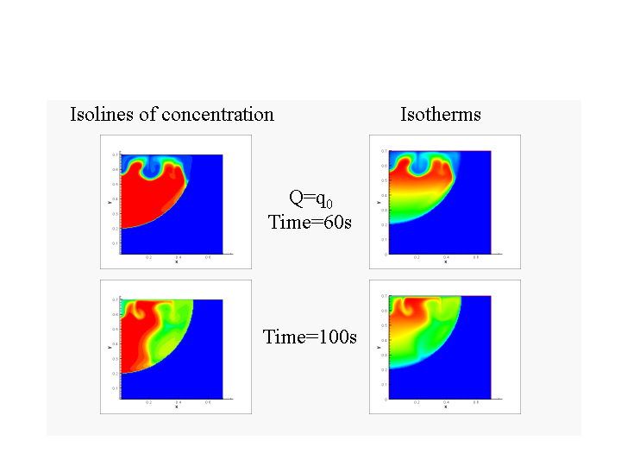

Figure 6: Inversion of the stratified layer of easy on heavy under 5% layers ratio.

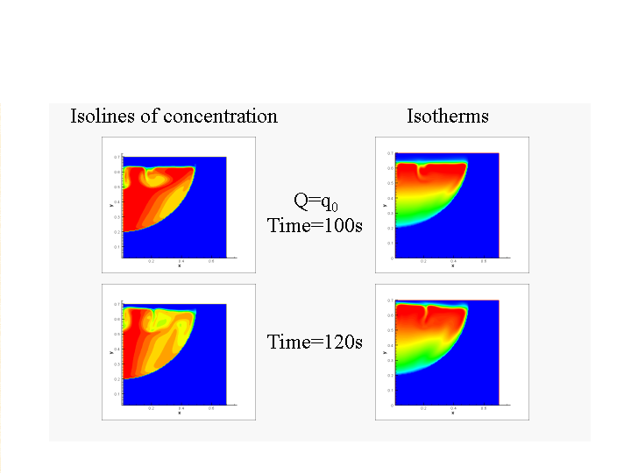

Figure 7: Inversion of the stratified layer of easy on heavy under 10% layers ratio.

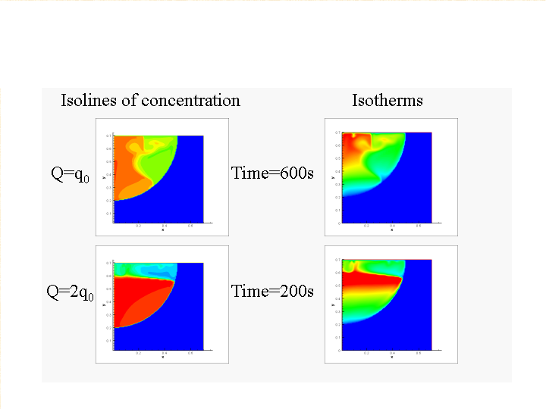

Figure 8: Inversion of the stratified layer of easy on heavy under 20% layers ratio.

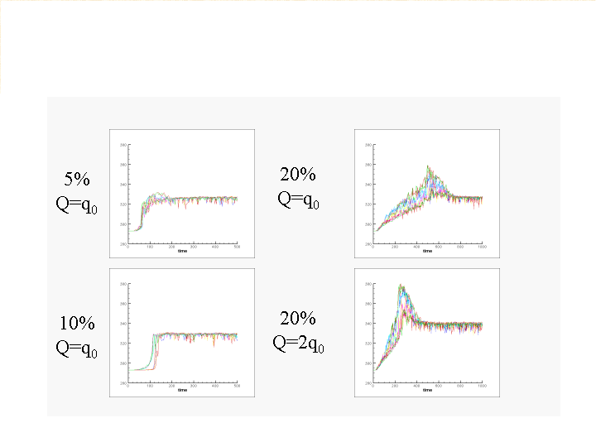

Figure 9: Time of a beginning of inversion at the different percentage ratio of layers.

### References

[AKS,  98] Aksenova A.E., Chudanov V.V., Churbanov A.G., Pervichko V.A., Vabishchevich P.N., Numerical methods for solving a diffusion/convection problem with regard to melting using a fictitious domain procedure. In Proceedings of 16th International Conference on numerical methods in fluid dynamics, Arcachon, France, 6th-10th July, 1998.

[AKS, 00] Aksenova A.E., Chudanov V.V., Pervichko V.A., Semenov V.N. Strizhov V.F. // Development and application of the CONV Codes. // In Proc. RASPLAV Seminar 2000, Munich, November 2000. CD-disk.. Session 3: Theoretical analysis. 18p.

[CHU,  99] V.V. Chudanov, A.E. Aksenova, et al., A Multi-Block Orthogonal Grid Generation using CAD system, Proc. 8th International Meshing Roundtable, SANDIA REPORT, SAND 99-2288, pp. 179-189, 1999.

[CHU, 00] V.V. Chudanov, A.E. Aksenova, V.A. Pervichko, et al. A Semi-automatic orthogonal and Cartesian local refinement grid generation using CAD”. In book Numerical Grid Generation in Computational Field Simulations. Published by Int. Society of Grid Generation, Edited by: B.K. Soni, J. Hauser, J.F. Thompson, P.Eiseman. Paperback: 1100 pages, ISBN 0-9651627-3-7, pp. 3-13, 2000.

[CHU, 02] Chudanov V.V., Aksenova A.E., Pervichko V.A. 3D unified CFD approach to thermalhydraulic problems in safety analysis. In Proc. of Technical Meeting on Use of Computational Fluid Dynamics (CFD) Codes for Safety Analysis of Reactor Systems, Including Containment, University of Pisa, Italy, 11-14 November, 2002.

[CHU, 05] V.V. Chudanov, A.E. Aksenova, V.A. Pervichko, I.G. Plotnikova, A.A. Korotkov. “Grid Office” for CFD Pre and Post Processing. To be published IMACS 2005.

[POL, 98] book from 1989, ``Heat Transfer 1., Convective Heat Transfer’’, Vilnus, Moklus Publ. Cor. .

[SON, 94] Proc. of workshop on Large molten pool heat transfer, Grenoble, France, 1994.

[SIM, 02] Sehgal and et al. Experiments of the effects of melt pool stratification on vessel thermal loads in the SIMECO facility.

[WIL, 04] book “Turbulence modeling for CFD” by David C.Wilcox, 2004.