# ANNEX I

# Work Plan (PARAMETER)

## I. Summary Project Information

### 1. Project Title

Fuel assembly tests under severe accident conditions

### 2. Project Manager

|  |  |  |  |  |  |  |  |  |
| --- | --- | --- | --- | --- | --- | --- | --- | --- |
| **Name:** | | Nalivaev Vladimir Ivanovich | | | | | | |
| **Title:** | Ph.D. | | | | **Position:** | | Division Deputy Director | |
| **Street address:** | | | | Zheleznodorozhnaya 24 | | | | |
| **City:** | Podolsk | | | | **Region:** | | Moscow | |
| **ZIP:** | 142100 | | | | **Country:** | | | Russian Federation |
| **Tel.:** | +7 (095) 715-9449 | | | | **Fax:** | +7 (0967) 54-8589 | | |
| **E-mail:** | | | dvp@luch.podolsk.ru | | | | | |

### 3. Participating Institutions

#### 3.1. Leading Institution

|  |  |  |  |  |  |  |  |  |  |  |  |
| --- | --- | --- | --- | --- | --- | --- | --- | --- | --- | --- | --- |
| **Short reference:** | | | | | FSUE SRI SIA “LUCH” | | | | | | |
| **Full name:** | | | Federal State Unitary Enterprise Scientific Research Institute Scientific Industrial Association “LUCH” | | | | | | | | |
| **Street address:** | | | | Zheleznodorozhnaya 24 | | | | | | | |
| **City:** | Podolsk | | | | | | | **Region:** | | Moscow | |
| **ZIP:** | 142100 | | | | | | | **Country:** | | | Russian Federation |
| **Name of Signature Authority:** | | | | | | | Chervyakov Leonid Dmitrievich | | | | |
| **Title:** |  | | | | | | | **Position:** | | Deputy General Director | |
| **Tel.:** | +7 (095) 715-9546 | | | | | | | **Fax:** | +7 (0967) 54-8589 | | |
| **E-mail:** | | dvp@luch.podolsk.ru | | | | | | | | | |
| **Governmental Agency:** | | | | | | Federal Agency of Atomic Energy | | | | | |

#### 3.2. Other Participating Institutions

#### Participant Institution 1

|  |  |  |  |  |  |  |  |  |  |  |  |
| --- | --- | --- | --- | --- | --- | --- | --- | --- | --- | --- | --- |
| **Short reference:** | | | | | IBRAE RAS | | | | | | |
| **Full name:** | | | Nuclear Safety Institute of Russian Academy of Sciences | | | | | | | | |
| **Street address:** | | | | B. Tulskaya 52 | | | | | | | |
| **City:** | Moscow | | | | | | | **Region:** | |  | |
| **ZIP:** | 115191 | | | | | | | **Country:** | | | Russian Federation |
| **Name of Signature Authority:** | | | | | | | Bolshov Leonid Aleksandrovich | | | | |
| **Title:** | Prof., Corresponding member of RAS | | | | | | | **Position:** | | Director | |
| **Tel.:** | (095) 952-2421 | | | | | | | **Fax:** | (095) 958-0040 | | |
| **E-mail:** | | [bolshov@ibrae.ac.ru](mailto:bolshov@ibrae.ac.ru) | | | | | | | | | |
| **Governmental Agency:** | | | | | | Russian Academy of Sciences | | | | | |
| **Sub-manager:** | | | | Kisselev Arkadi Evgenievich | | | | | | | |
| **Title:** | Ph.D. | | | | | | | **Position:** | | Head of laboratory | |
| **Tel.:** | (095) 955-2324 | | | | | | | **Fax:** | (095) 958-1151 | | |
| **E-mail:** | | ksv@ibrae.ac.ru | | | | | | | | | |

#### Participant Institution 2

|  |  |  |  |  |  |  |  |  |  |  |  |
| --- | --- | --- | --- | --- | --- | --- | --- | --- | --- | --- | --- |
| **Short reference:** | | | | | FSUE EDO “GIDROPRESS” | | | | | | |
| **Full name:** | | | Federal State Unitary Enterprise Experimental and Design Organization “GIDROPRESS” | | | | | | | | |
| **Street address:** | | | | Ordzhonikidze 21 | | | | | | | |
| **City:** | Podolsk | | | | | | | **Region:** | | Moscow | |
| **ZIP:** | 142103 | | | | | | | **Country:** | | | Russian Federation |
| **Name of Signature Authority:** | | | | | | | Dragunov Yury Grigorievich | | | | |
| **Title:** | Ph.D. | | | | | | | **Position:** | | Director-General Designer | |
| **Tel.:** | (095) 502-7910 | | | | | | | **Fax:** | (095) 71597-83 | | |
| **E-mail:** | | grpress@grpress.podolsk.ru | | | | | | | | | |
| **Governmental Agency:** | | | | | | Federal Agency of Atomic Energy | | | | | |
| **Sub-manager:** | | | | Semishkin Valery Pavlovich | | | | | | | |
| **Title:** | Ph.D. | | | | | | | **Position:** | | Deputy head of department | |
| **Tel.:** | (095) 502-7918 | | | | | | | **Fax:** | (095) 715-9783 | | |
| **E-mail:** | | semish@grpress.podolsk.ru | | | | | | | | | |

### 4. Foreign Collaborators/Partners

#### 4.1. Collaborators (CEG recommended EDF, FZK, IRSN, and also ITU, GRS,- the ITU only sent the letter) )

|  |  |  |  |  |  |  |  |  |  |  |
| --- | --- | --- | --- | --- | --- | --- | --- | --- | --- | --- |
| **Institution:** | | | | Forschungszentrum Karlsruhe | | | | | | |
| **Street address:** | | | | | Hermann-von-Helmholtz Pl. 1 | | | | | |
| **City:** | Eggenstein-Leopoldshafen | | | | | **Region/State:** | | | |  |
| **ZIP:** | 76344 | | | | | **Country:** | | | Germany | |
| **Person:** | | | Juri Stuckert | | | | | | | |
| **Title:** | | Dr. | | | | **Position:** | | Scientific Officer | | |
| **Tel.:** | +49 7247 82 2558 | | | | | **Fax:** | +49 7247 82 2095 | | | |
| **E-mail:** | | | juri.stuckert@imf.fzk.de | | | | | | | |

|  |  |  |  |  |  |  |  |  |  |  |
| --- | --- | --- | --- | --- | --- | --- | --- | --- | --- | --- |
| **Institution:** | | | | European Commission, Directorate-General Joint Research Centre, Institut für Transurane | | | | | | |
| **Street address:** | | | | | Hermann-von-Helmholtz Pl. 1 | | | | | |
| **City:** | Karlsruhe | | | | | **Region/State:** | | | |  |
| **ZIP:** | 76125 | | | | | **Country:** | | | Germany | |
| **Person:** | | | David Bottomley | | | | | | | |
| **Title:** | | Dr. | | | | **Position:** | | Senior Scientific Officer | | |
| **Tel.:** | (49) 7247 952 364 | | | | | **Fax:** | (49) 7247 952 593 | | | |
| **E-mail:** | | | bottomley@itu.fzk.de | | | | | | | |

#### 4.2. Partners

None.

### 5. Project Duration

24 months

### 6. Project Location and Equipment

|  |  |
| --- | --- |
| **Institution** | **Location, Facilities and Equipment** |
| **Leading Institution** | Building #1  Room #117 – section for assembly of fuel rod dummies, model fuel assemblies, and inspection tests of technical parameters.  Main equipment:   * Assembly racks – 2, * Argon-arc welding device – 1, * Electrocontact welding device – 1, * Lathe – 1, * Drilling machine – 1, * Tool-grinding machine – 1, * Electronic scales – 1, * Wiring table.   Room #115 – technological systems of PARAMETR facility: water treatment, steam generation, by-pass.  Rooms #115а, 115б – technological systems of PARAMETR facility: containment, gas feeding, systems for commutation of test parameters.  Room #115в – technological systems of PARAMETR facility: high-temperature heat exchanger, mixer, sampler for gas analysis.  Room #211 – technological systems of PARAMETR facility: power supply, system of control of power supply of FA.  Room #304 – technological systems of PARAMETR facility: sampler for gas analysis, chromatograph.  Room #215 – control room. 4 PC computers.  Material research section:  Room #210 – X-ray diffractometer.  Room #212 – electronic microscope, optical microscope.  Rooms #301, 303 – sampling section.  Machines: cutting-off machine, pressing machine, grinding machine, polishing machine.  Building #116/1A  Rooms #813, 814 – calculation and theoretical department.  Equipment: 4 PC computers. |
| **Participant Institution 1** | Rooms #301, 302, 304, 306, 308  Main equipment: required computing machinery. |
| **Participant Institution 2** | **Building #1**  Rooms #601, 603, 608  **Building #2**  Rooms #502, 505, 615  Main equipment:   * 12 Pentium IV PC; * ALPHA-DEC work station. |

## II. Specific information

### 1. Introduction and Overview

Safety is one of the main tasks of the design, construction, operation and decommissioning of NPPs. One of the main aspects of safety justification of NPPs is the analysis of accident states. In widely used VVER (PWR) reactors the most severe, in terms of consequences, is a loss of coolant accidents (LOCA), which include the beyond design basis stage – a severe accident stage - which could lead to severe damages, melting of the core, failure of the reactor pressure vessel, hydrogen release and release of radioactive fission products and core melt into the containment.

While analyzing the severe stage of an accident one is to have information on the core conditions and its cooldown options to chose appropriate actions to prevent further accident development and render the reactor safe.

The following processes can be observed in a severe accident (SA) development:

* a significant increase in oxidation rate of the core structural components (fuel rod cladding, guiding tube, spacing grids) which lead to phase and structural changes in materials as well as changes in their mechanical properties;
* accelerated interaction of the fuel rod cladding material with the fuel which lead to a significant change of the cladding properties and a further increase in temperature as a result and to the core component melting;
* damage of the core components including fuel rod degradation due to oxidation and deformation under excess internal pressure and release of fission gas into the core and physical and chemical reactions;
* growing damages, melting of the core components, formation and relocation of the melt.

In this regard, the targeted and systematic work is required to study properties of the core structural materials and their degrading margins during the accident to determine their safe operation limits at which the materials retain their capability to withstand high temperatures without losing main performance characteristics.

While developing engineering solutions and measures to manage a beyond design basis and severe accident stages the information is required on thermo-mechanical behavior of the core structural components under water flooding from top and bottom and how the core conditions affect rate, ways and methods of cooling.

Therefore, the first stage of finding solutions to the above presented tasks is to perform a set of integrated out-of-pile experiments with scaled models of fuel assemblies under conditions which simulate a severe accident. This is to be followed by detailed studies both of thermal-mechanical behavior of fuel assemblies and processes of components interaction with each other and coolant.

At present, similar experiments are underway in the research center Forschungszentrum Karlsruhe under the QUENCH experimental program aimed at studying mechanical and physical and chemical behavior of overheated fuel rod cladding with quenching from bottom (secondary flooding). These experiments, however, used zirconium dioxide imitator pellets instead of fuel pellets made of uranium dioxide. This is insufficient to describe the process of high-temperature interaction of the core materials under a severe accident.

Out-of-pile experiments to study severe fuel damage of bundles assembled with uranium dioxide fuel pellets (CORA-W1, CORA-W2) were performed in 1993 by the research center in Forschungszentrum Karlsruhe as a close cooperative effort undertaken by the Russian and foreign organizations to study into the Russian VVER-1000 fuel assemblies behavior at the early stage of the core damage. These experiments demonstrated the absence of major differences in trends of the severe damage progression for fuel assemblies of VVER-1000 reactors and PWR reactors. But mentioned experimental program did not include a study of mechanical and physical and chemical behavior of fuel rods under flooding conditions.

The problem of the reactor core structural material behavior under severe accident conditions with the flooding from top and combined flooding from the top and bottom has not been sufficiently studied as well.

In this connection, the goal of the proposed Project is out-of-pile tests of behavior of fuel assemblies made of standard structural materials used for VVER-1000 (Zr+1%Nb-alloy fuel cladding, uranium dioxide fuel pellets and guiding tubes made of Zr+1%Nb alloy) under simulated conditions of a severe accident similar to the conditions of QUENCH-06 experiment including the stage of low rate flooding from the top and high rate flooding from the top and bottom.

The basis for the Project implementation the Governing Board of the ISTC, May 17, 2005.

The project is being realized jointly by the leading organizations of the Federal Atomic Energy Agency of the Russian Federation:

- FSUE EDO “GIDROPRESS” – selection and justification of the scenario of experiments under conditions of a simulated severe accident of VVER-1000 reactor;

- IBRAE RAS – development of a calculation model of a simulator of VVER-1000 fuel assembly and carrying out a numerical assessment of the modes and parameters of tests;

- FSUE SRI SIA “LUCH” – assembly of model fuel assemblies, carrying out of pre-test calculations of the test parameters and bench experiments, cutting and conservation of model FA, carrying out material research.

Leading specialists from the organizations of the Federal Atomic Energy Agency of the Russian Federation participate in the work on the project:

A.A. Botchvar FSUE VNIINM – carrying-out of post-test material research;

A.I. Leypunskiy RSC RF IPPE – monitoring of hydrogen release in process of development of a severe accident;

ICP MAE – analysis of thermal mechanical behavior of model FA in process of development of a severe accident.

Competence of the participants of the Project is confirmed by the following publications:

FSUE SRI SIA “LUCH”

Deniskin V.P. et al. Bench simulation of the stages of accidents of VVER reactor installation accompanied by loss of coolant – Atomnaya Energiya, 2004, V. 96, Iss. 4, P. 247-255.

Nalivaev V.I., Nigmatulin B.I., Sidorov A.S. – Experimental research of behavior of model assemblies of fuel rod dummies in emergency modes using the PARAMETR bench.- Proceedings of ICONE4 – 4th ASME/JSME International Conference On Nuclear Engineering March 10-14 1996 New Orleans.

IBRAE RAS

Veshchunov M.S., Kiselev А.Е., Strizhov V.F. Development of SVECHA code package for modeling of in-vessel stage of a beyond design-basis accident of a water-water reactor // Izvestiya Akademii Nauk. Ser. Energetika. –No. 2. -2004. -P.6-21.

Kiselev A.Ye., Strizhov V.F., Voltchek A.M., Porracchia A., Gonzalez R., Chatelard P.. Assessment of the Modified ICARE2 Code Oxygen Diffusion Model for UO2/Zr(solid)/H2O Interactions. // IAEA Technical Committee on Behavior of LWR Core Materials under Accident Conditions, Dimitrovgrad. IAEA-TECDOC-921. -1995. -P.217-228.

FSUE EDO “GIDROPRESS”

Shchekoldin V.V., Fil N.S., Semishkin V.P., Konstantinov V.S., Parshin N.Ya, Popov E.B. Simulation of experiments using PARAMETR facility. – 4th International Scientific and Technical Conference "Assuring Safety of VVER NPP”, Podolsk, May 23-24, 2005.

### 2. Expected Results and Their Application

The Project pertains to the applied research aimed at safety ensurance in the course of design, construction and operation of NPPs. The main project objective is the investigation of VVER fuel assemblies’ behavior severe accident conditions, which results will be used for the development of methods and equipment to prevent further accident development and to render the reactor safe.

The implementation of tasks set for the Project will allow to obtain experimental data required for resolving the following practical tasks:

* Development of correct physical and chemical models and verification of SFD codes intended for simulation of severe accidents of reactors of VVER (PWR) type.
* Development of methods and corresponding hardware for analysis of the behavior of the core of VVER (PWR) reactors under the conditions of a severe accident, that can be used for forecasting of the evolution of the accident and decision-making on safety assurance.
* Systematization of information on thermal mechanical and corrosion behavior of model FA in the simulated conditions of a severe accident, which can be used for increasing the safety in designs of the next generation reactors and modernization of the existing reactors.

### 3. Meeting ISTC Goals and Objectives

The proposed Project meets the ISTC goals and objectives and will allow:

* to convert for peaceful activities a part of the Russian specialists who formerly were involved in weapons programs development;
* to use the obtained results for justification of safety of VVER (PWR) reactors;
* to improve reliability and safety of nuclear power reactors both existing and under design and development.

### 4. Scope of Activities

Realization of the project includes two main tasks: preparation and conduction of two experiments on testing of two model VVER FA made of standard materials for VVER-1000 reactor (Zr+1%Nb-alloy fuel cladding, uranium dioxide fuel pellets and guiding tubes made of Zr+1%Nb alloy) on PARAMETR facility, under conditions of a severe accident, similar to the conditions of QUENCH-06 experiment, including the stage of flooding from the top (first test) and simultaneous flooding from the top and bottom (the second test).

Realization of the first task – preparation and conduction of test of 19-fuel element model FA of VVER-1000 under conditions of a severe accident, including the stage of the fuel assembly flooding from the top, will allow to assess the thermal mechanical state of the flooded bundle and determine the thermal hydraulic parameters of the flooding from the top.

Resolving this tasks will allow to proceed with the realization of the second task of the Project – preparation and conduction of test of 19-fuel element FA of VVER-1000 reactor under conditions of a severe accident, including the stage of combined flooding of the fuel assembly from the top and bottom (simulation of a possible scenario of evolution of an accident with simultaneous flooding of the VVER-1000 core from top and bottom).

Realization of the tasks of the Project is carried out jointly by three organizations: FSUE SRI SIA “LUCH”, IBRAE RAS and FSUE EDO “GIDROPRESS”:

* FSUE EDO “GIDROPRESS” carries out justification of the scenario of the experiment on the basis of the design calculations of justification of VVER-1000 safety, participates in development of the main tasks of the experiments, pre-test calculations, processing of the results of the experiments and issue of technical reports;
* IBRAE RAS participates in development of the main tasks of the experiments, develops a numerical model of a 19-fuel element FA of VVER-1000 with internal indirect heating of the fuel elements and carries out calculation of the modes and parameters of the experiments, participates in processing of the results of experiments and issue of technical reports;
* FSUE SRI SIA “LUCH” carries out compilation and assembly of model FA, preparation of facility technological systems, participates in development of the main tasks of the experiment, carries out the experiments, processing of the results of the experiments, preparation and issue of technical reports.

#### Task 1

|  |  |  |
| --- | --- | --- |
| **Task description and main milestones** | | **Participating Institutions** |
| **Preparation and conduct of the model of a 19-fuel element FA of VVER-1000 under simulated conditions of a severe accident including** **low rate flooding of the assembly from the top**  **Quarter 1**  1.1. Choice and substantiation of the scenario of the experiments under simulated conditions of a severe accident of a reactor installation with VVER-1000 reactor on the basis of the codes TECH-M-9, MELCOR, RATEG/SVECHA.  1.2. Development of the main tasks of the 1-st experiment.  1.3. Completion by basic materials model FA (pellets, cladding, spacer grids, thermal insulation). Quarter 2 1.4. Development of a calculation model of 19-fuel element model FA of VVER-1000 with low rate flooding from the top for codes RATEG/SVECHA, MELCOR, RAPTA-5.  1.5. Numerical assessment of modes and parameters of tests of the 1st experiment using the codes RELAP/SCADSIM, TVEL-3, RATEG/SVECHA, MELCOR, RAPTA -5, PARAM-TG, ICARE – CATHARE. Quarter 3 1.6. Development of the main technical requirements to conduct the 1-st experiment.  1.7. Development and coordination of the program of the 1-st experiment.  1.8. Development of a system of flooding from the top, completion by additional materials model FA (thermocouples, heaters etc.).  1.9. Assembly, installation of the model FA and preparation of the technological systems of the facility to conduct the 1-st experiment.  1.10. Control commissioning works (verification of the technical parameters of the model FA and technological and information-measurement systems of the facility). Performance of the 1-st experiment.  **Quarter 4**  1.11. Demounting, dismantling, and conservation of model FA.  1.12. Processing of the results of the 1-st experiment. | | 1-FSUE SRI SIA “LUCH”  2- IBRAE RAS  3-FSUE EDO “GIDROPRESS” |
| **Description of deliverables** | | |
| 1 | The 1-st experiment program | |
| 2 | The 1-st experiment record | |

#### Task 2

|  |  |  |
| --- | --- | --- |
| **Task description and main milestones** | | **Participating Institutions** |
| **Preparation and conduct of the model of a 19-fuel element FA of VVER-1000 under simulated conditions of a severe accident including high rate flooding of the assembly from the top and bottom** Quarter 5 2.1. Post-test material analysis (dismantling of model FA, preparation of samples, optical and electronic microscopic research, X-ray structure analysis).  2.2. Development of the main tasks of the 2-nd experiment.  2.3. Completion by basic materials model FA (pellets, cladding, spacer grids, thermal insulation). Quarter 6 2.4. Development of a calculation model of 19-fuel element model FA of VVER-1000 with combined flooding of the assembly from top and bottom for codes RATEG/SVECHA, MELCOR, RAPTA-5.  2.5. Numerical assessment of modes and parameters of tests of the 2-nd experiment using the codes RELAP/SCADSIM, TVEL-3, RATEG/SVECHA, MELCOR, RAPTA -5, PARAM-TG, ICARE – CATHARE.  **Quarter 7**  2.6. Development of the main technical requirements to the conduct of the 2-nd experiment.  2.7. Development and coordination of the program of the 2-nd experiment.  2.8. Completion by additional materials model FA (thermocouples, heaters etc.)  2.9. Assembly, installation of the model FA and preparation of the technological systems of the facility to conduct of the 2-nd experiment.  2.10. Control commissioning works. Conduct of the 2-nd experiment.  **Quarter 8**  2.11. Demounting, dismantling, and conservation of model FA.  2.12. Processing of the results of the 2-nd experiment. Comparative analysis of the obtained experimental data with the results of Quench-06 experiment. | | 1- FSUE SRI SIA “LUCH”  2- IBRAE RAS  3- FSUE EDO “GIDROPRESS” |
| **Description of deliverables** | | |
| 1 | The 2-nd experiment program | |
| 2 | The 2-nd experiment record | |
| 3 | R&D final report | |

### 5. Role of Foreign Collaborators/Partners

* Information exchange during the project implementation.
* Joint review of science and technology reports.
* Joint workshops, meetings and consultations.
* Verification of results using independent methods and/or equipment.
* Shared use of test materials and specimens.
* Joint verification of results obtained through the Project.
* Consultations on the intellectual property rights in case of a joint invention.

### 6. Technical Approach and Methodology

The methodology of the tasks realization under the Project includes the following main stages:

* the development of the experiment scenario basing on the design calculations to justify safety using SCADP and MELCOR codes;
* the identification of the main objectives of the experiment;
* the development of a computer model of the VVER-1000 19-rod fuel assembly and justification of the experiment model nature;
* pre-test calculations of modes using RATEG/SVECHA computer code package and European code ICARE - CATHARE;
* development of main technical requirements for the experiment procedure;
* drafting and approval of the experiments programs;
* kitting-up, assembling, installation and preparation of the dummy fuel assembly and rig process systems;
* the experiments;
* processing of results and post-tests studies.

Technical realization of the project tasks is carried out using the PARAMETR facility of FSUE SRI SIA “LUCH”. The facility is intended for research of behavior of model FA of VVER reactors under conditions simulating various stages of LOCA-type events (see table 1, fig. 1).

Table 1

Proposed out-of-pile experiment scenarios

|  |  |  |  |  |  |
| --- | --- | --- | --- | --- | --- |
| Stage | Stage substance | Main parameters | | | |
| FA temperature, оС | Medium | Heating/cooling rate | Time, s |
| 1 | Heating of the fuel assembly (check and preparation of the rig power supply and measurement systems) | 500-550 | argon with flow rate of up to 3 g/s and temperature 20 оС | 0.1-0.2 deg/s | 300-500 |
| 2 | Heating of the fuel assembly within the steam and argon flow up to the equilibrium state (preparation of the steam generating and condensing system) | 500-550 | steam (up to 500оС) and argon (up to 20оС)  with flow rate of up to 3/3 g/s | - | up to 300 |
| 3 | Heating of the fuel assembly | up to 1200 | steam and argon with flow rate of up to 3/3 g/s | 0.5-1.0 deg/с | 700-1400 |
| 4 | Pre-oxidation of the assembly | up to 1200 | steam and argon with flow rate of up to 3/3 g/s | - | up to 3000 |
| 5 | Heating of the dummy fuel assembly | up to 2000 | steam and argon with flow rate of up to 3/3 g/s | 0.5-1.0 deg/s | 1000-1200 |
| 6 | Flooding of the fuel assembly: |  | | | |
| 6.1 | 1-st experiment (flooding from the top) | up to 100 | water with flow rate of up to 1 g/s per fuel rod | up to 100 deg/s | up to 200 |
| 6.2 | 2-nd experiment (combined flooding from the top and bottom) | up to 100 | water with flow rate:  from top up to 1 g/s per fuel rod,  from bottom up to  5 g/s per fuel rod | up to 200 deg/s | up to 50 |

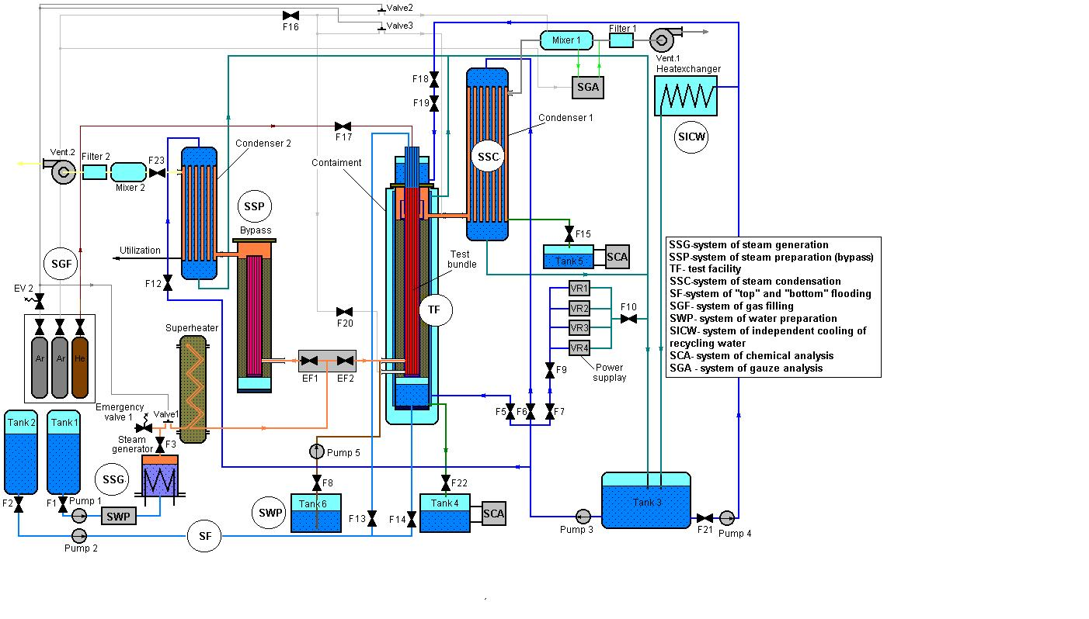

Fig. 1. Functional diagram of PARAMETR facility.

PARAMETR facility includes the following technological systems:

* Preparation of high quality water with controllable admixture content for provision of a water-chemical mode of a tested FA;
* Filling of individual rods with gas and control of internal pressure;
* Feeding of gas coolant to the tested model assemblies;
* Steam generation and overheating;
* Preparation of steam parameters (by-pass) and feeding of steam to the tested model assemblies;
* Utilization of steam; the system provides withdrawal of the steam and condensation of spent steam;
* Control of chemical composition of the condensate in study of the influence of water-chemical mode on FA behavior under conditions of an accident;
* Power supply of facility equipment;
* Acquisition and recording of the parameters of tests and facility systems;
* Emergency top and bottom flooding of the tested model FA.

According to the Project, two 19-fuel element FA of VVER-1000 reactor with the following technical specifications (see table 2) will be tested using PARAMETR facility:

Table 2

Design of Model Assembly

|  |  |
| --- | --- |
| Assembly of fuel rod dummies | |
| Number of rods/heated/unheated | 19/18/1 |
| Grid spacer pitch, mm | 12.75 |
| Heater | Tungsten (tantalum) |
| Outer diameter and thickness of cladding, mm | 9.13/0.7 |
| Cladding material | Zr-1%Nb |
| Length of heated rods, mm | 3120 |
| Length of unheated rods, mm | 2920 |
| Dimensions of heater, mm: | |
| Outer diameter/length | 4/1275 |
| Elevations | from 0 up to 1275 |
| Input steam, mm | -275 |
| Output steam, mm | 1328 |
| Fuel rods internal overpressure, MPa | 0.1-0.2 |
| Fuel pellets | |
| Heated rods  Outer diameter/central hole, mm | UO2 with hole  7.5/4.4 |
| Unheated rods  Outer diameter/central hole, mm | UO2 with hole  7.5/1.2 |
| Spacer grids | |
| Material | Zr-1%Nb |
| Height, mm | 20 |
| Axial distance between grids, mm | 255 |
| Position of fist (bottom) grid, mm | 50 |
| Number of grids | 6 |
| Shroud | |
| Material | Zr-1%Nb |
| Outer diameter and thickness, mm | 60.5/2 |
| Length, mm | 1740 |
| Shroud insulation | |
| Material | fiber-type ZrO2 |
| Thickness. mm | 28.75/24.25 |
| Height, mm | 1740 |

The parameters of tests of model FA are monitored by

temperature control:

- for temperatures up to 1200 оС – by chromel-alumel thermocouples HA(K) with electrically isolated measuring junction in a protective stainless steel enclosure with a diameter of 1.5 mm, based on a thermocouple cable of KTMS(HA) type;

- for temperatures up to 2000 оС – tungsten-rhenium thermocouples W5%Re/W20%Re with electrically isolated measuring junction in a protective tantalum (Та) enclosure with a diameter of 2 mm;

pressure control – standard pressure sensors (DD) MD-10 and MD-20.

Heated fuel elements of model FA are divided into three sections (see Fig.2). Electrical power of the heated sections and total capacity of FA is determined by the measurements of current Ii, and voltage Ui on sections (i=1, 2, 3).

Steam flow rate is set by the water flow rate of the steam generation system (PN1 pump) and controlled by the parameters of the steam generator (Nel.SG, ТSG, рSG) and parameters of the steam at the flowmeter section of steam pipeline (Т1, р1, Т2, р2).

Water flow rates of the systems of top and bottom flooding is set by the pump PN2 and valves V13 and V14.

Quantity and concentration of hydrogen yielded from the model FA is monitored by a gas analysis system, which includes vacuumization system, 10 samplers, gas chromatograph, electronic rotameter and standard gas analyzer СОВА-3.

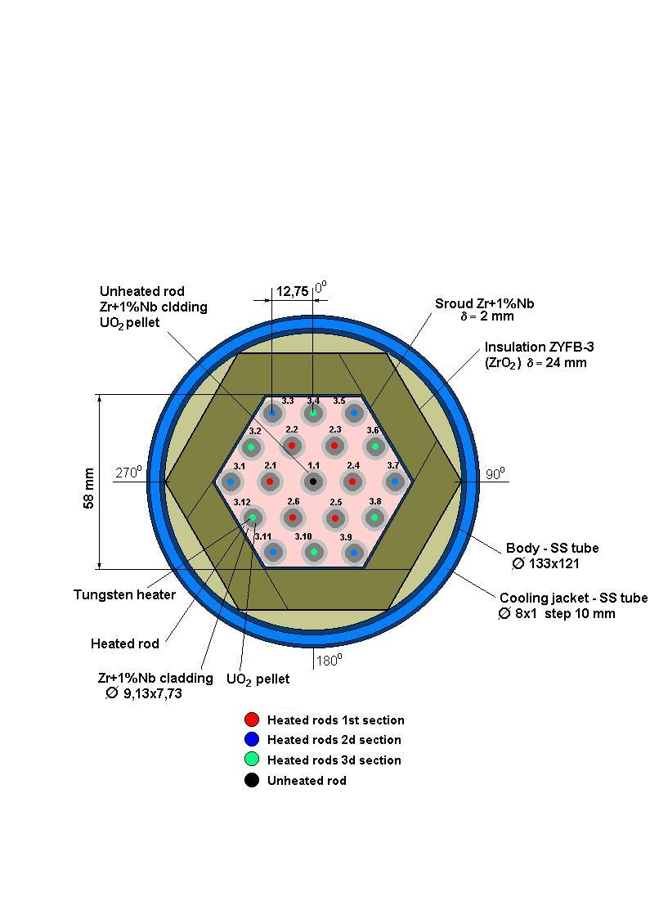

Fig. 2. Transverse cross-section of a model FA.

System of measurement of parameters of the tests of model FA is similar to the system of control of parameters in QUENCH-06 experiment with account for geometry of model VVER-1000 FA and includes 43 thermocouples monitoring temperature of fuel element cladding, installed at the distance of 100 mm from each other along the height and cross-section of the FA (see Fig.3), 19 pressure sensors on fuel elements, 6 pressure sensors and 9 thermocouples for monitoring of parameters of steam in the FA, and 16 more thermocouples for monitoring of temperature along the height of cowling and heat insulation, and 2 thermocouples for monitoring the temperature of steam of top flooding.

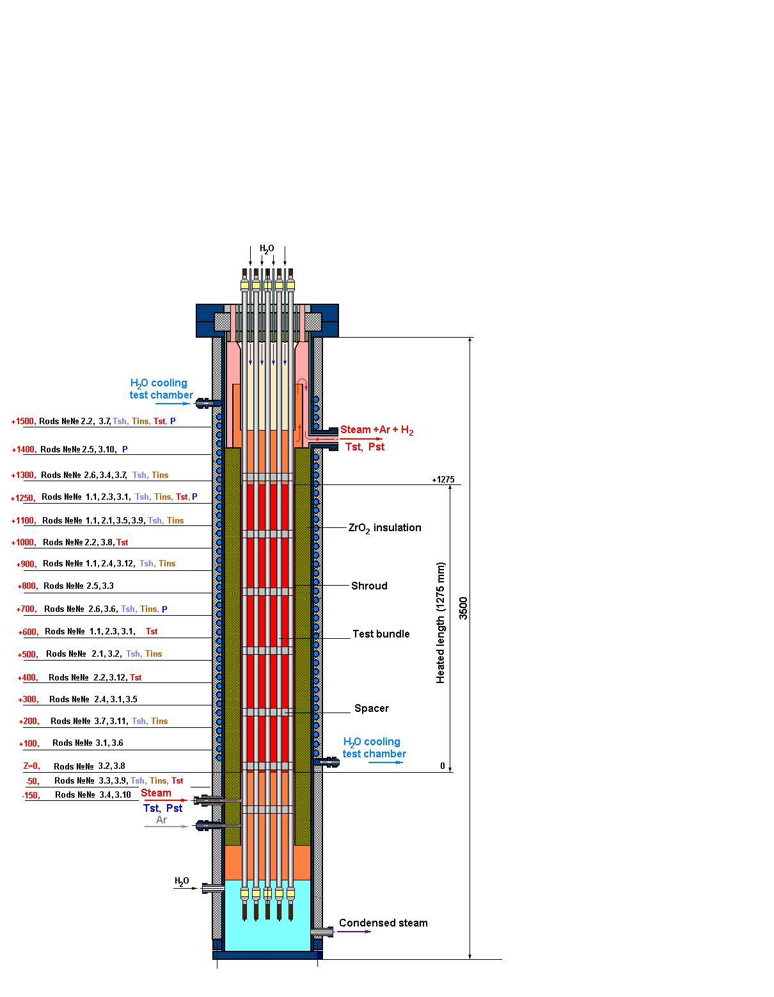

Fig. 3. Structure of the system of measurement of test parameters of model FA.

The model FA are tested according to the scenario, developed on the basis of design calculations on substantiation of safety of VVER reactors using SCADP and MELCOR programs, with calculated simulation of the experiments using the certified software package RATEG/SVECHA taking into account the results of QUENCH-06 experiment (see table 3).

Table 3

Principal specifications of PARAMETER facility

|  |  |
| --- | --- |
| Coolant | Saturated/superheated steam, argon |
| Coolant flow rate, g/s per rod | up to 0.2 |
| FA test temperature:  DBA, оС  Severe accidents, оС | up to 1200  up to 2000 |
| Working pressure in FA, MPa | up to 0.5 |
| Electric power, kW | up to 400 |
| Electric power per rod, kW | up to 10 |
| Water flow rate in the system of top and bottom FA flooding, g/s | up to 200 |

Substantiation of the proposed methodological and technical approach is provided by:

- development of a realistic scenario of the experiments based on design calculations on substantiation of safety of reactor installations equipped with VVER reactors;

- simulation of the experiments using software package RATEG/SVECHA; execution of pre-test calculations and estimates using European code ICARE-CATHARE;

- assembly of a fuel assembly simulator from the standard materials used in construction of fuel elements and VVER-1000 FA (Zr+1%Nb-alloy fuel cladding, uranium dioxide fuel pellets and guiding tubes made of Zr+1%Nb alloy);

- simulation of residual energy release in the fuel elements by indirect heating of the fuel element by internal heater.

### 7. Technical Schedule

|  |  |  |  |  |  |  |  |  |  |
| --- | --- | --- | --- | --- | --- | --- | --- | --- | --- |
|  | **Quarter 1** | **Quarter 2** | **Quarter 3** | **Quarter 4** | **Quarter 5** | **Quarter 6** | **Quarter 7** | **Quarter 8** | **Person*days** |
| **Task 1** |  |  | 1-st experiment program | 1-st experiment record |  |  |  |  |  |
| **Person*days** | **1450** | **1450.5** | **1450** | **1450** |  |  |  |  | **5800.5** |
| **Task 2** |  |  |  |  |  |  | 2-nd experiment program | 2-nd experiment record  R&D final report |  |
| **Person*days** |  |  |  |  | **1450** | **1450** | **1450** | **1488** | **5838** |
| **TOTAL** | **1450** | **1450.5** | **1450** | **1450** | **1450** | **1450** | **1450** | **1488** | **11638.5** |