**Expereimental model**

Our work is devoted to development of the hyperthermal heater design, with the help which one the heating of a body of a water-cooled reactor is imitated in case of an core fusion. The speech goes about development the heater made of refractory metals, such as molybdenum, tungsten, tantalum or graphite.

The design is shown in a fig. 1, which one allows to initiate of practical solution for a put problem.

Some principle engineering solutions are necessary in the basis of a developed design:

**At first** – the heater is made of molybdenum as most accessible and technologic stuff from group of refractory metals.

**For the second** – the heater is produced as of spirals bundle which were made from a molybdenic wire. Thus it is reached that the manufacturing of such design of the heater is the most technologicly and it will allow the heater to work at considerable voltage amounting value a several tens a volt and, accordingly, to have restricted values of a current, the value makes which one some hundreds ampere.

**At the third** – the vertical position of the heater is accepted as the speech goes about improvement of a heater design, instead of about usage it directly in the experimental model of the reactor.

Thus its arrangement in a body as contrasted to by horizontal arrangement is simplified, is more lightly to ensure identical spacing interval from the heater up to a wall of a body. Thus the design of the heater does not eliminate its horizontal arrangement.

**The spirals** of heaters are arranged by a half-disk as it is shown in a fig. 2. The number of spirals is ten. They are connected to top and bottom current leads. The current leads are made of molybdenic disks by thickness of 20 mm.

The upper disk is split and also consists of two halves. Each of halves electrically is insulated of another half as well as from body of model. The molybdenic current lead by diameter of 20 mm is connected to each of halves. The electrical scheme is made so that the current from the current lead moves on one of halves of upper molybdenic disk and on 5 spirals goes to the lower one-piece disk and from there goes back on other to 5 spirals on another half of upper cut up molybdenic disk and from there to the current lead.

Thereby, we have series connection of two bundles from 5 spirals. The spirals of the heater are made two-way of a wire by a diameter of 1.0 mm, step of a wrapper – 3 mm, length of a working section – 480 mm, upper diameter of spirals – 3.5 mm. Each bundle from 5 spirals has spacing which one implements with the help of molybdenic plates with the conforming holes by a diameter of 3.6 mm. Spacing plates are arranged – one on middle of an height of the heater, and two others – on the distance of 50 mm from top and bottom disks of current leads.

The top and bottom disks have isolators of alumina which one prevent an electrical fault to body of model with allowance for that during heating of spirals they are elongated and lower disk is displaced along body of model.

The current leads are made compound. The molybdenic rods by diameter of 20 mm and length of 170 mm are screwed directly in molybdenic disks. Then also on a thread to these rods the current leads from a stainless steel by the veiw of orthogon are screwed on which the cross-section is equal 20 mm×25 mm. The water cooled copper current leads by diameter of 15 mm are screwed in current leads.

**The body** of an experimental test section is made of a tube by diameter of 220×9 mm. Length of mid-range makes about 500 mm. The ends of tube by length on 300 mm are notched from inside and have wall thickness – 5 mm. The top and bottom ends of a body are removable also have covers with metallical seals by the way of lozenges. The body has pipe connections for an intake of argon, vacuum operation and installation of the pressure gauge.

The body of construction allows to work at pressure of argon of some atmospheres.

**Thermal isolation** of hyperthermal heaters is designed usually in the form of screens. However, such thermal isolation is effective, when the heater works in vacuum. If the heater works in gas medium at high pressure, the work of screens is unproductive as in such design natural convection of gas is great. For decreasing natural convection the thermal isolation of the heater is made as masonries from a fire-bricks with thermal isolate characteristic. The surface of a brick directly near to the heater is covered with one layer of a molybdenum metal paper.

**Measurements.** During tests the current of the heater and stress intensity both on all heater and on spirals on distance in 50 mm of molybdenum disks-current leads are measured. These measurements are carried out by spacing plates about which one was said above.

Temperature is measured of spirals of heaters in two points in mid-range on each bundle of spirals that is four values. These measurements are carried out with the help of WRe thermocouples with an insulated junction that allows to set thermocouples directly on spirals. Also temperature of molybdenum disks-current leads and temperature of current leads of a stainless steel are measured with the help of ХА thermocouples.

Temperature of a body of model is measured on the part of the heater in three cross-sections on a height. These measurements are carried out with the help of thermocouples trimmed in three longitudinal grooves. The grooves are arranged on distance in 20 mm from "axis" of the heater (its middle). Depth of grooves is 2.5 mm, width – 3 mm. In each of grooves are trimmed till three WRe thermocouples in capillary tubes of a stainless steel (9 thermocouples). From above groove are closed by stripes from a nickel and are welded by a contact spot welding. Besides between grooves are trimmed till three ХА thermocouple by diameter of 0.5 mm – in the same cross-section on an height as WRe thermocouple in grooves. These thermocouples from above are covered with a nickelous metal paper by depth 0.1 mm. On outside surfaces of a body in the field of arrangement of the heater are set cable ХА thermocouple by diameter of 1.0 mm, thermoelectrodes which one are welded by a contact spot welding directly to a surface of a body.

**The carrying out of tests** starts with repeated "washdown" by argon of a experimental model. The operation is made with the purpose of a deaerating from pores of thermal isolator and is come to filling of model by argon with its subsequent vacuum operation.

After realization of this operation on cold model the heaters are actuated on small power and the vacuum operation is prolonged on heated model. The further filling of model by argon and increase of electrical power carry out to the Program of works which were coordinated to the customer.

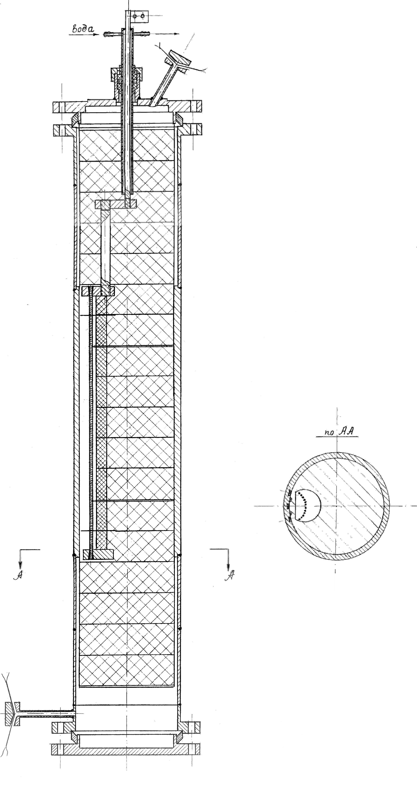

Fig. 1. Experimental model

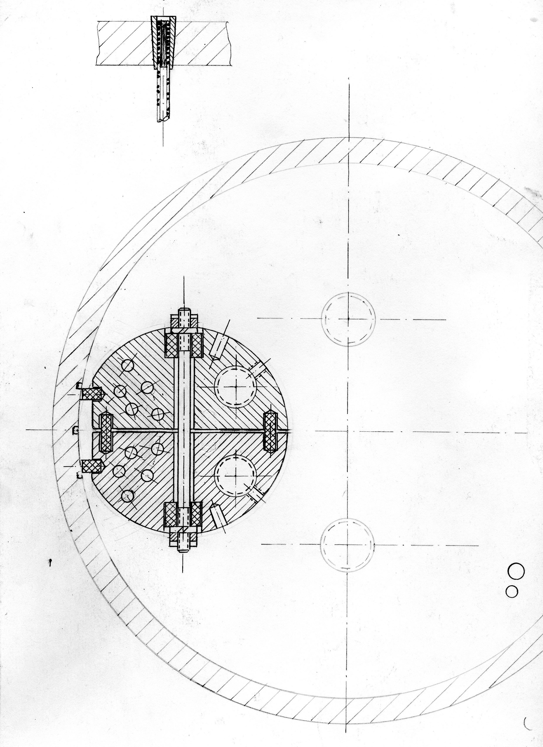

Рис. 2. The upper cut up current lead of experimental model