**Application 1**

**SCIENCE & TECHNOLOGY CENTER IN UKRAINE**



**Project Proposal**

**4452**

**Robot-technical complex for ChNPP on the base of robots of Ukraine and USA.**

**Ukraine**

1. **PROJECT PROPOSAL**

**1.1 Project Title:**

Robot-technical complex for ChNPP on the base of robots of Ukraine and USA.

**1.2 Project Manager:**

Name: Krasnov Victor (Specialist)

Tel: (+380.4493) 51901

Fax: (+380.4493) 51901

Email: [ojarbkva@slavutich.kiev.ua](mailto:ojarbkva@slavutich.kiev.ua)

**1.3 Participating Institutions:**

Main: Institute of problems safety of nuclear power plants of the National academy of sciences of Ukraine of National academy of sciences of Ukraine

Participating: National Technical University of Ukraine "Kyiv Politechnical Institute" of Department of education of Ukraine

**1.4 Current Foreign Collaborators:**

Lawrence Livermore National Laboratory -USA

Person: Craig F. Smith

Phone: (+1) 831-656-2185

Fax: (+1) 831-656-2834

Address: P. O. Box 808, Livermore, California 94550, United States of America

Atjmatic Systems srl - Italy

Person: Vazzio Chianella

Phone: 3903311963978

Fax: (+1) 831-656-2834

**1.5 Project Duration:** 30 months

**1.6 Participants:**

Number Person Days of Efforts

Weapon Scientists 25 4763

Total Participants 30 5988

**1.7 Project Summary:**

The main purpose of the project is to develop safe, unmanned technological processes for nuclear and radiation work aimed at the conversion of the Chornobyl "Shelter" object and the decommissioning of ChNPP by creating, on the basis of robot technical systems designed in the USA and Ukraine, a new robotic technical complex.

The essence of the project includes the completion and upgrade of the earlier robotic systems, by addressing the issues revealed during preliminary testing at SSE ChNPP, of the robot technical system "Pioneer" designed in the USA, as well as the robots developed in Ukraine, and their unification into a single complex possessing new technical capabilities, to realize the following activities and objectives:

1. Support the work to recharge the fuel located in the ChNPP Unit 3 interim repository.

2. Radiation and technological monitoring and characterization of stored spent nuclear fuel, plants for radioactive waste (RAW) treatment, and the "Shelter" object.

3. Characterization of fuel-containing masses (FCM) in the "Shelter" object and creation of a database to plan future work (including FCM sampling, 3-D mapping, measuring of parameters of ionizing radiation, mechanical and thermophysical characteristics.)

4. Development of the technological processes and conduct of a demonstration experiment of the extraction and containerization of accessible FCM clusters in the "Shelter" object.

5. Development of the capability to respond to urgent emergency and recovery works in case of accidents at nuclear power plants and other radiation and nuclear facilities in Ukraine.

Before the accident at ChNPP in 1986, the facilities and capabilities to complete the above-indicated tasks did not exist. That is why, as a result of the implementation of this project, there will be new world-class capabilities and facilities for the management of the consequences of such man-caused catastrophes that do not have analogues at this level of complexity and scale.

**1.8 Project Facilities:**

On the whole, the overall administrative and technical management of the project, including general assembly, software adjustment and comprehensive testing of the complex will be carried out by subdivisions of the coordinating organization - ISP NPP NRSD.

The relevant technical equipment and capabilities of the coordinating organization include:

1. A unique set of radiation-dosimetric equipment.

2. Electrical control-measuring equipment.

3. Radiation-stable television cameras.

4. Electricity supply sources.

5. A computer network consisting of PCs, printers, plotters and other equipment having data base on Object "Shelter" and ChNPP.

The technological base of the coordinating organization contains the following:

1. Mechanical site equipped with turning, milling and other metal-working machines.

2. Welding site equipped with welding units of different types.

3. Assembling site equipped with necessary facility and instrument.

Modernization, adjustment and autonomous testing of robots will be performed by all participants of the project at the ISRI IE "Rythm" territory.

Equipment of the co-executor organization :

1. Research and development laboratory (8 desks) equipped with drawing machines, computers, plotter, printers, scanner.

2. Electrolaboratory (4 desks) equipped with necessary control-measuring equipment and computers.

3. Hydropneumoautomation laboratory (3 desks) with compressor units.

4. Mechanical site equipped with metal-working machines.

5. Assembly-testing site containing lifting crane, premises for assembly and testing area equipped with simulators of different barriers.

The following equipment would be procured:

1. Electric motors and electromechanical drives of movement.

2. Radiation-stable TV cameras, illuminants, videocontrol devices.

3. Personnel and industrial computers and junction devices, interface cards.

4. Elements of control panels: frames, operator's panels, components (plates) of computers, keyboards, monitors.

5. Power supply devices: transformers, rectifiers, stabilizers.

6. Measuring sensors of temperature, humidity, angle location, radiation, acceleration.

7. Electric instrument: circular cutters, vibrodrills.

8. Electric radioelements: microcircuits, relays, diodes, transistors, hermetical seals.

9. Electric connectors, cabels, assembling wires, hoses, tubes.

10. Consumed materials: paper, cartridges for printers, xerox, paints, solvents.

**1.9 Project Science and Technology Areas:**

Primary: Nuclear Energy & Safety

Secondary: Industrial Technologies

Physics

**1.10 Total Estimated Project Cost by Year:**

|  |  |  |  |  |
| --- | --- | --- | --- | --- |
| **Cost Estimate (in USD)** | **Year1** | **Year2** | **Year3** | **Total** |
| Grant Payments | 57057 | 56684 | 25709 | **139450** |
| Equipment | 60300 | 1500 | 0 | **61800** |
| Materials | 15280 | 600 | 200 | **16080** |
| Other Direct Costs | 180 | 180 | 0 | **360** |
| Travel | 250 | 2950 | 0 | **3200** |
| Overhead | 7504 | 7504 | 3752 | **18760** |
| **Total STCU Financing Requested** | **140571** | **69418** | **29661** | **239650** |

**1.11 Project Description:**

**1.11 Introduction**

**What’s the problem?**

In 1986, a technological catastrophe, whose aftermath included unprecedented worldwide consequences, occurred at the Chornobyl nuclear plant (ChNPP). Not only did this result in the long-term problem of dealing with the Chornobyl Unit 4 “shelter” object, it also created unique challenges for the nearby unit 3, which must be solved in order to provide the conversion of ChNPP Power Unit 4 - **«Shelter» object** – into an ecologically safe system.

In conformity with Ukrainian strategy of «Shelter» object conversion and international plan (SIP) «Shelter implementation plan», a huge scope of diverse work is being carried out. Some of this work must be conducted unbder conditions of high levels of ionizing radiation which are dangerous for human beings, as part of the preparation for the «Shelter» object convertion into an ecologically safe zone, and for the decommissioning of the ChNPP . Currently, the world has no technical approach suitable for the safe conduct of much of the work described above (see.i.1.7), under conditions found in «Shelter» object.

Therefore, the problem requires the development and use of unmanned technological processes capable of operation in a nuclear and high-radiation environment and creation of the technical capabilities for their realization, to provide fulfillment of the work aimed at «Shelter» object conversion and ChNPP decommissioning with minimum personnel exposure and radioactive contamination of the surrounding area.

**1.12 Literature Search**

**What are other people doing?**

Considerable previous achievements of note include the creation of remotely controlled mobile robots such as those of «Andros» series, company «Remotec» (USA), «Gudini», «Pioneer» of company «Redzone Robotics» (USA), «Scorpion» of company «Richmond electronic» (UK), «Centaur» of company «Calchena» (France), «Theodor» (Germany) et al. Each of the indicated robotic systems is capable of reliably performing some of the specific required technological operations envisioned for the conversion and decommissioning effort; however, many of the tasks of «Shelter» object conversion are so technically complicated, that none of indicated robots is capable of independently solving them.

**How are their results being applied?**

The problems of ChNPP and «Shelter» object can best be solved by the unification of individual robots in common technological complexes being controlled from a single center. Besides, the unification of the operations being performed by each robot can bring a qualitatively new result in a complicated technological process, such as:

- fragmentation and containerization of FCM and RAW;

- laying of large areas with dust binding compositions and shielding of FCM clusters.

The most promising approach is the creation of a robot technical complex consisting of the following basic parts that are currently available at the ChNPP.

1. Robot technical system «Pioneer» created by company «Redzone Robotics» under technical management of Livermore Lawrence National Laboratory (LLNL) and with participation of Carnegie Mellon University (USA).

2. Mobile robots RTC-100М and RTC-100М (Р), created by MNII PM «Ritm» under National Technical University of Ukraine (NTUU) «KPI» in partnership with LLNL, company «Redzone Robotics» (USA) and under active participation of Dr. Mark S.Rowland and Dr. Craig F.Smith.

These indicated robots have passed preliminary tests with positive reports in «Shelter» object; however, currently they are not being applied because of individual structural deficiencies, whose elimination demands additional funding.

3. Mobile-technological robots of «ТР» (No1-No10) series created in Coordinating Organization (ISP NPP). During 1988-2004, a wide range of research work was carried out to solve the «Shelter» object problems with using different modifications of that series.

**1.13 Purpose and Objective**

**What are we going to do?**

The main purpose of the project is to develop safe, unmanned technological processes for nuclear and radiation work aimed at the conversion of the Chornobyl "Shelter" object and the decommissioning of ChNPP by creating, on the basis of robot technical systems designed in the USA and Ukraine, a new robotic technical complex.

The essence of the project includes the completion and upgrade of the earlier robotic systems, by addressing the issues revealed during preliminary testing at SSE ChNPP, of the robot technical system "Pioneer" designed in the USA, as well as the robots developed in Ukraine, and their unification into a single complex possessing new technical capabilities, to realize the following activities and objectives:

1. Support the work to recharge the fuel located in the ChNPP Unit 3 interim repository.

2. Radiation and technological monitoring and characterization of stored spent nuclear fuel, plants for radioactive waste (RAW) treatment, and the "Shelter" object.

3. Characterization of fuel-containing masses (FCM) in the "Shelter" object and creation of a database to plan future work (including FCM sampling, 3-D mapping, measuring of parameters of ionizing radiation, mechanical and thermophysical characteristics.)

4. Development of the technological processes and conduct of a demonstration experiment of the extraction and containerization of accessible FCM clusters in the "Shelter" object.

5. Development of the capability to respond to urgent emergency and recovery works in case of accidents at nuclear power plants and other radiation and nuclear facilities in Ukraine.

The totality of the above work can not be completed using any single robotic system, but the unification of several robotic systems into a single complex gives such a possibility.

The above-identified project objectives can be achieved if the following main tasks are realized:

1. Conduct theoretical research and development of the required safe unmanned technological processes for operation in a nuclear and radiation environment.

2. Upgrade and complete each robot contained within the complex to provide:

2.1. Elimination of structural and scheme-technical deficiencies detected during previous tests of the robots.

2.2. Provide for unification and metrological coordination with control and diagnostic instrumentation, power sources, videomonitors and computers that are a part of a common control center.

2.3. Vary the structure of each robot and replace individual elements (manipulators, cable drums, TV cameras et al.) on different mobile chassis as necessary and appropriate.

3. Unify robots into a single complex with a common control center:

3.1. Create a common radiation-resistant microprocessor system and its associated softwarefor complex control

3.2. Manufacture new cable set for connecting robots, control boards and control center.

4. Develop a joint approach to integrate several robots within the complex under conditions of radiation-«clean» test ground with physical modelling of real conditions of «Shelter» object.

It is very important also to analyze the economic aspects of the project, which assumes the use of already available robots, in which a wide range of elements (manipulators, cable drum, radiation-dosimetry system, bores etc.) are in operational condition. Thus, the project cost will be significantly less than the costs for creating a completely new complex.

*The main purpose of the project is to create a robot technical complex by upgrading, adapting and integrating mobile robots currently available at ChNPP and unifying them into a single structure controlled from a common center. Such an integrated complex is designed to be capable of carrying out the future works for the «Shelter» object conversion and ChNPP decommissioning with minimum personnel training, radiation exposure and environmental pollution. Key technical objectives include:*

*1. Definition of the location (coordinates) of FCM clusters and RAW with respect to the plan of the premises and their television image.*

*2. Characterization of FCM and RAW, which includes measuring the parameters of radioactivity (α,β,γ fields), neutron flux densities, and measurement of mechanical and thermophysical parameters.*

*3. Picking up, in special containers, samples of FCM, solid and liquid RAW, dust and smears from surfaces, and aerosols from air.*

*4. Dismount of FCM clusters, their fragmentation and containerization or encapsulation.*

*To realize the described tasks, the following preparatory work should be completed in advance:.*

*5. Conduct reconnaissance of walking routes and record these findings on plans of the premises.*

*6. Introduce shielding for FCM and disperse dust binding compositions.*

*7. Clear access obstructions, organize passages, lay cables, install TV-cameras and provide for lighting.*

*All of the above works cannot be completed using a single robot, and only their unification in a single complex gives such a possibility.*

*To achieve the above objectives of the project, the following main tasks are needed:*

*1. Upgrade and complete each robot contained within the complex to provide:*

*1.1. Elimination of structural and scheme-technical deficiencies detected during previous robot tests, taking into account all the remarks of ChNPP experts.*

*1.2.* Provide for the unification and metrological coordination *with control-diagnostic instrumentation, power sources, videomonitors and computers contained within a common control center.*

*1.3.* Vary the structure of each robot and replace individual elements (manipulators, cable drums, TV cameras et al.) on different mobile chassis as necessary and appropriate.*.*

*2. Unify robots into a single complex with a common control center.*

*2.1. Creat a common radiation-resistant microprocessor system and its appropriate software.for control of the complex*

*2.2. Manufacture new cable set for connecting robots, control boards and control center.*

*3.* Develop a joint approach to integrate several robots within the complex under conditions of radiation-«clean» test ground with physical modelling of real conditions of «Shelter» object.

*.*

It is very important also to analyze the economic aspects of the project, which assumes the use of already available robots, in which a wide range of elements (manipulators, cable drum, radiation-dosimetry system, bores etc.) are in operational condition. Thus, the project cost will be significantly less than the costs for creating a completely new complex.

**What’s the objective?**

*The purpose of the project is to create a robot technical complex that would be capable to perform works for «Shelter» object conversion and ChNPP decommission with minimum exposure of personnel and environment.*

This purpose will be achieved by the development of safe unmanned technological processes for operation in a nuclear and radiation environment to realize needed work for the conversion of the "Shelter" object and for the decommissioning of Chornobyl NPP, and to create, on the basis of existing robot technical systems designed in the USA and Ukraine, a new robot technical complex to implement this work.

**1.14 Expected Significance**

**What’s new?**

Novel aspects of the proposed project are found in its purpose, tasks (see i.1.13) and its technical means, which are to be created for the achievement of the project objectives. The novelty of the overall ttechnical purpose is the result of the uniqueness of the problems to be addressed, resulting from the ChNPP accident which has no other world analog. In addition to the novelty of the overall project the approach to addressing the separate project elements also incorporates novelty. These elements include:

1. Radiation detection and characterization under extremely challenging conditions; FCM recovery, fragmentation and packaging in containers; Collection of FCM and RAW of different structure (solid, loose, dust-like, liquid); and the conservation and stocking of containers.

2. Sampling of aerosols, FCM and RAW (solid, liquid, dust-like) in preliminary specified points (zones) and safe delivery of the samples to the research laboratory.

3. Charactrerization of the parameters and spatial distribution of ionizing radiation and their recording onto plans of the premises along with video documentation.

Not less important will be expectable results described in i.1.13. In each case, the project involves novelty because of the unique situation of the “shelter” object.

**1.15 Organization, Qualification and Staffing**

**Who are we?**

The coordinating organization of project is the Department of Nuclear and Radiation Safety (NRSD) of the Institute for Safety Problems of Nuclear Power Plants (ISP NPP) of the National Academy of Sciences (NAS) of Ukraine.

Over the entire work period at ChNPP since the 1989 accident, the department has been carrying out a large scope of research, which resulted in the establishmenty of a unique base of experience in the design of mobile robots and the performance of safe work under the most complicated conditions of «Shelter» object.

The coordinating organization has the following licenses o enable work realization.

1. License of series ОВ, №000225 «Activity for transporting radioactive materials», issued on October 6, 2006.

2. License of series ОВ, №000221 «Activity for designing nuclear facility or repository for burial of radioactive waste», issued on September 29, 2004.

3. License of series ОВ, №000223 «Activity for using ionizing radiation sources », issued on September 29, 2004.

4. Certificate for quality management system pertaining to work realization in ISO 9001:2000 as of January 30, 2004.

The organization-coexecutor of project is the Interbranch Research and Development Institute of Mechanical problems (MNII PM) «Ritm» under the National Technical University of Ukraine «Kyiv Polytechnic Institute» («KPI»). The institute has successfully realized project No715, 2704 jointly with Research and Technology Center in Ukraine (NTCU); projects В313820 and Р-016 with Lawrence Livermore National Laboratory (LLNL, USA); and project 98/4030 with the Ministry for Extraordinary Situations (MES) of Ukraine.

As a result of completion of the above project, a whole range of remotely controlled radiation-resistant aggregates for ChNPP was created and tested with positive results; among them there are robots «РТК-100М» and «РТК-100М (Р)», which will be incorporated, jointly with robot «Pioneer», into the proposed robot technical complex.

The original technical development of these robot elements included the issuance of 10 patents in Ukraine by leading research workers of MNII PM «Ritm», six of which were authored in association with specialist Mark S.Rowland and Craig F.Smith of LLNL .

The high professional level of MNII SE «Ritm» is confirmed by documents such as the following:

1. License No. 07/5-П-0796-24 of Ministry of environmental protection of Ukraine for designing equipment for radwaste management.

2. Certificate КА-№000034 of National Space Agency of Ukraine for right to conduct (realize) space activity.

The proposed project team consists of scientists and engineers who for many years worked at leading enterprises and research institutions of defence establishment of former USSR.

Among them there are specialists in the following fields of expertise:

a) system for control of movement and orientation of aircraft (AC);

b) systems and devices of AC terrestrial research;

c) systems for control of movement of traveling (mobile) objects;

d) nuclear power plants;

e) automated electric drive;

f) systems of hydropneumoautomatics;

g) computers and programming

The leading specialists have completed more than 50 scientific works, with appropriate author certificates, patents and publications, related to the above fields.

**How does this project relate to our other work?**

Over the entire work period since the 1986 accident at the ChNPP, the executor team has accumulated considerable specific experience in creating remotely controlled radiation-resistant equipment and mobile reconnaissance-technological robots.

MNII SE «Ritm» created the robot «RTC-100М» and «RTC-100М (Р)», which jointly with robot «Pioneer» will be incorporated into the proposed robot technical complex. The workers of MNII SE «Ritm» are working jointly with specialized designer bureau for television systems (SKB TVS). With financial support from the Research and Technological Center of Ukraine (NTCU), they are realizing project No 2593 for the creation of remotely controlled robot applicable to investigate boreholes, pipes, premises and cavities in the «Shelter» object, ChNPP, and other nuclear objects. ISP NPP engineers, jointly with experts from «Redzone Robotics», previously conducted ChNPP the trials and «cold» testing of the robot «Pioneer», on whose base the proposed robot technical complex (RTC) will be created.

Currently, ISP NPP workers are carrying out research work associated with the erection of the confinement structure over the ChNPP building.

**1.16 Expected Results**

**What will be done in the framework of this project?**

In this project, remote technologies for the conversion of the <<Shelter» object and ChNPP decommissioning will be designed; in addition, an experimental model robot technical complex will be created for the realization of those technologies, comprised of upgrades of the mobile robots «Pioneer», «RTC-100М» and series «ТР» that are located in ChNPP.

The complex is intended to achieve complicated (multiple-function) work, which can not be realized individually by any robot. The complex will be used in the first stages of the conversion of the «Shelter» object into an ecologically safe zone, as well as during ChNPP decommissioning.

Section i.1.13 describes the additional work that can be realized under the scope of this project .

The economic benefit of project realization consists in a significantly lower cost to develop this robotic capability, since the complex includes already available robots, as compared to creation of analogous complex with using a new design and manufacture cycle.

An additional advantage of the project consists in reducing the terms for its implementation into real process of «Shelter» object conversion in comparison with the terms for introduction of a new analogous complex.

Scientific and technical products created within the framework of the proposed project will include the following parts.

1. A Report on the research of the scientific, technical and economic aspects of the development of remote technologies for the conversion of the «Shelter» Object, the decommissioning of ChNPP, and the creation of a robot technical complex that provides their realization».

2. A set of design and construction documentation for upgrading and completion of robots «Pioneer», series «ТР» and «RTC-100М» contained within the offered complex.

3. A set of design and construction documentation for robot technical complex (RTC) «PIONEER-ChNPP», consisting of upgraded robots indicated in i.1.

4. An experimental model for the manufacture of the complex (RTC), based on the documentation of i.1, 2.

5. The software (SW) for the total complex and for each individual robot.

6. The technical description (TD) and operation manual (OM) for the total complex and for each individual robot.

7. A program, procedure and report on complex tests in radiation «clean» conditions.

8. Information and advertising materials for search of potential investors (partners).

When creating the above scientific and technical products, Tasks 1-3 described in i.1.1.3 will be realized.

**What’s next?**

The uniqueness and specificity of the work conditions in the «Shelter» object restricts the possibilities of wide commercial usage of the complex as a whole on other objects, since, frankly speaking, there are no analogous objects. But, the original technical decisions of the individual elements of the complex (mobile chassis of high flotation ability, compact drums manipulator with high specific capacity, volumetric measuring systems of technical viewing, changeable technological accessories and tools) will be patented and used during creation of robots that are close to its function:

a) to solve ecological problems;

b) to mitigate the aftermath of extraordinary situations and natural cataclysms;

c) for antiterrorist actions and mitigation of aftermath of technogenic accidents;

d) to maintain nuclear installations and NPPs;

e) to participate in completive stages of «Shelter» object conversion into a «clean» zone.

The original technical decisions of elements of already manufactured robots, on whose base is proposed to create the complex, resulted in ten Ukraine’s patents. Five new decisions will be drawn up as patent applications of Ukraine during the project realization.

In order to sell the robots abroad, patenting of significant peculiarities of the created robots in those countries will be appropriate; this will also generate interest and result in advertising measures (see i.1.19).

As the positive results of the project are realized, it is expected that interest will be generated, first from the designers of robots, which after upgrading will be incorporated into created complex.

1. Companies «Redzone robotics inc.», Livermore Lawrence National Laboratory of Department of Energy (USA).

2. Coordinating organization.

3. Organization-coexecutor.

4. Project Management Unit (PMU) for SIP (t. Slavutych, Ukraine).

To receive the further funding and to develop successful designs, which will be realized in this project, the executors will conduct a thorough search of the mobile robots market and the Ukrainian state clients and foreign partners for their designing, manufacture, sale and other works described in i.1.19.

**1.17 Scope of Activities**

**How will the investigation be organized?**

The Project is assumed to be accomplished through execution of three main stages, each of which consists of three substages.

1. Upgrade and completion of robots available at «Shelter» object («Pioneer», «RTC-100М» and «ТР») and their adaptation for joint work under ChNPP conditions (10 months).

2. Integration of the above robots into a single robot technical complex for realization of work for the conversion of the «Shelter» object and decommissioning of ChNPP (10 months).

3. Comprehensive trials of the complex and testing under radiation «clean» conditions with simulated ChNPP conditions («Shelter» object ) (10 months).

At the first stage, following work will be realized:

1.1. Development of technological processes for «Shelter» Object conversion, their breakdown into operations, distribution of functions between the robots contained within the complex, and compiling of Terms of Reference (TR) for upgrading and completion of each robot.

1.2. Development of design and construction program and operational documentation for upgrading each robot according to TR (i.1.1).

1.3. Manufacture of details and units, assembly and electrical mounting of all robots incorporated into the robot complex in conformity with documentation (i.1.2).

The first stage work will be, mainly, carried out by the organization-executor. Currently, the coordinating organization is investigating technical and technological aspects of unification of robots upgraded in the first stage into a single complex and is preparing the Terms of Reference for its design.

At the second stage, following work will be realized.

2.1. Development of design and construction program and operational documentation for the complex as a whole.

2.2. Test of upgraded robots for consistency of TR requirements (i.1.1).

2.3. Establishment of the function of each robot and realization of its operations. Personnel training of the coordinating organization on the rules nd procedures for control of each robot according to the operational documentation (i.1.2).

The second stage work will be performed by a group consisting of all of the executors.

At the third (completion) stage of the project, the following work will be realized.

3.1. Manufacture of details and units, assembly and electrical mounting of complex as a whole according to documentation of i.2.1.

3.2. Identification of the joint work of robots within the complex. Modification of software for control center gear.

3.3. Comprehensive test of complex and development of approach to completion of technological processes.

Work of i.i.3.1 і 3.2 are carried out in the laboratories of the organization-coexecutor, and i.3.3 – in the coordinating organization.

In this summary, the auxiliary second-level work is not detailed. Such detail would include activities in support of realization of each substage, for instance:

- information-patent search of technical decisions;

- coordination of joint works and technical issues;

- correcting of design-construction documentation;

- patenting original decisions;

- development of program and procedure for tests;

- search and purchase of completing articles;

- preparation of technical and financial reports;

- information-advertising measures.

**1.18 Technical Methodology**

**How will the science be done?**

The main problem at the first stage of the project is the development of technological processes for the conversion of the «Shelter» Object, the correct choice of appropriate accessories and tools to be included, and the identification of nominal modes of operation of the component robotic systems.

Mathematical descriptions of processes for crushing solid FCM and RAW, or the drift of loose FCM do not exist. There is no also reliable data on mechanical properties of different structural FCM forms: from vitrified and concreted to porous (foamed), loose and aerosols. Thus, to develop the technologies for robot tests or technological gears, physical modelling methods will be applied, i.e., experimental searches will be conducted using simulators of relief, obstructions and working media, which are intended to maximally approach the real situations expected for the interior of the <<shelter>> obtect. The tools for realization of individual operations will be selected to match the closest analogs of treated FCM and RAW, e.g.: concrete, chipping, sand, finely dispersed dust, liquid.

The methodology for upgrading robots at the first stage of project will be based on the following principles:

- the possibility of use of each modernized robot both within the complex, and individually;

- the extension of technical possibilities and improvement of characteristics of robots after upgrading;

- the increase of reliability of the most important elements of the complex by way of doubling, making of light duties etc.;

- the elimination of defects detected at all the stages of experimental workout of robots.

The unification of individual robots into a single complex at the second stage of the project will be made on the basis of the following approaches:

- the creation of methods enabling the complex to overcome emergency situations based on their modelling during complex tests and workout of PO;[NEED TO SPELL OUT ‘PO’]

- ensure that failure of a robot not cause a larger malfunction or loss of work ability of the rest of the complex;

- the distribution of functions between the robots is made by considering their advantages and strengths;

- the enhancement of the complex reliability is provided by method of maximum doubling of functions of robots and their elements;

- the equipping of the robots with unified structural elements to enable draw out (tugging) or pulling out of broken robot from the hazardous zone;

* the provision of maximum replaceability.

**1.19 Sustainability Planning**

**Which “Market” will we study?**

Robotization of technological processes that are hazardous for human life and health is a stable and highly desired capability in modern society, with tendency towared greater utilization.

The most probable and hazardous works include those related to:

1. Mitigation of the aftermath of technogenic accidents at power engineering plants and chemical enterprises.

2. Mitigation of the aftermath of natural catastrophes: earthquake, fire, flooding.

3. Mitigation of the aftermath or prevention of ecological pollutions, dismount of herbicide clusters and other poison substances.

4. Antiterrorist actions and measures, disposal of explosives.

5. Cleaning and decontamination of stores for radioactive waste.

6. Completion work for conversion of the «Shelter» object and surrounding areas.

**What is our specific market research objective?**

The most universal suitable technical way for realization of above works are the mobile technological robots, which are now in much demand.

Thus, the executors of this project, after its completion, will use the obtained experience to promote future activities in the field of creation of mobile technological robots for departments of power engineering, extraordinary situations, natural protection, especially in the developing countries.

For this, one should collect such information:

1. Technical parameters and cost of mobile robots of different classes and their manufacturers.

2. Potentials of consumers of products, their technical demands and financial possibilities.

One could affirm, for instance, that the demands of Ukraine in radiation-resistant robots of different types (with considering their restricted radiation resource) total 500 sets, but the financial possibility for their purchase are significantly less.

There is no doubt that mobile robots designed and fabricated in Ukraine will be much (at least 50%) cheaper than analogous robots being created in the developed countries.

The low prime cost of Ukrainian robots is the result of several factors:

1. The high level of scientific and technical skills (experience) of Ukrainian design organizations.

2. The low cost of project work as compared to world level.

3. The comparatively low manufacturing cost at undercharged conversion enterprises.

4. The comparatively low cost of domestic materials and accessories.

5. The low cost of personnel training and robots maintenance.

Therefore, it is economically expedient, first of all, to create in Ukraine robots for all phases of «Shelter» object conversion in conformity with the SIP «Shelter implementation plan» plan.

For this, foreign managers of the SIP project and the Project Management Unit (PMU) in Ukraine should be familiarized with the potential of executors of Project offered by NTCU.

Other direction of further activity of the project team collectivity can be its cooperation with foreign companies in the field of designing and manufacturing mobile robots. The most promising, in project authors’ opinion, is cooperation with such companies as described below.

1. «Richmond Electronics» (UK) – mobile robots with attachments for hydroabradant cutting and hydrodynamic destruction.

2. «La Calhene» (France), «Remotec inc.» (USA) – mobile robots for nuclear objects maintaining and decommission.

3. «Ansaldo», «Sisgeo» (Italy), «Oakridge National Laboratory» (USA) – robot for researches of boreholes, pipelines and tanks.

4. Companies of Israel, by creating antiterrorist mobile robots, e.g. «Merkan».

**What are we going to do?**

Talks on cooperation with the foreign managers of SIP Project Management Unit should be held in the format of personal contacts in the town of Slavutych (Ukraine). The talks should be initiated after the completion of the first project stage (see i.1.17), when the propositions of the project authors can be backed by demonstration of the upgraded robots.

The organization of cooperation with foreign companies should also be initiated immediately at project initiation with the distribution of announcements and requests about the project in Internet through the coordinating organization and the NTCU sites.

To create the mobile robots, the Ukraine government will be involved, by way of submission the request for funding of appropriate projects in the state budget through the Ministry of Extraordinary Situations.

Besides the above steps, project executors will give information at conferences and will organize information desks during topical exhibitions. After specific propositions on cooperation are obtained, measures will be provided to protect intellectual property by way of patenting technical decisions in relevant countries – investors and potential consumers.

Planning and coordinating measures aimed at prolongation of works will be realized by the Lead Engineer, who has passed additional management training.

**What will result?**

The best final result of will be the signing of a contract or protocol of intentions prior to project completion with a company-partner (in conformity with business-plan), or with a State structure (ministry) according to the Request for funding. In this case, all further steps of collectivity will be defined by the contract or protocol terms. Another positive result will be the talks with potential partners at the stage of coordinating the technology implementation plan. If our plans for early success are not realized, additional steps will be taken as at project completion to continue progress in the area of the project:

1. An operating experimental model of the complex that confirms the correctness and reality of concept of unification of robots for realization of complicated remote technologies will be established.

2. A set of designer program documentation will be available, in which successful designer decisions are contained and that provide realization of unique technological operations.

3. Information and advertising materials prepared as extended technical reports for the project, includeing written reports and video reels about the complex tests, will be prepared.

4. A financial report will be prpeared to document the costs for the project realization confirming low prime cost of Ukrainian remotely controlled robots.

The materials described in i.2-4 can be published on the Internet at the Coordinating organization’s site.

Based on the above results, the search of potential partners can be continued after project completion, since over the project period (2,5 years) all the problems of ChNPP and other extraordinary situations will not be solved.

During project realization, the following items will be completed:

1. Technical reports with substantiation of principal decisions and test results.

2. Slide presentations in Powerpoint.

3. WEB-page with description of main achievements.

4. Reports on realization of measures for self-sufficiency, for use with visiting conferences and exhibitions.

5. A technical and economic substantiation of the financial benefits of the offered variant of using available robots.

The above information will allows the executors to effectively present the project results and to promote the future use of the project outcomes.

**Application 3**

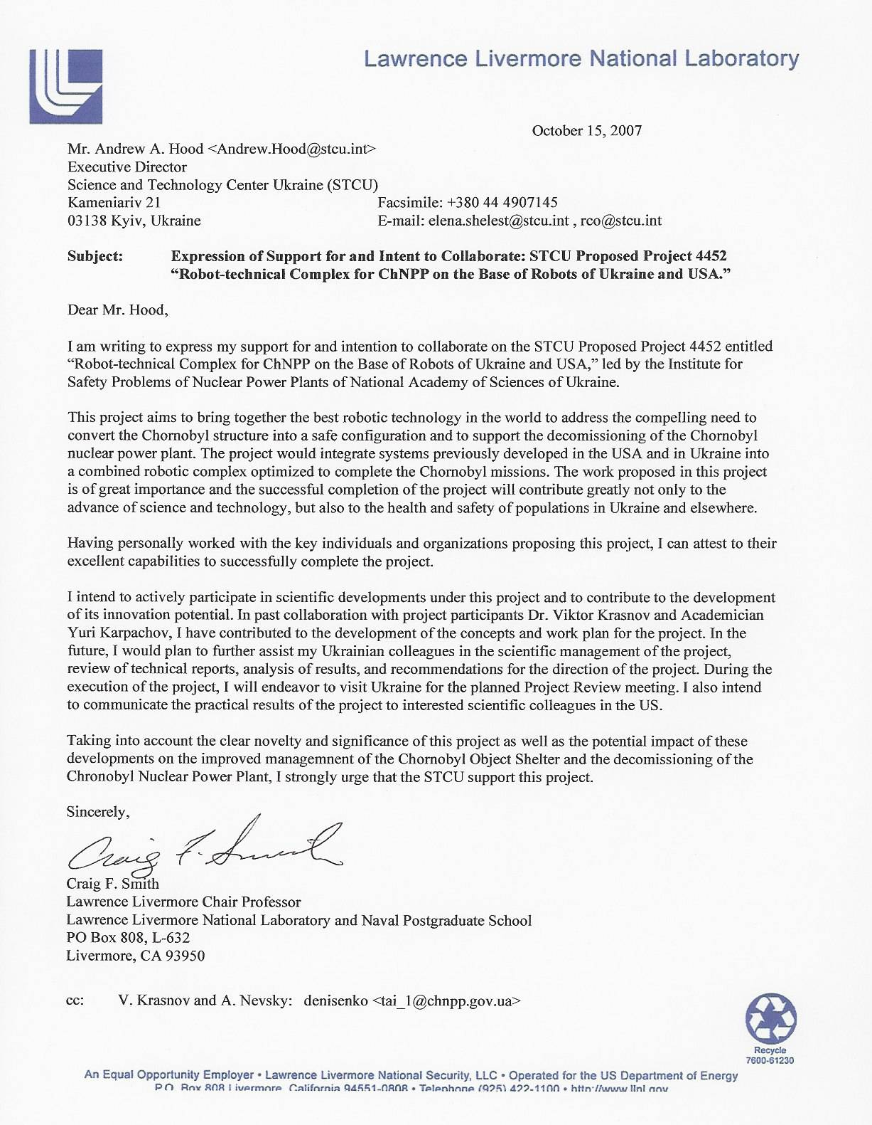

**Application 4.**

**CONFIRMED**

**by Director General of State**

**Corporation UkrDO “Radon”**

**__________________ Tokarevsky V.V.**

**June 18, 2007**

**CONCLUSION**

of research- and scientific and technical expertise of tender materials related to

proposition for Project UNTC No 4452 „Robot and technical complex for

Chornobyl NPP based on Ukraine and USA robots".

1. Object of expertise

The object of expertise is the materials of Project No 4452 „Robot and technical complex for Chornobylої NPP based on Ukraine and USA robots", whose purpose is the development of nuclear and radiation safe unmanned technological processes for work realization and which is aimed at „Shelter" Object conversion and creation of robot and technical complex for their realization.

The content of the project covers the completion and upgrading of robot and technical system „Pioneer" designed in the USA, as well as robots designed in Ukraine, and their unification in a single complex possessing new technical abilities.

2. Evaluation of quality of submitted documents

This project meets the Tender conditions. Restricted access is forecast to obtained results, with considering the practice of UNTC projects’ realization (restricted access to premises, in which the project is being realized, patenting of research results, author publications, computer passwords for information for this project).

3. Analysis of relevance, modernity and prospects for research product implementation

In 1986, a technogenic catastrophe, whose aftermath had not had any world analogs, occurred at Chornobyl Nuclear Power Plant (ChNPP), The problems to be solved for provision of ChNPP’s power Unit 4 - " Shelter object " – into an ecologically safe system, are also unique ones.

Currently, the world has not got any technical gears for safe realization of many works in the conditions like in „Shelter Object". Therefore, the problem is concluded in developing nuclear and radiation safe unmanned technological processes and creation of technical means for their realization, which would provide the implementation of works aimed at „Shelter Object" conversion and ChNPP decommission with minimum exposure of personnel and radioactive environmental contamination.

In this project, a complex will be created that is destined to realize complicated (multiple-function) works, which can not be made by any individual robot. Economic benefit of project realization is concluded in significantly less cost of complex, due to usage of already available robots, as compared to creation of analogous complex demanding full cycle of designing and manufacturing. Additional advantage of project is the shortening of terms for its implementation during realization of works aimed at „Shelter Object" conversion, as compared to the terms needed for development of a new analogous complex.

4. Results of this work realization can be used: The results of this work can be used at nuclear power plants and other radiation and nuclear installations of Ukraine, for mitigation of aftermath of technogenic accidents at power engineering objects and chemical enterprises, mitigation of aftermath of ecological pollution, dismantling the clusters of unsuitable for use of plant protection means and other high-toxic substances.

5. Analysis of readiness to project realization of organization-executor

Project Coordinating Organization is Nuclear and Radiation Safety Division (NRSD) of Institute for Safety Problems of Nuclear Power Plants (ISP NPP) of National Academy of Sciences of Ukraine.

Over work period at ChNPP (since 1986), the Division has been carried out a huge amount of researches which resulted in obtaining unique experience in designing mobile robots and safe work realization in complicated conditions of „Shelter" object.

Project Co-executor Organization is Interbranch Research and Development Institute for Mechanics Problems (IRDI MP) „Ritm" under National Technical University of Ukraine „Kyiv Polytechnic Institute". The Institute realized successfully the Projects NoNo 715, 2704 jointly with Research and Technology Center in Ukraine (NTCU); projects ВЗ13820 and Р-016 with Livermore Lawrence National Laboratory (USA); project 98/4030 with Ministry for Extraordinary Situations of Ukraine.

As a result of above realized projects, a whole range of remotely controlled and radiation resistant aggregates was created and tested with positive estimation for ChNPP, among which are robots „RTK-YuOM" and „ RTK-YuOM (R)", which will be incorporated jointly with robot «Pioneer» to expectable robot and technical complex.

Original technical decisions of robot elements prepared by leading experts of RTK-YuOM «Ritm» were granted by 10 patents of Ukraine, among which six – in association with LLNL experts Mark S.Rowland and Craig F.Smith.

The basis of project executor team includes the scientists and engineers working for many years at leading enterprises and research plants of military and industrial complex of the former USSR.

The team contains the experts of branches as regards:

а) systems to control movement and orientation of flying vehicles (FV);

б) systems and devices for FV ground research;

в) systems to control movement of movable (mobile) objects;

г) nuclear power plants;

д) automated electric drive;

е) systems for hydropneumoautomatics;

ж) computing machines and programming.

Leading experts have more than 50 research works, author certificates, patents and publications in above fields.

General conclusion

Robotization of technological processes, which are dangerous for men’s life and health, is a stable and irreversible tendency of development. So, it is economically expedient to create in Ukraine the robots for „Shelter" Object conversion into an ecologically safe system and to solve other tasks.

Considering the above, I deem as rational to offer this project for revision of Expert and Technical Commission of Ukraine’s Ministry for Education and Science and to recommend project No 4452 ..Robot and technical complex for Chornobyl NPP based on Ukraine and USA robots" to participate in UNTC Tender in conformity with Intergovernmental Agreement of October 25, 1993.

Expert:

Deputy Director General of SC

«UkrDO «Radon», d.t.c. Korchahin P.O.

**Application 5.**

**Технические предложения по доработке и модернизации робототехнической системы «Пионер» для ее применения в предстоящих работах по преобразованию объекта «Укрытия» и снятию с эксплуатации ЧАЭС.**

**КлючниковА.А., Краснов В.А. (ИПБ НАНУ), Леськив С.Д., Невский А.П. (ГСП ЧАЭС),**

**Карпачев Ю.А. (МНИИ ПМ «РИТМ»).**

В рамках поддержки программы по стабилизации объекта “Укрытие” Департамент энергетики США и НАСА финансировали проведение работ по созданию робототехнической системы “Пионер”.

Техническое руководство проектом осуществлялось Ливерморской Национальной Лабораторией США. Руководство проектной группой, включающей в себя Институт Робототехники - Карнеги Мэллон Университет, Лабораторию Реактивного Движения НАСА, Эймс Лабораторию НАСА, Корпорацию Вэстингаус Электрик, осуществлялось компанией RedZone Robotics Inc.

Система “Пионер” представляет собой многофункциональную дистанционно- управляемую диагностическую систему, которая предназначена для проведения разведки и сбора необходимой информации в радиационно-опасных помещениях объекта “Укрытие” и обеспечивает решение следующих задач:

• трехмерное картографирование помещений объекта “Укрытие”;

• видеоразведка с помощью цветной радиационно-стойкой ТВ камерой;

• мониторинг окружающей среды и радиационной обстановки;

• отбор проб материалов с помощью керноотборника;

• доставка и установка контрольно-измерительной аппаратуры в радиационно-опасные помещения;

• организация и расчистка проходов.

По конструктивному исполнению система “Пионер” является экспериментал ногофункциональной блочно-модульной системой и состоит из шести отдельных подсистем:

- гусеничное транспортное средство (ТС);

- подсистема подключения к электросети и распределения энергии (СУРЭ);

- пульт управления (ПУ);

- подсистема регистрации параметров окружающей среды (СРПОС);

- подсистема отбора проб бурением (СООБ);

- подсистема трехмерного картографирования (3М Картограф).

Управление транспортным средством, со всем навесным оборудованием осуществляется через общий кабель, который обеспечивает его удаление от пульта управления на расстояние до100 м.

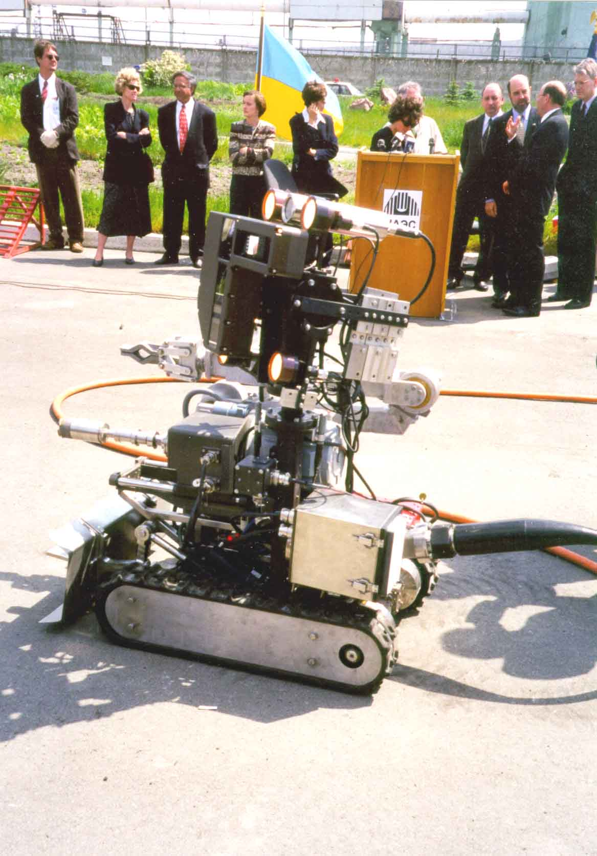

В период с 18.04 по 28.05 99 представителями объекта“Укрытие”, ORNL, RedZone Robotics, CMU и МНТЦ “Укрытие” были проведены входной контроль, предварительные испытания, “холодное” тестирование и демонстрация системы “Пионер”. В ходе испытаний был выявлен ряд конструктивных замечаний, основными из которых являются:

1. массогабаритные характеристики кабеля (200 кг) снижают маневренные характеристики установки и требуют значительных физических и дозовых затрат персонала для его укладки;
2. проектное исполнение трехмерного картографа снижает устойчивость робота во время преодоления им препятствий под высокими углами и может привести к его опрокидыванию

Рис.1. в помещениях объекта “Укрытие”;

Рис.1. Робот PIONEER.

1. конструктивное расположение измерительных датчиков в нижней части агрегата (расстояние от корпуса датчиков до пола 25 мм) может привести к их поломке в процессе эксплуатации, а также снижает ходовые характеристики робота в части преодоления различных препятствий..

По результатам проведения предварительных испытаний в итоговом отчете для Министерства энергетики США «Объектом «Укрытие» совместно с ОЯРБ МНТЦ "Укрытие" разработаны технические предложения по ее доработке и модернизации для решения различных задач в объекте «Укрытие», а также по созданию на базе модулей и блоков системы «Пионер» и робототехнических систем разработанных в Украине и за рубежом специализированных блочно-модульных комплексов дистанционно-управляемых агрегатов (ДУА) для проведения работ по преобразованию объекта «Укрытие» и снятию с эксплуатации Чернобыльской АЭС.

Система “Пионер”, с учетом проведения доработок и устранения замечаний, выявленных в процессе проведения предварительных испытаний, может быть применена в объекте “Укрытие” и на Чернобыльской АЭС для решения следующих задач:

* проведение радиационно-технологического мониторинга хранилищ отработанного ядерного топлива, заводов по переработке жидких и твердых радиоактивных отходов (РАО);
* сопровождение работ по перегрузке топлива находящегося в третьем энергоблоке Чернобыльской АЭС во временное хранилище;
* картографирование помещений в объекте “Укрытие” и получение объемных виртуальных моделей;
* создание трехмерных цифровых изображений доступных скоплений ТСМ и дистанционного измерения их геометрических размеров;
* обнаружение и уточнение границ расположения скоплений ТСМ под наплывами бетона;
* мониторинг условий окружающей среды и радиационной обстановки, используя как уже имеющиеся датчики, так и дополнительные;
* доставка и установка датчиков измерения физических параметров в местах контроля;
* проведение различных работ с применением манипулятора (пылеподавление, взятие проб, экранирование скоплений ТСМ и т. д.);
* размещение оборудования в местах с высокими радиационными полями;
* расчистка и организация проходов.

При выполнении каждой из перечисленных задач на подвижной платформе должно монтироваться только необходимое из представленного комплекта оборудования, а также дополнительные устройства и приспособления, способствующие проведению работ. С целью снижения массы кабеля необходимо провести работы по созданию комплекта специализированных кабелей для выполнения различных работ, например:

- измерение параметров окружающей среды;

- видеоразведка и картографирование;

- проведение работ с манипулятором;

* расчистка проходов и др.,

а также системы автоматической выдачи и подмотки кабелей в процессе эксплуатации.

Для решения задач предусмотренных в утвержденной украинской «Стратегии преобразования объекта «Укрытие», которая согласована с SIP, параллельно с работами по доработке, целесообразно рассмотреть вопрос о создании на базе модулей и блоков системы “Пионер”, а также робототехнических систем специализированных комплексов дистанционно-управвлямых агрегатов для проведения разведки и характеризации скоплений ЛТСМ, а также работ по извлечению и контейнеризации доступных скоплений ЛТСМ:

1. Комплекс диагностических дистанционно-управляемых агрегатов для проведения разведки и характеризации ТСМ в составе:

* агрегата радиационной и технической разведки, включающего шасси, систему технического зрения и набор датчиков для измерения общефизических полей в различной комплектации;
* агрегата видеоразведки и картографирования, включающего шасси, систему технического зрения, систему телескопического типа (например, разработанную компанией Remotec), обеспечивающую подъем установленной на ней телекамеры на высоту до трех метров и в зависимости от решаемых задач картографа, телегаммавизора или сканирующего коллимированного гамма-детектора;
* агрегата для отбора проб ТСМ и РАО (диапазон установки углов керноотборника должен обеспечиваться автоматически, глубина бурения до 100мм, диаметр керноотборника до 20 мм);
* агрегата для доставки и установки датчиков измерения общефизических полей, а также взятия проб твердых, сыпучих и жидких фракций ТСМ и РАО.

2. Комплекс дистанционно-управляемых агрегатов для извлечения и контейнеризации доступных скоплений ТСМ, например, в подреакторных помещениях, который обеспечивает:

- расчистку и организацию проходов к скоплениях ТСМ, в том числе фрагментацию бетона и металлоконструкций;

- экранирование скоплений ТСМ;

- фрагментирование скоплений ТСМ, например, методом распорного разрушения;

- погрузку фрагментов ТСМ в контейнеры;

- транспортировку контейнеров в помещения временного хранения;

- пылеподавление и пылеудаление при проведении работ;

- дезактивацию помещений и оборудования.

С целью повышения технических и эксплуатационных характеристик в составе систем и выполняемых ими функций рассмотреть возможность:

• обеспечения энергоснабжения и управления агрегатами как по кабелю так и от автономного источника питания установленного на агрегатах, с управлением по радиоканалу;

• представления оператору трехмерной информации за счет введения в состав системы технического зрения стереомодуля с выводом информации на шлемный визир (виртуальные очки) и дисплей;

• применения подсистемы измерения координат агрегатов;

• представления оператору информации о положении (координатах) агрегатов в системе координат, связанной с обследуемыми помещениями, а также взаимное положение агрегатов;

• применения подсистемы автоматического обнаружения препятствий и измерения дальности;

• применения подсистемы диагностики исправности агрегатов и составных модулей;

• применения модуля встроенного тренажера для подготовки оператора;

Конструктивное исполнение агрегатов и оборудования должно базироваться на блочно-модульном принципе построения с обеспечением их ввода в помещения объекта “укрытие” через штатные существующие проходы или проведением минимальных работ по их организации.

Для выбора базовых модулей и узлов целесообразно провести сравнительную оценку предлагаемых модулей фирмы RedZone с аналогичными модулями, разработанными американскими фирмами. Так например, американской компанией Remotec разработана серия роботов типа Andros (рис.2) в модульном исполнении с комплектом сменного оборудования и аппаратуры, с возможностью управления как по кабелю так и по радиоканалу. Кроме того, компанией Remotec разработан ряд роботов для проведения работ на атомных объектах США.

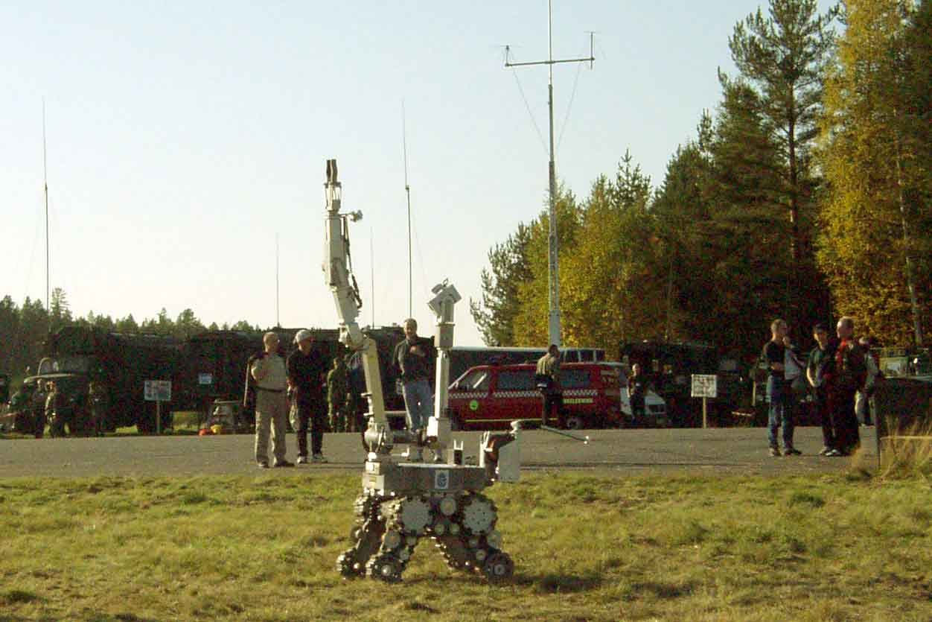

Рис. 2. Робот ANDROS фирмы REMOTEC (США).

В 2001г., в рамках американо-украинского проекта, межотраслевой научно-исследовательский институт прикладной механики «Ритм» (МНИИ ПМ «Ритм»), совместно с Ливерморской национальной лабораторией имени Лоуренса проведены работы по разработке и созданию многофункциональных дистанционно-управляемых систем РТК-100М (рис.3.) для проведения работ в радиационно-опасных помещениях ядерных объектов США, с учетом возможности их адаптации для применения в объекте «Укрытие».

При проведении данной работы были учтены замечания выявленные при проведении испытаний системы «Пионер» на ГСП ЧАЭС.

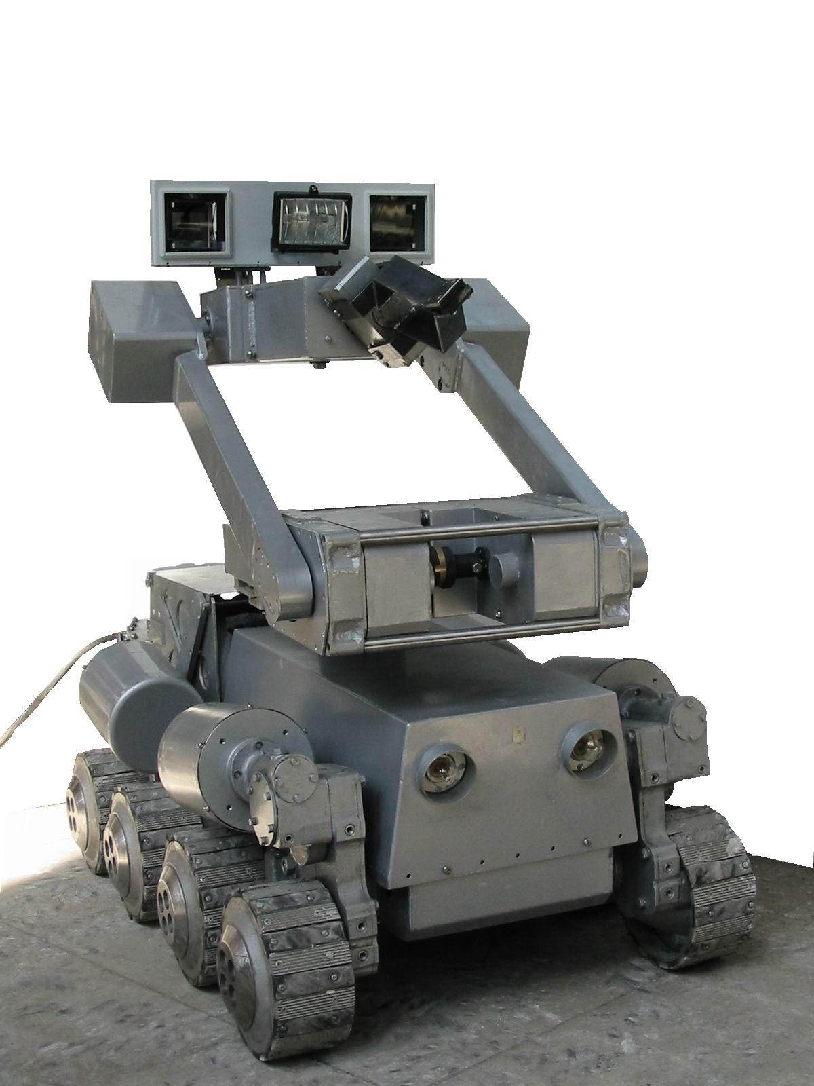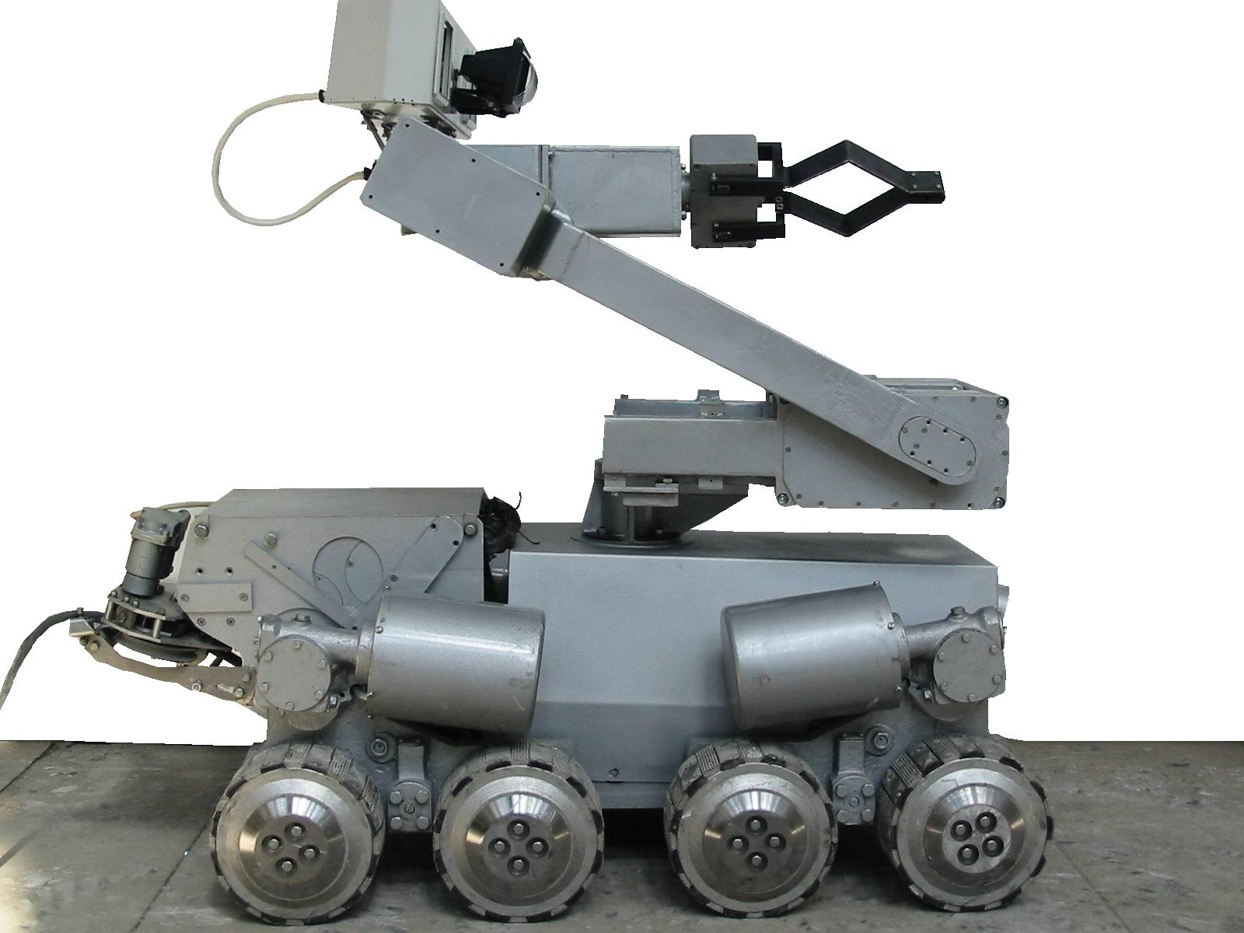

Рис.3.

В процессе проведения данной работы МНИИ ПМ «Ритм», Ливерморской национальной лабораторией имени Лоуренса совместно с объектом «Укрытие» и ИПБ АЭС НАНУ, рассмотрены вопросы по созданию на базе модулей и блоков робототехнической системы «Пионер», а также робототехнических систем разработанных в Украине и США специализированных блочно-модульных комплексов дистанционных систем для проведения работ, связанных с обследованием помещений и характеризацией ТСМ, созданием локализующих защитных покрытий для безопасного обращения с ТСМ, а также для извлечения и контейнеризации доступных скоплений ТСМ.

В настоящее время ИПБ АЭС НАНУ совместно с МНИИ ПМ «Ритм» проводятся работы по отработке технологического процесса и созданию специализированного блочно-модульного комплекса дистанционных систем и агрегатов для извлечения и контейнеризации доступных скоплений ТСМ через существующие штатные проходы и обеспечивающего решения следующих задач:

расчистку и организацию проходов к скоплениях ТСМ

экранирование скоплений ТСМ;

фрагментирование скоплений ТСМ;

погрузку ТСМ в контейнеры;

транспортировку контейнеров в помещения временного хранения;

пылеподавление при проведении работ;

дезактивацию помещений и оборудования.

Для отработки технологического процесса контейнеризации доступных скоплений ТСМ, а также проведения демонстрационного эксперимента ИПБ НАНУ создан экспериментальный блочно модульный комплекс дистанционно-управлямых агрегатов, в следующем составе:

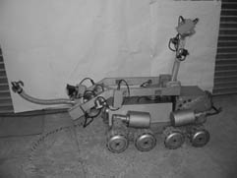

Рис.4.. ДУА радиационной разведки для отбора проб

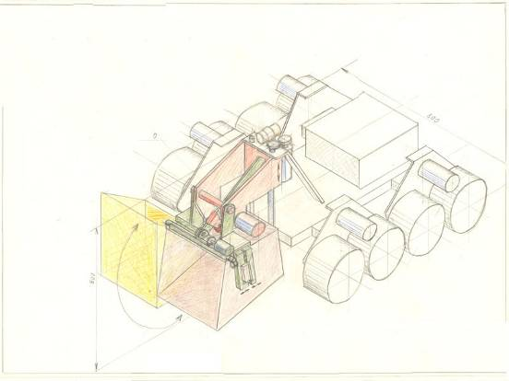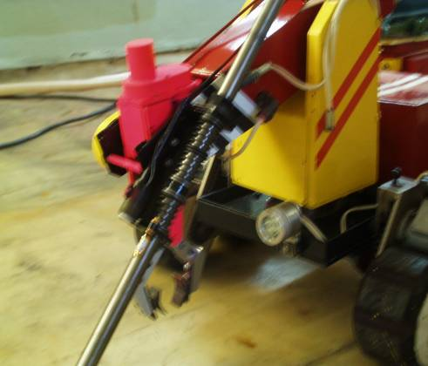

Рис.5. .ДУА для сбора погрузки и фрагментирования ТСМ

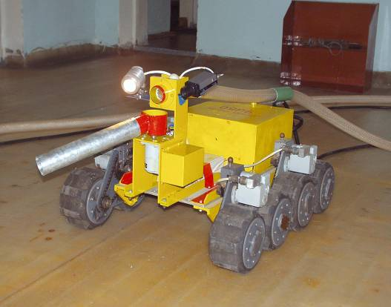

Рис.6. ДУА пылеподавления .

А также робототехнический комплекс РК-100М, с комплектом сменного оборудования для выполнения различных операций, разработанный МНИИ ПМ «Ритм» (рис.3.).

Маршрут движения агрегатов, при проведении демонстрационного эксперимента, приведен на рис.7.

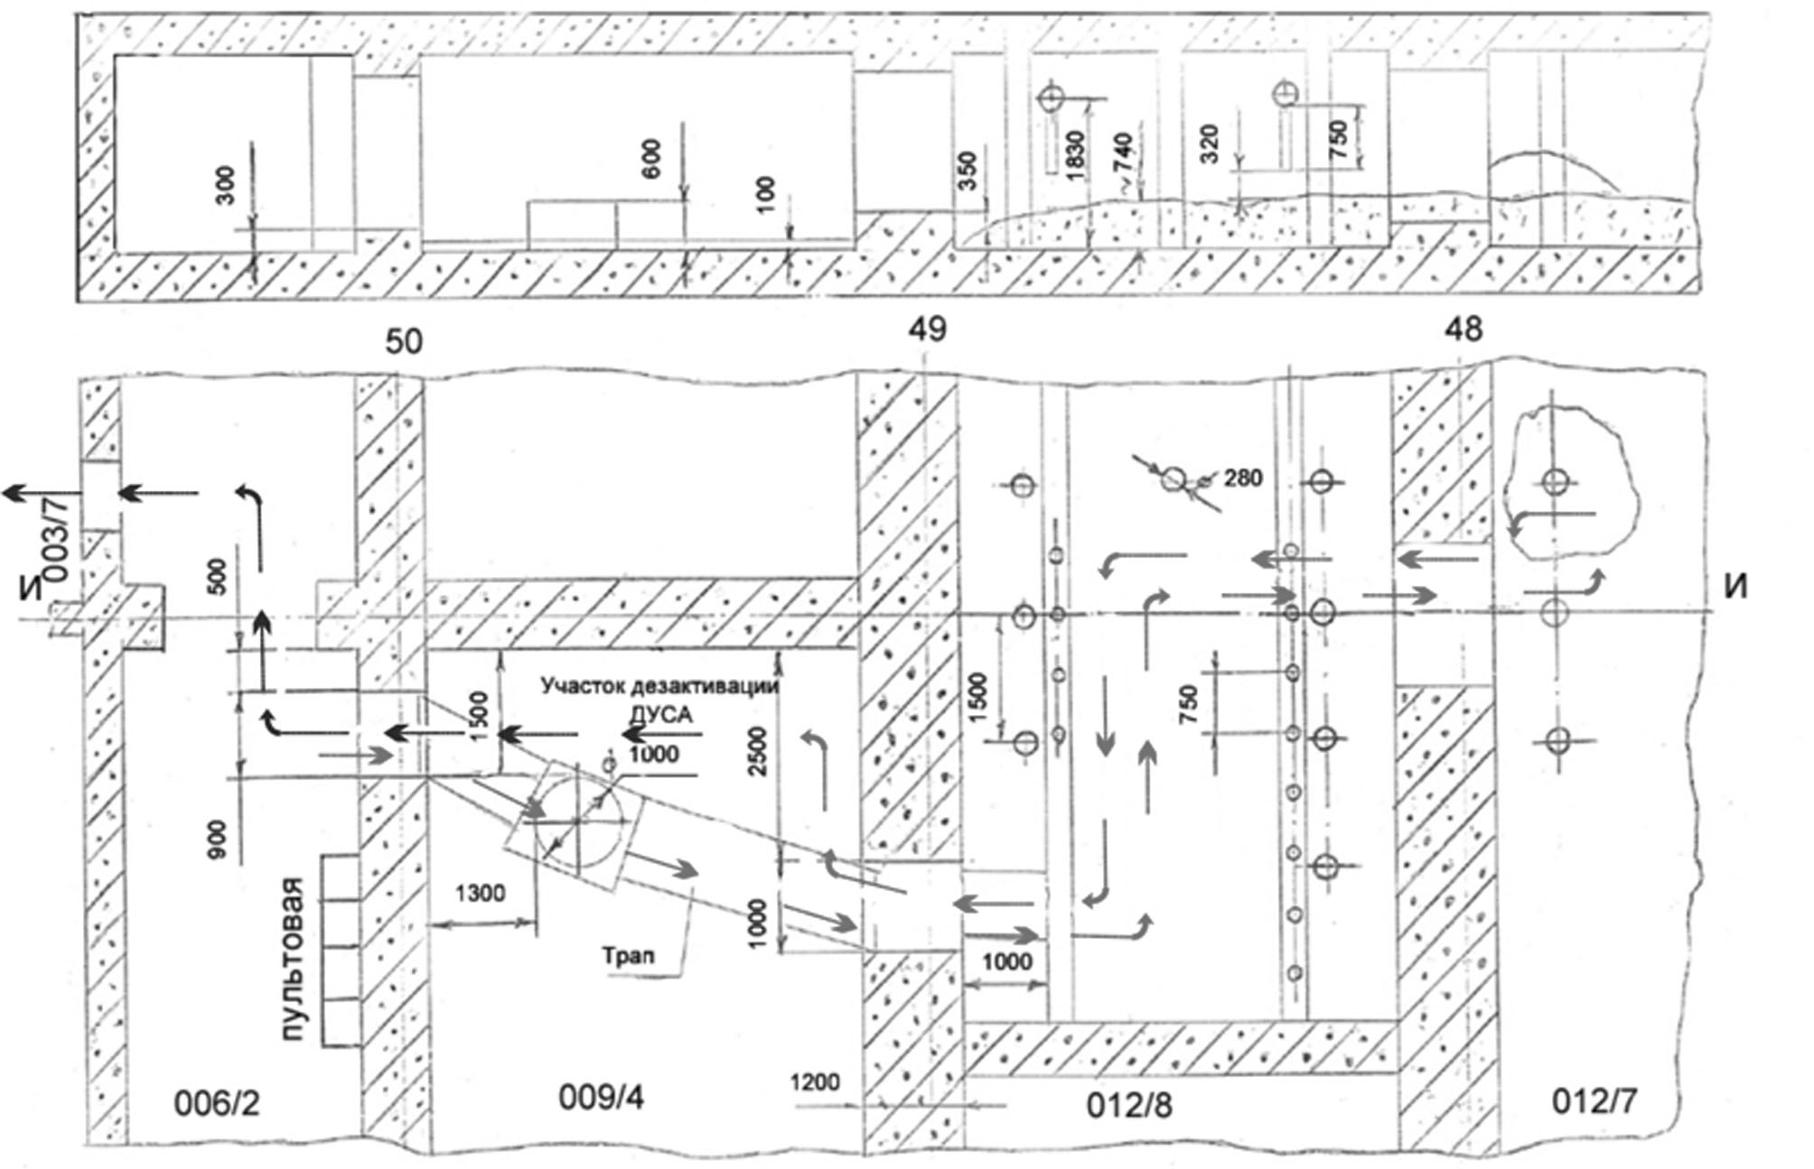

Рис. 7.

В результате выполнения данной работы в объекте «Укрытие» будут оборудованы помещения и созданы рабочие места для подготовки и проведения демонстрационного эксперимента извлечения ТСМ, а также для реализации альтернативного варианта технологического процесса извлечения ТСМ, расположенных в пом. 012/7, без нарушения существующего защитного барьера.

Кроме того, выполнение данной работы послужит «полигоном» для отработки технологий, уточнения требований к дистанционной технике и оборудованию, которые будут применены на последующих этапах работ по реализации комплексной программы обращения с ТСМ

С целью уточнения технических характеристик, решаемых задач и состава оборудования должны быть проведены работы под руководством ГСП ЧАЭС по тщательной разработке технологических процессов предстоящих работ в конкретных помещениях объекта “Укрытие” и ГСП ЧАЭС с проведением моделирования**.**

Для координации проведения работ по модернизации системы “Пионер”, а также внедрения американских дистанционных технологий для проведения предстоящих работ по преобразованию объекта “Укрытие” и снятию с эксплуатации Чернобыльской АЭС целесообразно рассмотреть вопрос о создании совместной рабочей группы из представителей ГСП ЧАЭС, ИПБ НАНУ, LLNL, ORNL, RedZone Robotics Inc.