|  |  |  |
| --- | --- | --- |
| ISTC Project No. 3592 | | |
| Investigation of corium melt interaction with NPP reactor vessel steel (METCOR-Р) | | |
| Annual Technical Report | | |
| on the work performed from Apr 01, 2007 to Mar 28, 2008  (first year) | | |
| **A.P. Alexandrov Research Institute of Technology (NITI)**  **Sosnovy Bor, 188540 Leningrad Region, Russia** | | |
| Project Manager | Vladimir Bentsianovich Khabensky, Prof., Dr. |  |
| Director | Vyacheslav Andreyevich Vasilenko, Prof., Dr. |  |

|  |  |
| --- | --- |
| Project title: | **Investigation of corium melt interaction with NPP reactor vessel steel (METCOR-Р)** |
| Leading institute: | The A.P. Alexandrov Research Institute of Technology (NITI) of the ROSATOM State Corporation |
| Participating institutions: | No |
| Project starting date: | 01 April 2007 |
| Project duration: | 36 months |
| Project Manager: | Prof., Dr. Khabensky V.B., Senior Researcher, NITI of the ROSATOM State Corporation  Address: 19, 50 Let Oktyabria Str., Apt.50, Sosnovy Bor, 188540, Leningrad Region, Russia |
| Phone: | +7(813-69) 60-625 |
| Fax: | +7(813-69) 23-672 |
| e-mail: | [vbkh@sbor.net](mailto:vbkh@sbor.net) |

# Brief description of the Work Plan: Project objectives, expected results, technical approach.

The overall objective of the Project is the NPP nuclear reactors safety enhancement in case of a severe accident involving core meltdown. Specifically, the project aims to investigate experimentally and theoretically physicochemical processes that occur at the interaction of a pool of prototypic molten corium with reactor vessel steel. The work is supposed to determine steel corrosion during the in-vessel retention of the melt and the reactor vessel external cooling with boiling water.

The interaction of molten corium with vessel steel is investigated in the project under the below-described conditions:

* Vertical orientation of the interaction surface for determining the influence of surface orientation on the process of corrosion by comparing the results with those obtained previously for the horizontally oriented surface.
* Changing of the oxygen potential of the system during the interaction by replacing an inert atmosphere with the oxidizing one (steam), which under reactor conditions may increase the melt temperature, change location of the metallic and oxidic parts of the melt relative to each other, increase heat flux to the vessel (in particular, at the expense of the focusing effect), and increase the release of aerosols and fission products.
* Interaction with the European reactor vessel steel.

The main results of the project will be as follows:

* + Experimental data on the kinetics and depth of vessel steel corrosion at the interaction with molten corium.
  + Mechanisms of physicochemical processes that determine the process of corrosion.
  + Experimental data on steel corrosion under conditions of the nonstationary process during molten corium oxidation.
  + Qualitative and quantitative peculiarities of the European reactor vessel steel corrosion.
  + Dependencies for calculating corrosion kinetics within the investigated range of variables.

The project-generated results can be used for:

* + modeling physicochemical processes of corrosion in severe accident numerical codes;
  + verifying numerical codes;
  + specifying the temperature and mechanical conditions of the reactor vessel;
  + developing and substantiating different concepts of molten corium localization during a severe accident involving core meltdown, those envisaging the in-vessel melt retention in the first place.

Experimental investigations in the framework of the project employ the experimental facilities Rasplav-2 and Rasplav-3 which have been successfully used for 15 and 5 years, respectively. To produce molten corium, these installations employ the method of induction melting in the cold crucible (IMCC) that makes it possible to work with melts heated up to 3300 K. The IMCC method offers contact-free energy input into the melt and volumetric heat in the layer of melt of a certain thickness.

Rasplav-2 is used for the tests with the oxidized and suboxidized oxidic systems, while Rasplav-3 is employed for the tests with metal-oxidic systems. Rasplav-2 and Rasplav-3 are capable of producing up to 8 and 2 kg (respectively) of high-temperature molten corium in the neutral atmosphere, air or steam above the melt.

A part of posttest studies of the interaction mechanisms employ the following methods:

- Visual polythermal analysis in the cold crucible (VPA IMCC) and in the Galakhov microfurnace (VPA GM).

- Differential thermal analysis (DTA).

- High-temperature microscopy (HTM).

The physicochemical analysis of corium and steel samples employed the following methods:

* Elemental composition analysis (X-ray fluorescence analysis (XRF), chemical analysis (ChA), inductively coupled plasma mass spectrometry (ICPMS), spark source mass spectrometry (SSMS)).
* Phase composition analysis (X-ray diffraction (XRD), energy dispersive X-ray spectrometry (EDX)).
* Metallography and ceramography (optical microscopy (Opt M), scanning electron microscopy (SEM)).

# Technical work progress in the current year (first year)

The Work Plan Experimental Matrix envisaged fulfillment of 5 tasks aimed at obtaining experimental and analytical data on kinetics of vessel steel specimens corrosion at the interaction with molten corium, depending on: the interaction surface orientation in space; the nonstationary processes of melt oxidation at the replacement of an inert atmosphere with the oxidizing one (air/steam); and the grade of steel used for the European reactor vessels.

The content of the tasks was as follows:

**Task 1 -** Experimental facility modernization, adjustment and preparation. Elaboration of techniques for experimental and posttest investigations. Elaboration of test specifications.

**Task 2 -** Interaction of the suboxidized molten corium with the vertically positioned vessel steel specimen. Interaction of the oxidized C-100 and UO2+x-ZrO2-FeOy molten coriums with the horizontally positioned vessel steel specimen in the oxidizing atmosphere (air, steam).

**Task 3 -** Nonstationary processes during oxidation of the suboxidized oxidic and metal-oxidic melts at the replacement of an inert atmosphere (argon) with steam.

**Task 4 -** Interaction of molten corium with the European reactor vessel steel specimen.

**Task 5 -** Complex physicochemical and thermodynamic analysis of the performed tests, experimental series and the entire set of experimental and numerical investigations. Deliverables preparation. Numerical models development. Preparation of research papers and conference presentations.

Each task is subdivided into the following stages: tests performing, primary analysis, pre- and posttest calculations, physicochemical analysis and the complex analysis of the obtained results.

The scope of work performed during the first year of the project is described below.

**Task 1**

* Three constructive schemes of the Rasplav-3 facility modernization have been developed for conducting experimental investigations of the interaction between the vertically positioned vessel steel specimen and the suboxidized molten corium (Fig. 1). Each option has its advantages and drawbacks.

Advantages of the diagram 1a) are the convenient specimen position and applicability of the ultrasonic sensor. However, in this case the pool volume is too large, a crust may form at the surface within the pyrometer sighting spot, and sealing of the furnace volume is complicated.

Option 1b) offers a developed interaction surface a possibility to use the ultrasonic sensor, but it has its drawbacks, which are the low efficiency of the inductor, a too shallow molten pool and complicated sealing of the inductor.

The diagram 1c) presents a well-proven design of the crucible, but in this case positioning of sensors in the specimen is too tight and the temperature profile in the specimen is asymmetrical.

1 – crucible sections;

2 – water-cooled pyrometer shaft;   
3 – inductor;   
4 – steel specimen;   
5 – specimen calorimeter;   
6 – US sensor

7 – K-thermocouples;   
8 - melt



**a)**

1 – water-cooled cover;

2 – water-cooled pyrometer shaft;   
3 – specimen;   
4 – specimen calorimeter;   
5 – US sensor

6 – inductor;

7 –- melt;

8 – K-thermocouples;

9 – quartz tube



**b)**

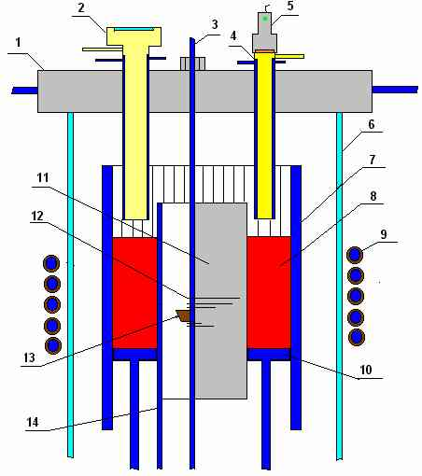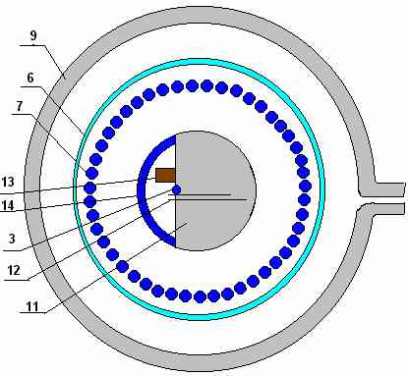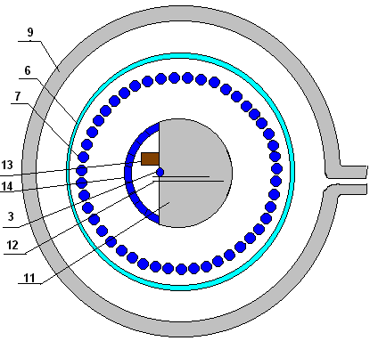

1 – water-cooled cover; 2 – water-cooled pyrometer shaft; 3 – specimen calorimeter;   
4 – water-cooled shaft of the ultrasonic distance sensor; 5 – ultrasonic distance sensor; 6 – quartz tube;   
7 – crucible sections; 8 - melt; 9 inductor; 10 – calorimeter; 11 – specimen; 12 – K-thermocouples;   
13 – ultrasonic sensor; 14 – cooled case.

**c)**

**Fig. 1. Constructive schemes of the Rasplav-3 facility modernization**

* An analysis of the proposed modernizations, in particular numerical evaluation of the required generator power, the cold crucible and generator size, manufacturability of the structure, specimen cooling system, molten pool volume and completeness of the measurement system allowed choosing a facility diagram with the traditional design of the vertical crucible and vertical, axially positioned cylindrical vessel steel specimen with an internal cooling channel (Fig. 2).

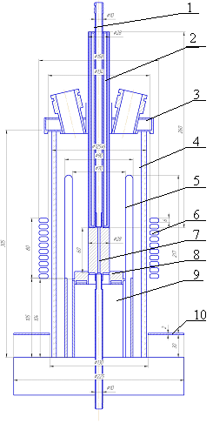

1 – specimen cooling fitting, 2 – water-cooled screen, 3 – water-cooled cover,   
4 – quartz tube, 5 – crucible sections, 6 – inductor, 7 – specimen, 8 – calorimeter,   
9 – calorimeter support, 10 – uncooled screen.

**Fig. 2. Facility diagram with the vertical crucible of conventional design and the vertical vessel steel specimen.**

* Some new elements and the working section of the modernized Rasplav-3 facility have been manufactured, the platform test facility assembled, verifying switching-ons performed, the furnace adjusted for MCP-1 test, and the energy release and temperature regime in the specimen in the absence of the melt experimentally determined. The Rasplav-3M facility has been prepared for performing the project tests.

**Task 2**

**Subtask 2.1**

The interaction of the suboxidized molten corium with the vertically cooled vessel steel specimen (МСР-1 test) has been experimentally investigated.

МСР-1 was aimed at determining the influence of the interaction surface orientation on vessel steel corrosion. To make a reliable comparison, the initial conditions of MCP-1 had to be identical to those in the МС-6 test (Project No.833.2 METCOR) with the horizontally positioned vessel steel specimen. However, due to the formation of a thick crust on the melt surface and the resulting changes in hydrodynamics of the melt, experimental conditions of MCP-1 have also changed, if compared to MC-6. For instance, the oxidation index in MCP-1 happened to be equal C-17, while in МС-6 it was С-32; the maximum heat flux from the melt to the specimen was ~2 MW/m2, while in МС-6 it was 1.25 MW/m2; and the maximum temperature at the interaction interface was 1435ºC against 1400ºС in MC-6. Apparently, these differences in experimental conditions have determined differences in corrosive interaction characteristics. For instance, the interaction interface temperature at which corrosion stops was 1000-1090ºC in MCP-1 and 1120-1200ºС in МС-6; the incubation period in МСР-1 was < 4000 s vs. 16000 s in МС-6; and composition of the metallic interaction zone in MCP-1 contains more U and Zr (mass %) than that in МС-6. It should be noted that no direct measurement of the steel specimen corrosion rate was provided in MCP-1, therefore the rate of corrosion was approximately calculated on the basis of thermocouple readings and the final position of the corrosion front.

In more detail, the results of МСР-1 were evaluated within the framework of Task 5 using the data from posttest physicochemical analyses and numerical investigations.

To explain the differences between MCP-1 and 6, there has been proposed a hypothesis that links the ultimate position of the interaction boundary with attaining chemical equilibrium by the oxide-metal system that forms under thermogradient conditions. This hypothesis makes it possible to determine the ultimate temperature of corrosive interaction, which, depending on the concrete interaction conditions, equals either the eutectic, or the liquidus temperature of the composition in the interaction zone. Based on the conservative conditions, the eutectic temperature of ~ 1060ºC can be accepted from the practical point of view as the ultimate temperature of corrosive interaction.

An analysis of the MCP-1 results involving the data obtained from МС-6…МС-9 (Project No.833.2 METCOR) and MASCA has provided an interpretation of the MCP-1 results without a connection to the spatial orientation of the interaction surface.

Nevertheless, performance of a test under conditions comparable with those in MCP-6 and with direct measurement of the corrosion rate using ultrasonic sounding is deemed expedient for determining corrosion kinetics during the interaction of the suboxidized corium with the vertically positioned vessel steel specimen and for a more strict substantiation of the conclusions presented above.

**Subtask 2.2**

The interaction between molten UO2+x-ZrO2-FeOy corium and the vessel steel specimen with the horizontally positioned interaction surface has been experimentally investigated in air and steam at a high temperature on the specimen surface (1000-1135ºC) [the test МСР-0 (МС-12)].

The test was aimed at: obtaining a confirmation that the rate of vessel steel corrosion accelerates at temperatures above ~1050ºC on the interaction interface; checking the influence of steam or air on the process of corrosion; and at obtaining experimental data on the rate of vessel steel corrosion at >1050ºC on the interaction interface.

* As the result of the test, the obtained experimental data on the corrosion kinetics during the vessel steel interaction with molten UO2+x-ZrO2-FeOy corium in air and steam at 1000-1135ºС on the interaction interface have significantly supplemented the data from the project No.833.2 METCOR.
* No significant influence of the oxidizing atmosphere (steam, air) on the kinetics of steel corrosion has been found within the studied temperature domain.
* For the first time, the main differences between steel corrosion under the considered conditions and in the oxidizing atmosphere (without corium) have been found to be as follows:
* The rate of corrosion is time-independent at a constant temperature on the interaction interface and is conditioned by the constancy over time of thickness of the corrosion layer on the steel surface;
* Corrosion intensifies when the temperature on the interaction interface exceeds some threshold value that approximately corresponds to 1050ºC on steel surface and results from formation of a liquid intergranular phase in the corrosion layer, and of continuous liquid phase percolation (drain) channels in the crust, which sufficiently intensify the iron ions transportation.

Concerning Task 5, the obtained experimental data, the results of posttest physicochemical and numerical analyses, as well as the findings from МС-1, МС-2 and МС-11 performed within the framework of the ISTC project No.833.2 METCOR were used for developing a calculated dependence that permits determination of the rate of vessel steel corrosion at the interaction with molten UO2+x-ZrO2-FeOy corium in the oxidizing atmosphere.

**Subtask 2.3**

Corrosion of vessel steel has been experimentally investigated at its interaction with molten C-100 corium in air (MCP-2 test).

МСP-2 was aimed at obtaining experimental data on the steel specimen corrosion rate within a broad range of temperatures on the interaction interface; at determining the influence of the above-melt atmosphere (steam, air); at identifying the mechanism of corrosion and revealing its differences from the corrosion during the interaction of a steel specimen with the UO2+x-ZrO2-FeOy corium in the oxidizing atmosphere; as well as at developing a model of corrosion and a correlation that would generalize all the experimental data on vessel steel corrosion in the oxidizing atmosphere above a melt with the specified composition.

The performed МСР-2 test and posttest physicochemical analyses have yielded the following results:

* New experimental data on the corrosion kinetics of VVER vessel steel at its interaction with molten UO2+x-ZrO2 corium in air at 870…1370°С on the interface surface. The data from the ISTC project No.833.2 METCOR have been sufficiently supplemented.
* The absence of influence of the oxidizing atmosphere composition (air, steam) on the kinetics of steel corrosion has been confirmed.
* In contrast to the UO2+x-ZrO2-FeOy corium, no intensification of the corrosion rate was observed in the case with the high-temperature UO2+x-ZrO2 corium up to the maximum TS of 1370ºC attained on the interface in the tests.
* For the high-temperature UO2+x-ZrO2 corium, steel corrosion is determined by diffusion processes within the corium crust on the steel surface. This crust is sufficiently thicker than the corrosion layer; it stays solid and does not contain complete liquid phase channels characteristic of the crust from the tests with the UO2+x-ZrO2-FeOy corium.
* Concerning Task 5, the results of a complex analysis of the obtained experimental data, the results of posttest analyses, and of the findings from MC-10 performed within the framework of the ISTC project No.833.2 METCOR were used for developing a model of corrosion and obtaining a correlation that generalizes experimental data on corrosion with the UO2+x-ZrO2 corium. All experimental points can be generalized by the proposed linear dependence in semilogarithmic coordinates with a satisfactory precision.

# Technical status

The scope of performed work corresponds to that targeted for the first year of the project. It should be noted that a decision has been taken at a meeting with collaborators to replace the second test with the vertically positioned specimen (Task 2) with the test MCP-2, which should be performed after a system of direct measurement of the corrosion rate at the vertical working section has been developed. It has been decided that the test that will follow MCP-2 in the beginning of the 2nd year of the project should investigate the transient process during molten corium oxidation (under initial conditions analogous to those in MC-6 of the ISTC project No.833.2 METCOR) at the replacement of an inert atmosphere (Ar) with the oxidizing one (steam).

50 % of Task 1, 70% of Task 2 and 50% of Task 50 have been performed during the first year of the project.

# Co-operation with foreign collaborators

Foreign collaborators within the project are noted experts representing different research centers of the European Union:

1. Dr. Walter Tromm, Germany  
   Forschungzentrum Karlsruhe GmbH, NUCLEAR
2. Dr. Alexei Miassoedov, Germany  
   Forschungszentrum Karlsruhe GmbH, IKET
3. Dr. David Bottomley, Germany  
   EUROPAISCHE KOMISSION, Institut fur Transurane (ITU)
4. Dr. Pascal Piluso, France  
   CEA Cadarache – DEN/DTN/STRI
5. Olli Kymalainen, Finland  
   FORTUM Nuclear Services Ltd.
6. Manfred Fischer, Germany  
   AREVA NP GmbH
7. Sieghard Hellmann, Germany  
   AREVA NP GmbH

During the first year of the project implementation, close cooperation has been maintained with foreign collaborators in the form of detailed discussion and coordination of the work plan and experimental matrix, analysis and evaluation of each test performed during the last year, refinement of test specifications, simultaneous performance of numerical analysis, as well as preparation of joint research papers and conference presentations.

The scope and results of the work performed within the METCOR-P project have been discussed during a meeting with collaborators and at meetings of Contact Expert Group of Severe Accident Management (CEG-SAM).

The first METCOR-P Steering Committee meeting with collaborators was held in St.Petersburg on 31 May 2007. The experimental matrix was thoroughly considered and tests succession approved. The project team reported on the work performed for the modernization and preparation of the experimental basis for conducting the project tests and improving experimental techniques and the measurement system for the vertically positioned vessel steel specimen. The question about the delivery by collaborators of vessel steel blanks for producing test specimens and Task 4 performing has been resolved.

During the year, the project team participated in the 12th CEG-SAM meeting in St.Petersburg (Russia) on 11-13 September 2007 and in the 13th CEG-SAM meeting in Cadarache (France) on 11-12 October 2007. At these meetings, the scope of investigations performed within the framework of the project has been reported and the measures to be taken to respond to critical remarks made by the Rosatom Export Control concerning the METCOR-P project discussed.

A conference presentation entitled “Interaction between Molten Corium UO2+x-ZrO2-FeOy and VVER Vessel Steel” has been jointly prepared with collaborators (Bechta S. et al.) using materials from the ISTC project No.833.2 METCOR and some new data. The presentation is to be made at ICAPP’08 in Anaheim, CA, USA (see Appendix 1).

# Problems, Suggestions

Because of the criticism expressed by the Rosatom Export Control concerning the work plan, deliverables preparation has been suspended and the project work slowed down. Owing to the joint efforts with collaborators and CEG-SAM, the problems pointed out by the Export Control have been resolved and a permission from the Export Control to carry out the work received, provided the recommendations given by the Export Control will be observed. Due to the delay in implementation of the project, experimental work should be intensified, or, if keeping to the initial schedule will be impossible, the ISTC should be approached with a request about extending the project for 6 months without additional funding.

# Prospects of further research development

The scope of work planned for the first year of METCOR-P project has been fulfilled completely. In addition, a series of adjustment tests have been performed to improve numerical techniques and broaden experimental capabilities of the Rasplav-3 facility.

In order to perform the works of the second year of the project implementation, it is necessary to additionally modernize the experimental basis and the measurement system for investigating nonstationary processes related to kinetics of the suboxidized melt oxidation at the replacement of an inert atmosphere with the oxidizing one (steam), to adjust the ultrasonic sounding system for monitoring the corrosion front when the vessel steel specimen is positioned vertically. Blanks of the European reactor vessel steel have been received from collaborators for producing the specimens to be studied in the tests on vessel steel corrosion in the framework of Task 4.