**Large scale corium experiment**

1. Total scheme and geometry of large scale experiment

1. As a model of a concrete tank we will use a cylindrical concrete tank with sizes:

- concrete tank internal diameter ~0.6-0.8 m;

- concrete tank depth ~0.6-0.8 m;

- thickness of concrete tank walls ~0.5 m;

- thickness of concrete tank bottom ~0.5 m.

2. To reduce thermal losses from a melt surface, above the concrete tank a heat reflector.

3. The experiment will begin with initiating the hard pyrotechnic composition (~100-150 kg), located in the concrete tank at the initial time. Hence an initial molten pool will be created.

4. Further, pyrotechnic briquettes are thrown into the existing molten pool (from height ~0.5-1m) with a frequency of ~0.25-0.3 kg/s. Accordingly, we accomplish the following goals:

- the melt mass is increased (up to ~1000-1200 kg within ~1-1.5 hours);

- at the expense of energy release from combustion of briquettes inside the melt we provide the required heat fluxes to the walls and the bottom of the concrete tank (~100-150 kW/m2 within ~1-2 hours);

- the necessary melting temperature is provided for (~2500-3000C).

5. Uniformity of energy release in the melt will be achieved by throwing briquettes into different areas of the melt by means of 4 chutes.

6. Additional molten pool heating will be achieved by means of ~6-8 gas burners, located uniformly around the z-Axis ~ 20-30 cm above the pool surface.

7. Height of the molten pool in 1-1.5 hours after the beginning of the experiments will reach~0.4-0.5 m; the volume of the melt will amount up to ~100-150 l.

1. PTC and corium composition

1. To create the molten pool and provide the required heat fluxes and temperatures we plan to use the rather known pyrotechnic compositions, whose combustion is described through the given below reactions as follows:

2Fe2O3 + 3Zr = 3ZrO2 + 4Fe + 2840 kJ /kg, (1) 2Fe2O3 + 3U = 3UO2 + 4Fe + 1550 kJ /kg. (2)

Here specific energy release is given per mass unit of initial PTC.

We plan to use only these materials in our experiments. Hereby, a melt will contain three components: UO2 + ZrO2 + Fe.

2. To provide heat fluxes ~100-150 kW/m2 into the walls and the bottom of the concrete tank, whose dimensions are given above, it is necessary to have energy release inside the melt at combustion of PTC ~150-200 kJ/s. When PTC at a rate of ~0.25-0.3 kg/s of enters a melt the required specific energy release of PTC must be ~500-600 kJ/kg. Note that we are dealing with “useful” energy release, namely such energy release, that remains from complete energy release after deducting losses for heating of reactants and reaction products (1)-(2) and phase transition of products.

3. Useful energy release ~500-600 kJ/kg can be given, for instance, by such PTC as:

[0.33(2Fe2O3 + 3Zr) +0.666(2Fe2O3 + 3U)] → 550 kJ/kg (3)

[0.23(2Fe2O3 + 3Zr) +0.77(2Fe2O3 + 3U)] → 500 kJ/kg (4)

The PTC at complete combustion will provide the following corium composition:

52% UO2 + 21% ZrO2 + 27% Fe (3a)

61%UO2 + 14% ZrO2 + 25% Fe (4a)

1. Measuring and diagnostic system

In the course of the experiment we will measure the following parameters:

1. The temperature of melt surface, walls and bottom of the concrete tank.

2. Heat fluxes in the walls and the bottom of the concrete tank;

3. Ablation of the walls and the bottom of the concrete tank.

1. The temperature will be measured using two methods.

- the molten pool temperature will be measured with the help of surface pyrometry;

- the temperature of the walls and the bottom of the concrete tank will be measured using thermocouples embedded in the concrete (~150 thermocouples);

2. Heat fluxes in the walls and the bottom of the concrete tank will be calculated using the data of the same thermocouples that are used for measuring a temperature.

3. Ablation of the walls and the bottom of the concrete tank can be measured by the help of the same thermocouples that are used for measuring a temperature (as thermocouples destruction).

60–80 cm

input

ventilation

input

ventilation

80–100 cm

40–50 cm

~400 cm

~50 cm

~50 cm

protective hood

heat reflector

~100 cm

4 chutes symmetrically disposed around the z-Axis

output ventilation

150–200 cm

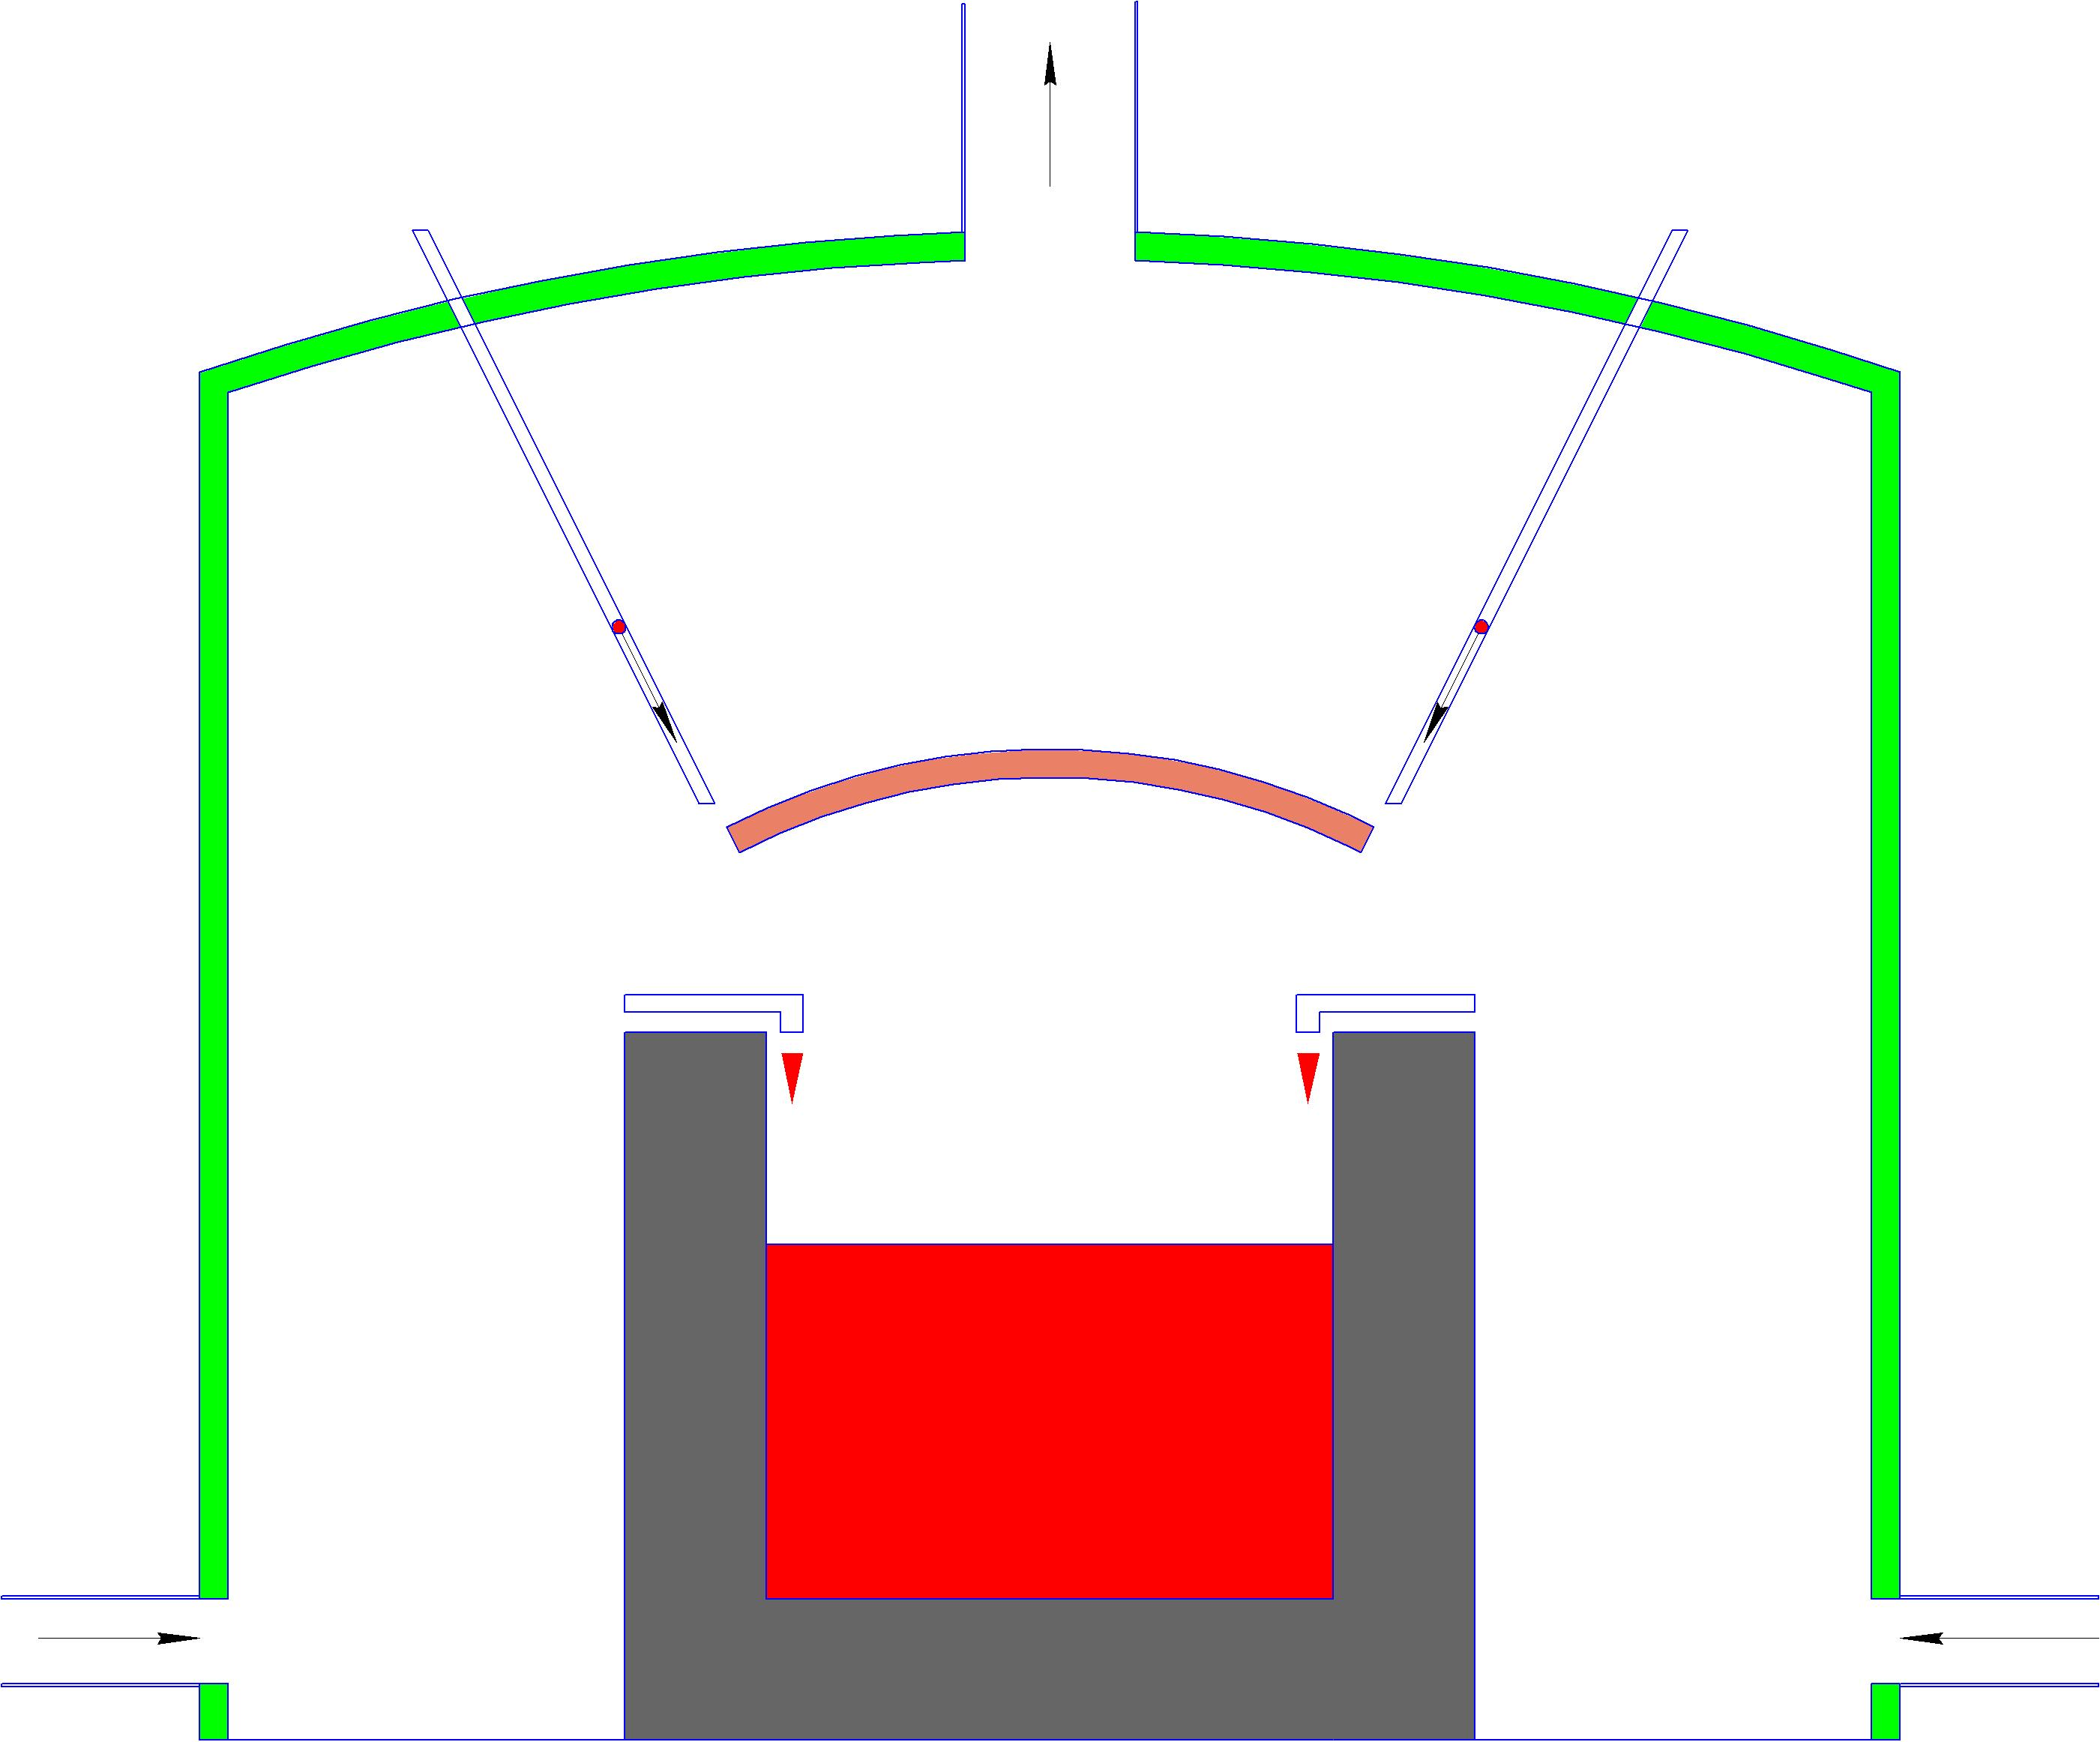

Scheme of large scale experiment

Cost estimation

1. Project name

**Development and experiments at large-scale MCCI installation.**

1. Project Duration

**18 months.**

1. Total Project Effort

|  |  |
| --- | --- |
| **Total number of participants** | 150 |
| **Total project effort (person*days)** | 20000 |

1. Estimated Project Costs

|  |  |
| --- | --- |
| **Total cost of the financing organization on the project (US $)** | 1 370 000 |
| *Including:* |  |
| **Payments to Individual Participants (US $)** | 800 000 |
| **Equipment+Materials** | 470 000 |
| **Other Direct Costs** | 20 000 |
| **Travel** | 50 000 |
| **Waste Utilization** | 30 000 |
|  |  |
| **Non-financial cost of the Russian organizations** | 1 400 000 |
| **Estimated Project Costs** | 2 770 000 |