

Alexander S. Gontar

**Head of department of FSUE "SRI SIA "Luch"**

* **Head of Institute studies on: “Development, calculational-and-theoretical, technological, material-scientific investigations and tests of fuel elements of thermionic space nuclear power plants "**
* **Participant of work on calculational-and-experimental modeling of processes in VVER fuel elements including RIA and LOCA conditions.**



SOME RESULTS OF WORK

**which could be of interest for future investigations into design and materials of VVER (PWR) fuel elements under RIA and LOCA conditions**



1. SIMULATED URANIUM DIOXIDE (simfuel)

Simfuel contains additives (fission products simulators) which are introduced into uranium dioxide during powder preparation at the rate corresponding to the given burn-up depth.

To produce simfuel, the following dioxide production technologies developed in the Luch for space NPP were used:

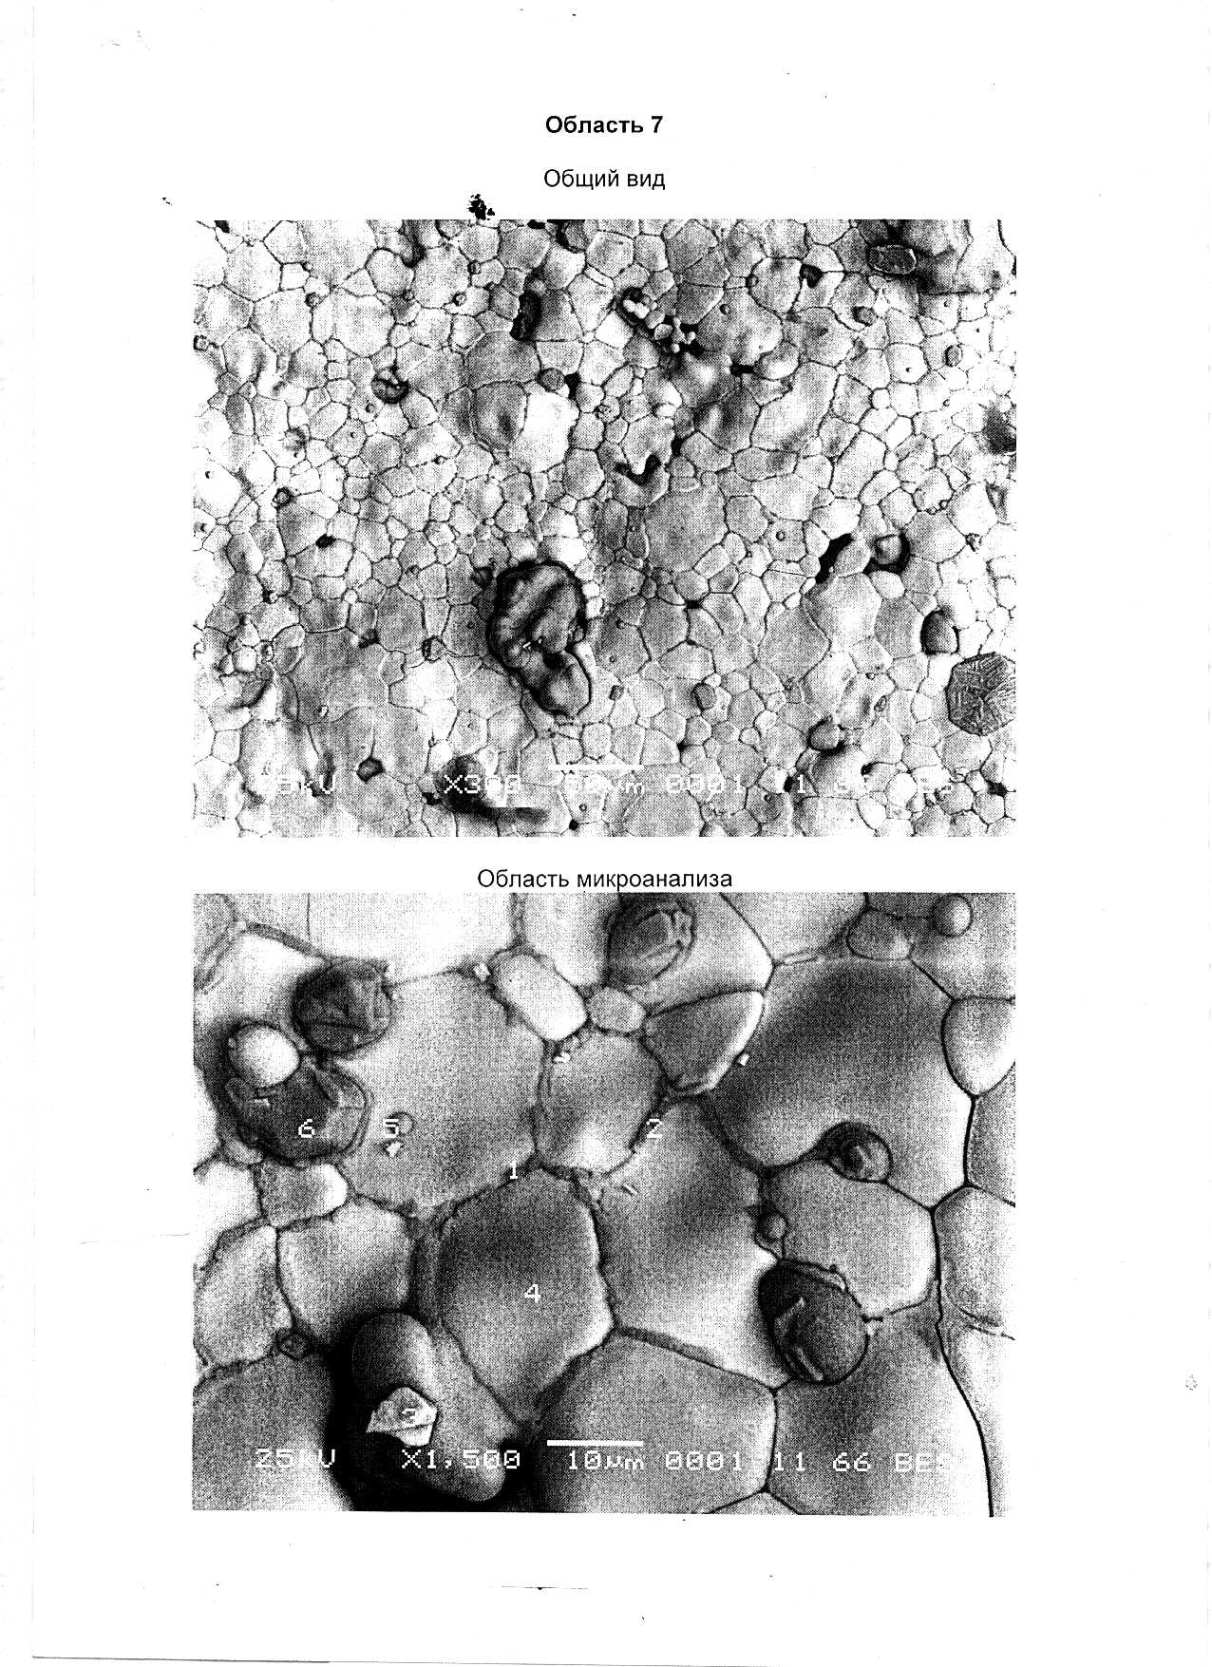

* *uniform distribution of small additives;*
* *given value of oxygen coefficient (O/U);*
* *thermally stabilized porosity;*
* *controlled grain size*

The existing technology allows introducing 10-12 fission product simulators into simfuel.



Fission product content (mass %) in uranium dioxide after burn-up of 40-80 MW day/kg U

|  |  |  |  |  |  |  |  |  |  |  |
| --- | --- | --- | --- | --- | --- | --- | --- | --- | --- | --- |
|  | Burn-up, МW⋅day/kgU | | | | The state in which  it is in fuel |  | Burn-up,  МW⋅day/kg U | | | The state in which  it is in fuel |
| 40 | 60 | 80 | | 40 | 60 | 60 |
| **Nd** | 0.44 | 0.66 | 0.92 | | **GROUP I**  They are completely dissolved in uranium dioxide | **Mo** | 0.41 | 0.61 | 0.80 | **GROUP III**  They are completely or partially (Mo) as independent metal phase; Mo is slightly dissolved in uranium dioxide |
| **Ce** | 0.34 | 0.47 | 0.59 | | **Rn** | 0.27 | 0.44 | 0.62 |
| **La** | 0.15 | 0.21 | 0.28 | | **Pd** | 0.13 | 0.27 | 0.45 |
| **Pr** | 0.13 | 0.19 | 0.25 | | **Tc** | 0.09 | 0.13 | 0.15 |
| **Sm** | 0.09 | 0.13 | 0.17 | | **Rh** | 0.05 | 0.06 | 0.06 |
| **Y** | 0.06 | 0.08 | 0.09 | | **Nb** | <0.01 | <0.01 | <0.01 |
| **Gd** | 0.01 | 0.03 | 0.07 | |  |  |  |  | **GROUP IV**  Gaseous fission products |
| **Eu** | 0.02 | 0.03 | 0.04 | | **Kr**  **Xe** | 0.05  0.062 | 0.06  0.95 | 0.08  1.28 |
| **Pm** | <0.01 | <0.01 | 0.01 | |
|  |  |  | |  | **GROUP II**  They are slightly dissolved in uranium dioxide; in the main, they are as independent oxide phase (Ba, Sr, Cs)ZrO3 |  |  |  |  | **GROUP V**  Volatile fission products  (Jr, CsJ, CsTe, etc..) |
|  |  |  |  |
| **Zr** | 0.44 | 0.61 | 0.78 | | **J** | 0.03 | 0.04 | 0.06 |
| **Ba** | 0.17 | 0.27 | 0.40 | | **Cs** | 0.34 | 0.49 | 0.62 |
| **Sr** | 0.11 | 0.15 | | 0.18 | **Te** | 0.05 | 0.09 | 0.12 |
| **Rb** | 0.04 | 0.06 | | 0.08 |  |  |  |  |
|  |  |  | |  |  |  |  |  |



Simfuel samples for investigating UO2 properties at burn-up of 60 MW day/kg U

|  |  |
| --- | --- |
| **Introduced simulators** | **Reasons for choice** |
| **GROUP I**  Nd2O3; СeO2; La2O3 | * high concentration * different effect on stoichiometry and lattice parameter |
| **GROUP II**  ZrO2; Ba; SrO | * high concentration * difference of solubility in UO2 |
| **GROUP III**  Mo, Ru, Pd | * high concentration * difference in interaction with oxygen |

The stated elements were introduced into UO2 at the rate equal to the total concentration of fission products in each group



Results of investigation into properties of simulated uranium dioxide

**(the concentration of fission products corresponds to burn-op of 60 MW day/kgU)**

* thermal conductivity decreased by 30-50 %;
* creep rate increased by a factor of 3-4;
* ultimate strength decreased by 30-40%;
* the temperature of brittle-ductile transition decreased by 10-15%

The stated changes in the UO2 properties result according to the calculational data in reducing the damage threshold of pellets from 590 J/g down to 320 J/g at pulse half width of 0.005 s.



Consequences of changes in UO2   
properties at deep burnup

* Fuel temperature condition considerably changes
* Cracking of UO2 pellet increases
* The nature of mechanical interaction with cladding changes
* Intermetallic compounds of fission products with cladding materials are formed, e.g. ZrRh, ZrRh2, ZrRh3, ZrRh4. Their solubility in α-Zr makes up 1 mass % with the lattice structure of CsCl type.

Simfuel use in tests allows taking into account these consequences and determining the fission-product yield (simulators) through cracks and other damages in the cladding



Current work on simfuel at the "Luch"

1. Improvement of simfuel technology by using nanodimensional powders of fission product simulators for approaching simfuel the full-scale state under irradiation further.
2. Improvement of simfuel technology by introducing insoluble gaseous fission products (Group IV) into UO2

CONCLUSION

In our opinion, it would be useful to apply simfuel in future projects for investigating fuel element behaviour under RIA and LOCA conditions in UO2 state at burn-up value achieved at present or at project burn-up value.



2. INVESTIGATION OF MODEL vver FUEL ELEMENTS UNDER CONDITIONS OF PROJECT accident

* Data on thermal conductivity of the gap (0.5-2.5 mm) between the core and cladding, filled by Не+Н2О mixture depending on linear power at the cladding temperature of 600-800о С have been obtained.
* Annealing of slightly-irradiated (~ 6⋅1014 neutron/сm2) untight fuel elements with the controlled oxygen potential of (-50…-450) kJ/mol of Не+Н2О medium in the gap has been performed. The following results have been achieved:
* interaction between uranium dioxide and Не+Н2О with the oxygen potential of (-50…-100) kJ/mol at annealings of 800о С for 10 hours and 1200о С for 1 hour was not observed; in the first case, a total cladding oxidation was noticed;
* relative yield of fission products made up (5-9)⋅10-4. Recoil atoms from the damaged cladding appear to be a source of fission products.



CONCLUSION

In our opinion, the obtained data show that it is useful for large-scale tests of fuel assemblies to be accompanied by tests of individual model fuel elements to understand the processes taking place during the project accident better.