**One plasmatrons tests (TOP)**

**Objectives**

* To research the temperature field around plasmatrons in prototypic corium.
* To estimate the thermal insulation effect close to real INVECOR test condition.
* To check the Zr-coating reliability in the large scale condition.

*It should be noted that one plasmatrons tests were performed due to delay in material and equipment delivery necessary for large scale tests performance.*

**1. Test TOP-1**

**1.1 Test preparation**

Graphite nozzle of outer plasmatrons electrode was coated with molten zirconium using especially designed device /see you fig. 1/. Electrode nozzle and initial zirconium were heated by graphite cylinder via irradiation heat exchange.

Initial zirconium

Electrode nozzle

Graphite cylinder

Inductor coils

Graphite lid

Inductor coils

Thermal insulation

(graphite felt)

Alumina sleeve

Graphite base

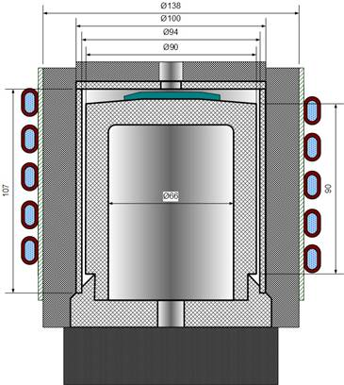

Fig. 1 Scheme of electrode coating

On the subsequent stage of coating thread was made on the lateral surface of nozzle for allowing the slower zirconium melt spreading. Part of initial zirconium in the form of wire was placed into the thread. Different ways of initial zirconium displacement are shown in fig. 2.

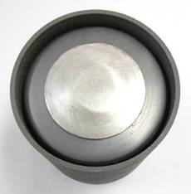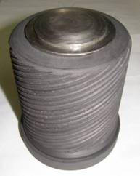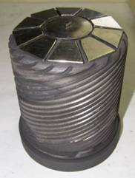

Fig. 2 Initial zirconium displacement

Results of electrode nozzles coating with smooth surface and thread are shown in fig. 3.

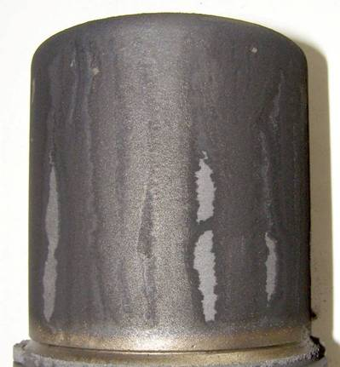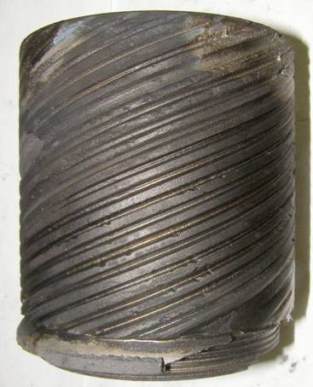

a) smooth lateral surface b) lateral surface with thread

Fig. 3 Results of electrode nozzle coating with zirconium

Coated electrode nozzle with thread was installed like plasmatrons composition into experimental assembly. Scheme of experimental cell is shown in fig. 4.

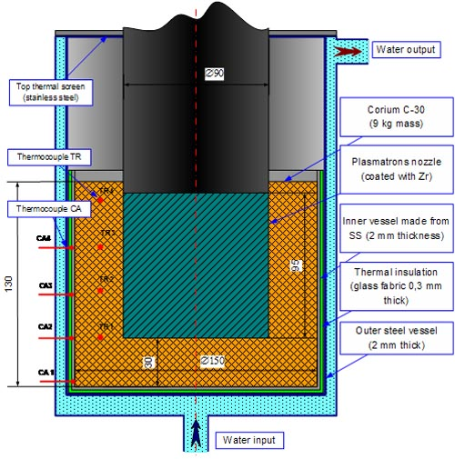

Fig. 4 Scheme of test cell for TOP-1

Two parts of outer electrode were joined via threaded connection. It should be noted that molten zirconium covered the technological thread /see fig. 5/ during the application of protective coating. It was necessary to delete this extraneous coating for possibility of joining the two parts of outer electrode. It is possible that this procedure caused the damage of Zr-coating due to fixing the covered nozzle in the lathe chuck.

Extraneous Zr-coating on the thread

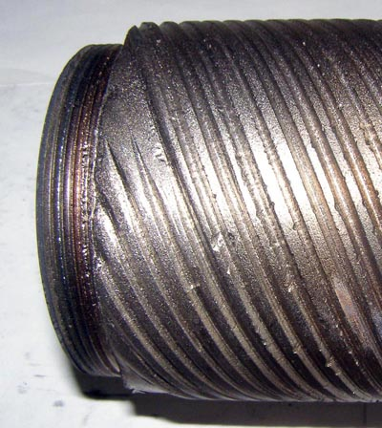

Fig. 5 Technological thread on the electrode nozzle after Zr-coating

Units of experimental cell are shown in fig. 6.

|  |  |  |
| --- | --- | --- |
|  |  |  |
| Inner vessel  (wrapped with glass fabric) | Outer (water cooled) vessel | Outer electrode of plasmatrons (wrapped with zirconium blocks) |

Fig. 6 Units of experimental cell for TOP-1

Different stages of experimental cell assemblage are shown in fig. 7

|  |  |  |
| --- | --- | --- |
|  |  |  |
| Filling of bottom part  of inner vessel | Plasmatrons  in the experimental cell | Almost finished assemblage  of experimental cell |

Fig. 7 Stages of experimental cell assemblage

**1.2 Pre-test calculation**

Pre-test calculation showed that maximum temperature of plasmatrons units is about 3400 K at electrical power of plasmatrons 18 kW supposing that plasmatrons is dipped into corium with temperature of 3100 K. Temperature of copper part of plasmatrons is lower than 1250 K. About 80% of plasma energy is transferred to outer electrode. Temperature field in the plasmatrons is shown in fig. 8. Fig. 9 presents the temperature field in the experimental cell.

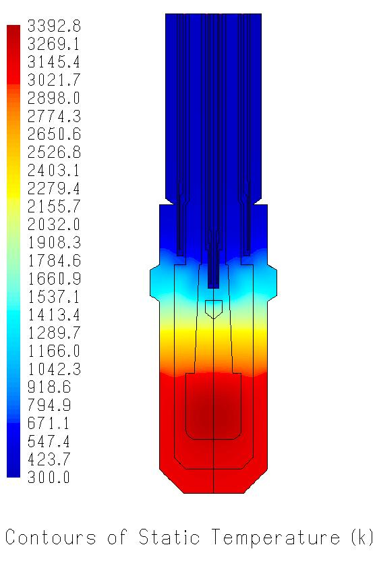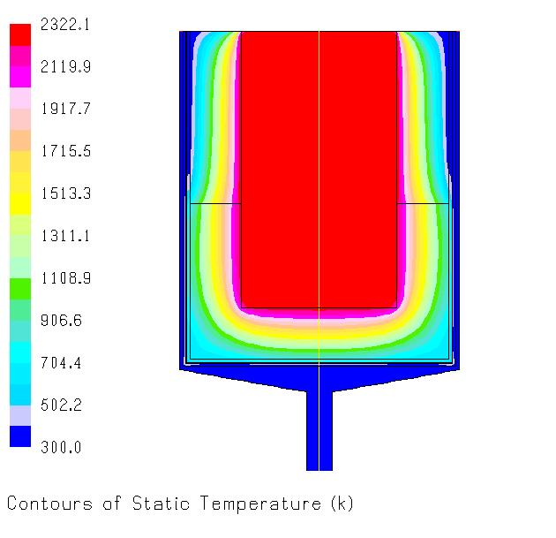

Fig. 8 Temperature field in plasmatrons Fig. 9 Temperature field in experimental cell

**1.3 Test performance**

Test TOP-1 was performed during 1 hour. Electrical power of plasmatrons was about 17 kW. Measured temperature history on the wall of the inner vessel is shown in fig. 10.

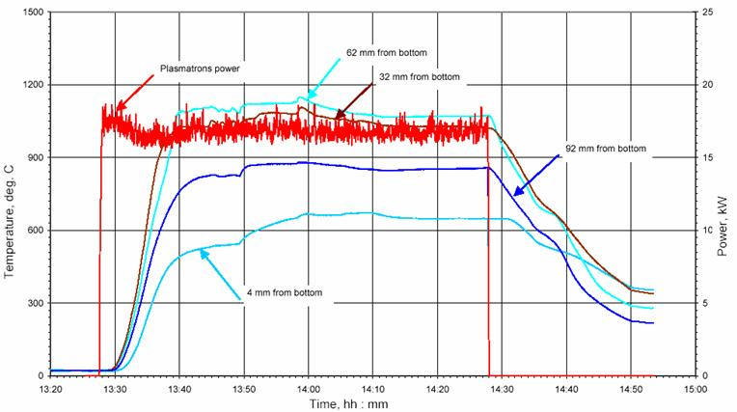

Fig. 10 Measured temperatures on the lateral wall of the inner vessel

The hottest zone of inner vessel wall was heated up to 1150 deg. C what was significantly higher than predicted temperature.

Measured temperature inside corium at a distance 10 mm from sidewall of inner vessel was about 2100 deg. C /see fig. 11/. Unfortunately the thermocouples in the hottest zone were damaged in 10 minutes after start of heating.

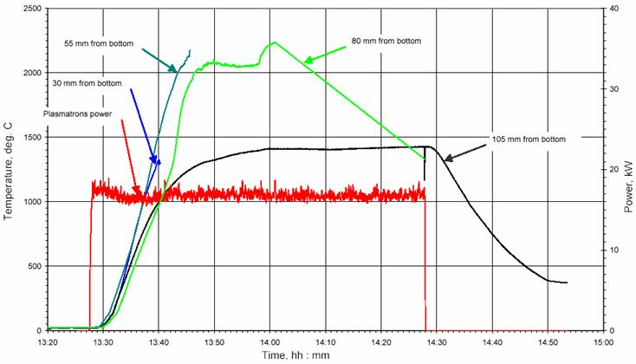

Fig. 11 Temperature of corium

Calculation of energy balance considering the cooling water parameters showed that not less than 83% of plasma energy was supplied to corium.

**1.4 Results of post-test research**

Fig 12 presents the different stages of experimental cell disassembling.

|  |  |  |
| --- | --- | --- |
|  |  |  |
| a) Top screen is removed | b) Copper part of plasmatrons  is removed | c) Inner vessel is extracted  from experimental cell |
|  |  |  |
| d) Upper part of outer electrode is removed | e) Bottom view of inner vessel | f) Inner electrode outside view |

Fig. 12 Stages of experimental cell disassembling

It is seen that most part of corium components was caked inside inner vessel. Large burnout (about 25 mm in diameter) was found in the bottom of inner vessel /fig. 12 e/.

Erosion of inner (expendable) electrode of plasmatrons is not large. Thus, test duration at similar condition could be prolonged not less than up to 2 hours.

Inner vessel was cut in the diametric plane. Previously it was filled with molten sulfur to hold the non-caked particles inside vessel. The section plane view is shown in fig. 13.

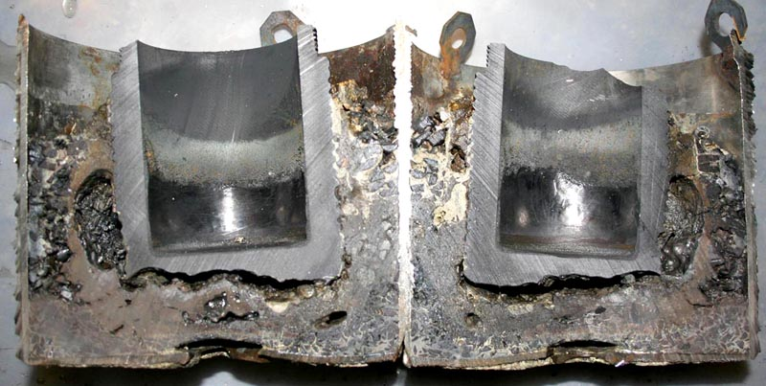

Fig. 13 Section plane of inner vessel with caked corium

It was found large erosion on the bottom and lateral part of electrode from the site of corium. Large voids are seen in the regions of electrode erosion. Erosion of graphite from the site of plasma burning absents almost fully. Brown colored solidified melt rounds the electrode /fig. 14/. This material looks like solid solution of urania and zirconia.

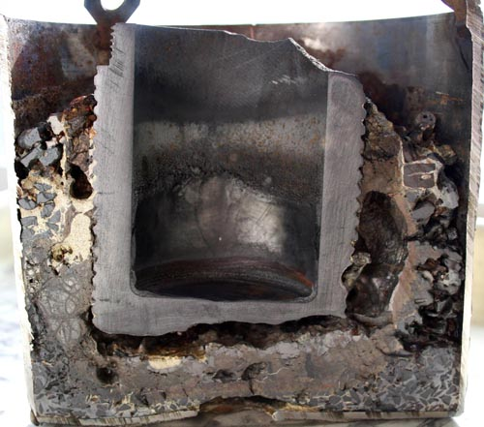

Fig. 14 Section plane close-up view

Samples of solidified melt were taken for subsequent phase analysis. Scheme of sampling is shown in fig. 15.

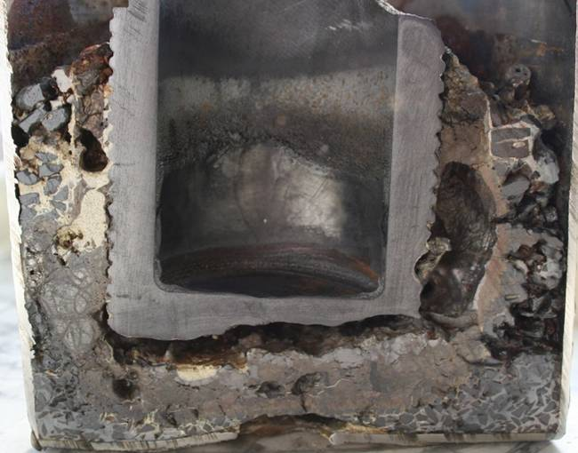

S-2

S-7

S-1.1

S-3

S-4.2

S-4.1

S-6

S-5

S-9

S-4.3

Fig. 15 Scheme of solidified melt sampling

Main phases of chosen samples are solid solutions (U,Zr)O2-X with face-centered lattice and phases of variable composition like Zr(U)(C,O,N). Results of qualitative phase analysis are presented in Table 1.

Table 1 Phase composition of chosen samples of solidified melt

|  |  |  |  |
| --- | --- | --- | --- |
| Sample | Main phases | | Other phases |
| S1.1 | U0.6Zr0.4O2, UO2 | Zr(O,C), Zr(N,O,C) | ZrO2 |
| S1.2 | U0.6Zr0.4O2, U0.9Zr0.1O2 | Zr(O,C), Zr(N,O,C) | ZrO2 |
| S2 | U0.75Zr0.25O2, U0.6Zr0.4O2 | Zr(U)(O,C,N), Zr(N,O,C), (U,Zr)(O,C,N) | α-Zr(O) |
| S3 | UO2, U0.6Zr0.4O2 | - | ZrO2(monoclinic) |
| S4.1 | U0.8Zr0.2O2 | U(Zr)(C,O,N)−Zr(U)(C,O) | UC2 |
| S4.2 | U075Zr0.25O2, U0.6Zr0.4O2 | (Zr(O,C), (U,Zr)(O,C,N), Zr(N,O,C) | - |
| S4.3 | U0.6Zr0.4O2), (UO2), (U0.9Zr0.1O2) | Zr(O,C), Zr(N,O,C), (U,Zr)(O,C,N) | - |
| S6 | U075Zr0.25O2 | (U,Zr)(C,O,N)−Zr(C,O) | UC2 |
| S7 | U0.75Zr0.25O2, UO2 | ZrC, (U,Zr)(C,O,N)−ZrC | UC2 |
| S8 | U0.65Zr0.35O2, U0.8Zr0.2O2 | Zr(O,C), ZrC | - |
| S9 | U0.75Zr0.25O2 | ZrC, (U,Zr)(C,O,N)−ZrC | - |

Note. Content of oxygen in the solid solution was not defined exactly. More correct formula is (UA,ZrB)O2-X.

As polished sample S-5 /fig. 16/ presents the different stages of UO2 pellets dissolution in the molten zirconium.

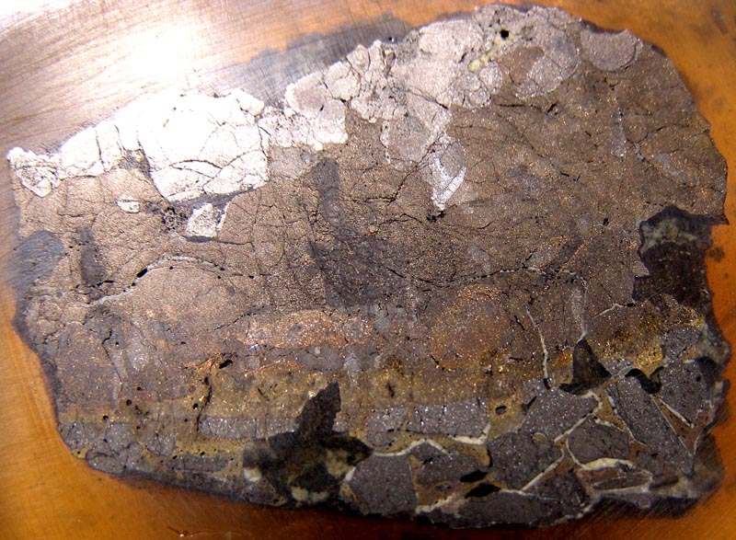

Fig. 16 Surface of polished sample S-5

**1.5 Conclusion on TOP-1**

1) Electrical power of 17 kW is enough for melting zirconium and dissolution of UO2 pellets.

2) Most likely cause of electrode erosion was mechanical treatment of the technological thread in the turning lathe (jam of electrode nozzle after coating application in the lathe chuck). Other words, protective coating (an a part of nozzle) was damaged before test. Thus, it is necessary to change the nozzle design to avoid the mechanical treatment of this unit after Zr-coating application.

3) It is desirable to elevate the thermal insulation in the upper part of experimental cell due to variable profile of energy release in plasmatrons along the height.

4) It is desirable to increase the initial loading mass of corium components up to 12 kg to imitate the real INVECOR test (60 kg of corium for 5 plasmatrons)

5) It is desirable to prolong the test duration up to 2 hours to check the planned duration of INVECOR integral tests.

**2. Test TOP-2**

**Objectives**

* To check the Zr-coating reliability on the electrode nozzle of changed design.
* To increase the initial loaded corium mass up to 12 kg.
* To prolong the test duration up to 2 hours.
* To increase the thickness of bottom layer of corium to avoid the inner vessel burnout.
* To improve the thermal insulation in the upper part of inner vessel lateral wall.

**2.1 Test preparation**

Design of lower part of outer electrode nozzle was changed as id is shown in fig. 17.

Technological thread for joining with upper part of electrode

Fig. 17 Design of lower part of outer electrode for TOP-1 (left) and for TOP-2 (right)

New design of electrode allowed to avoid the molten zirconium spreading on the technological thread during the Zr-coating process. Scheme of experimental cell is shown in fig. 18 and fig. 19.

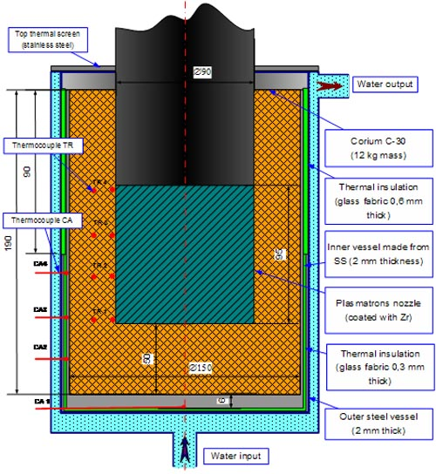

Fig. 18 Scheme of experimental cell for TOP-2

Main differences compared with TOP-1 are:

* Initial loading mass was increased up to 12 kg.
* Thickness of bottom layer of initial corium was increased up to 50 mm.
* Upper part of inner vessel (90 mm height) was wrapped with 2 layers of glass fabric.
* Thickness of the inner vessel bottom was increased up to 10 mm.
* Main part of initial zirconium was distributed along the total loading mass in the form of fine chips.
* BN-350 blanket pellets on the base of depleted uranium were used in the corium composition.
* Additional thermocouple was installed on the bottom of inner vessel.
* Two disks made from zirconium were installed into experimental cell for fixing of plasmatrons and thermocouples position in the experimental cell (fig. 19).

Glass fabric

Centering Zr rings

UO2 (pellets)

ZrO2 (powder)

Zr (chips)

Electrode nozzle protected with Zr

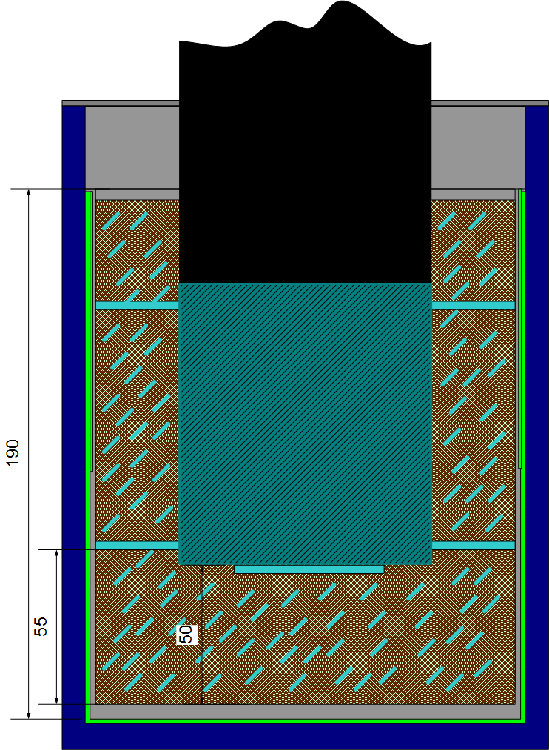

Fig. 19 Scheme of experimental cell loading for TOP-2

Lower part of outer electrode used in TOP-2 and protected with Zr-coating is shown in fig. 20.

|  |  |
| --- | --- |
|  |  |
| a) Nozzle covered with  Zr-protection | b) Assembly of two parts of outer electrode |

Fig. 20 Preparation of electrode nozzle

View of inner vessel is shown in fig. 21.

|  |  |  |
| --- | --- | --- |
|  |  |  |
| a) Vessel equipped with thermocouples | b) Vessel wrapped with glass fabric | |

Fig. 21 Inner vessel preparation

Fig. 22 presents the different stages of experimental cell preparation.

|  |  |  |
| --- | --- | --- |
|  |  |  |
| a) Initial loading | b) Experimental cell in the test facility | c) Almost assembled  experimental cell |

Fig. 22 Experimental cell preparation

**2.2 Pre-test calculation**

Predicted temperature field in the experimental cell for TOP-2 considering the results of TOP-1 test is shown in fig. 23.

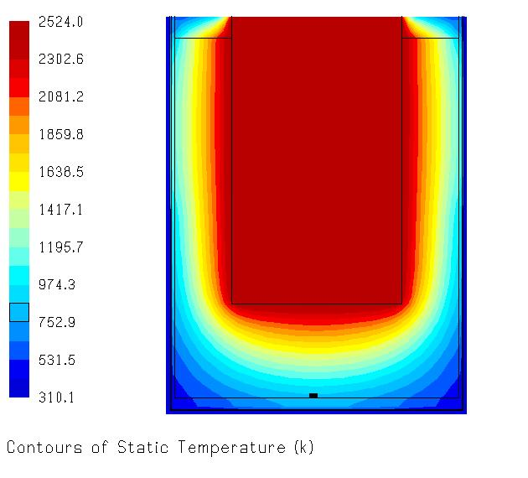

Fig. 23 Pre-calculated temperature field in experimental section TOP-2

Calculated rate of temperature increase in different points of experimental cell is shown in fig. 24.

0

500

1000

1500

2000

2500

3000

0

200

400

600

800

1000

1200

1400

1600

1800

Time, seconds

Temperature, K

Surface of plasmatrons

Corium on the level of 20 mm from the inner vessel bottom

(under electrode end face)

Corium near the inner vessel bottom

Corium on the radius of 65 mm

(in the middle of experimental cell)

Corium near the inner vessel lateral wall on the center level

Fig. 24 Predicted temperature history in experimental cell

**2.3 Test performance**

Test duration was almost 2 hours. Electrical power of plasmatrons was kept about 16,5 kW. Scheme of thermocouples location is shown in fig. 25. Measured temperatures in different points of inner vessel wall are shown in fig. 26.

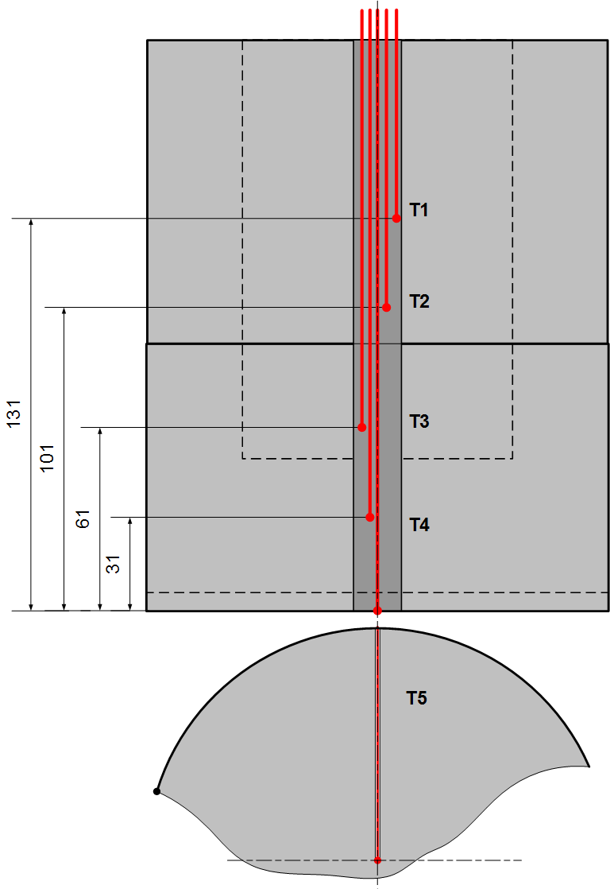

Fig. 25 Thermocouples location on the wall and bottom of the inner vessel

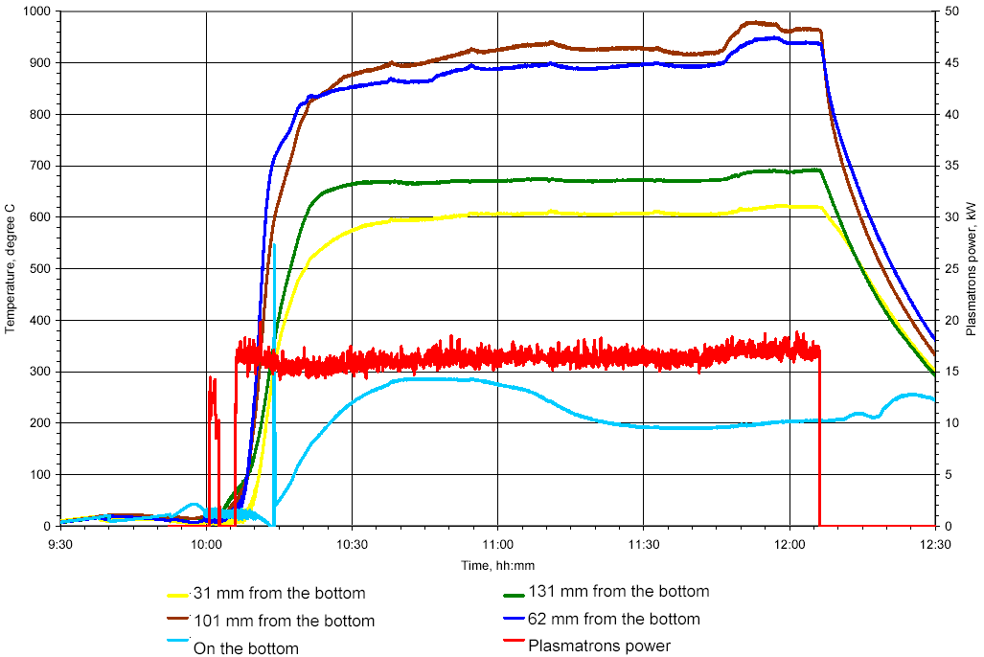

Fig. 26 Temperature history in different points of inner vessel wall

Temperature of corium was measured using tungsten-rhenium thermocouples installed around the plasmatrons on the equal distance between plasmatrons and inner vessel walls (i.e. on the distance of 15 mm from the lateral site of plasmatrons) /fig. 27/. Temperature plot of corium is shown in fig. 28.



Fig. 27 Thermocouples location in the corium loading

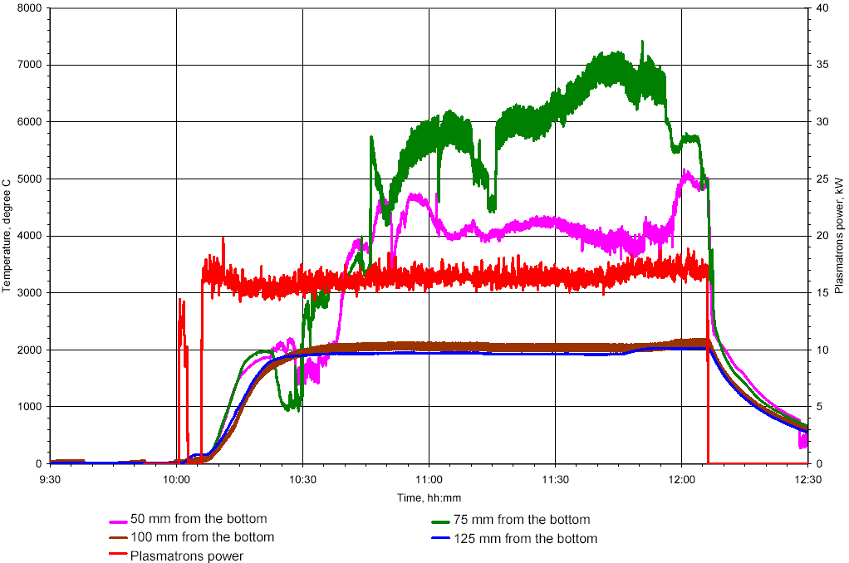

Fig. 28 Temperature history in the corium

It is clearly that thermocouples installed on the distance 50 mm and 75 mm from the bottom of inner vessel were damaged during the test. Thermocouples installed at more high position indicated temperature about 2000 degree C.

**2.4 Results of post-test research**

Plasmatrons with partly caked corium was removed easy from the inner vessel during experimental cell disassembling /fig. 29/.

|  |  |  |
| --- | --- | --- |
| a) inner vessel with plasmatrons | b) upper layer of loading was removed | c) view of lateral wall of inner vessel after glass fabric removal |

Fig. 29 Sequence of experimental cell disassemble

|  |  |  |
| --- | --- | --- |
| e) extraction of plasmatrons with caked corium from the inner vessel | f) view plasmatrons with caked corium | g) view of inner surface of the inner vessel |

Fig. 29 Sequence of experimental cell disassemble (continued)

Caked corium was separated easy from the lateral surface of plasmatrons /fig. 30/.

|  |  |
| --- | --- |
|  |  |
|  |  |

Fig. 30 Removal of caked corium from the lateral surface of plasmatrons

It was found that protective coating remained on the electrode nozzle surface but transformed into yellow colored loose layer. Centering Zr rings were not melted during the test. The protective coating was divided from the graphite surface /fig. 31/ without efforts.

|  |  |
| --- | --- |
|  |  |

Fig. 31 Separation of protective coating from the graphite surface

Lower part of corium /fig. 32/ looked like once melted ingot. It was separated from the electrode end face with some efforts. Maximum thickness of the ingot was approximately 30 mm.

|  |  |
| --- | --- |
|  |  |

Fig. 32 View of lower corium ingot.

Samples of solidified corium melt for a phase analysis were taken correspondently to scheme in fig. 33. Results of phase analysis are given in Table 2.

|  |  |
| --- | --- |
| **S5**  **S6**  **S7**  **S8**  **Pellet UO2** |  |
|  |  |

Fig. 33 Scheme of sampling

Table 2 Results of X-Ray phase analysis

|  |  |  |
| --- | --- | --- |
| Sample | Main phases | Other phases |
| S5 (top of ingot) | **U0,9Zr0,1O2** | **α-Zr(O)**, Zr(O,C) |
| S6 (middle of ingot) | **U0,9Zr0,1O2** | **α-Zr(O)**, Zr(O,C) |
| S7 (bottom of ingot) | **UO2,** U0,8Zr0,2O2 **−** U0,4Zr6O2 | **α-Zr(O)**, Zr(O,C) |
| S8 (interface between electrode face end and top of corium ingot) | **U0,9Zr0,1O2** | **α-Zr(O)**, Zr(O,C) |

It was not found increased contents of zirconium carbide in the surface sample taken from interface between electrode and solidified corium ingot (samples S5 and S8 showed practically identical composition). Probably, the initial thickness of Zr-coating on the electrode face end was very thin due to excellent spreading of molten zirconium along the graphite surface.

Cross section of corium ingot /fig. 34/ showed that corium in this zone was fully melted during the test. It has very low porosity and looks rather homogeneous.

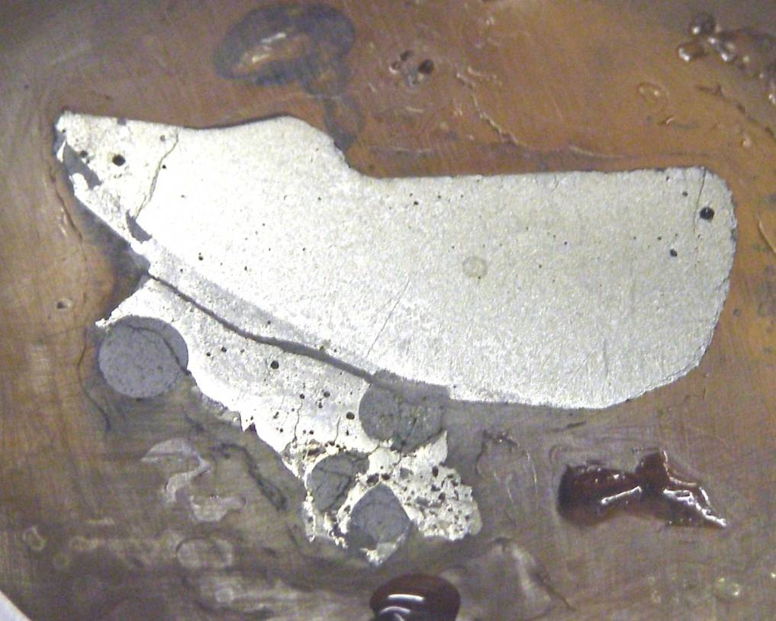

Fig. 34 Corium ingot cross section

**2.5 Conclusion on TOP-2**

1) Electrical power of plasmatrons was approximately 16,5 kW (i.e. for 0,5 kW lower compared with test TOP-1)

2) Temperature of the lateral wall of inner vessel was markedly different compared with TOP-1.

3) Main energy release has the place in the bottom direction.

4) Corium under plasmatrons end face was melted fully on the depth of approximately 30 mm.

5) A between electrode statements of plasmatrons showed that test duration at obtained condition may be longer 2 hours (erosion of inner electrode is not dramatic).

6) Protective coating on the outer electrode surface showed high reliability during 2 hours in spite of separation of remained coating after test finishing and experimental cell disassembly.

**3. Test TOP-3**

**3.1 Test preparation**

**Objectives**

* To specify the temperature field around plasmatrons in prototypic corium.
* To enhance the thermal insulation effect on the lateral wall of inner vessel.
* To continue the checking of the Zr-coating reliability in the large scale condition.

Stages of electrode nozzle preparation are shown in fig. 35.

|  |  |  |
| --- | --- | --- |
|  |  |  |
| a) Initial unit | b) Setting of initial zirconium | c) Nozzle after heating in small-scale facility |

Fig. 35 Electrode nozzle coating with zirconium

View of inner vessel is shown in fig. 36.

|  |  |  |
| --- | --- | --- |
|  |  |  |
| a) Vessel equipped with thermocouples | b) Close-up view of thermocouples in grooves | c) Inner vessel wrapped with glass fabric |

Fig. 36 Inner vessel preparation

Thermocouples were traced into separate unlike of TOP-1 and TOP-2 tests where thermocouples were traced in the common rolled groove. The outer diameter of inner vessel was decreased for 1 mm to increase the thermal resistance.

Scheme of experimental cell was analogous to test TOP-2 /fig. 18, 19/.

Fig. 37 presents the different stages of experimental cell preparation.

|  |  |  |
| --- | --- | --- |
|  |  |  |
| a) Electrode nozzles with centering Zr-ring | b) Filling of bottom layer  of initial corium | c) Almost assembled  experimental cell |

Fig. 37 Experimental cell assembly

The shape of centering Zr-rings was changed compared with TOP-2 test to diminish the contact surface between outer surface of plasmatrons and inner vessel wall.

3.2 Test performance

Test duration was about 2 hours at plasmatrons electrical power approximately 16 kW. Cooling water flow rate into copper part of plasmatrons was decreased from 180 g/s to 80 g/s. It allowed to decrease slightly the non-productive heat losses. The space in the experimental facility was filled with nitrogen (without preliminary argon gas supply) for estimation of nitrogen influence on researched processes. Measured temperatures in different points of inner vessel wall are shown in fig. 38. Layout of thermocouples location was similar to test TOP-2.

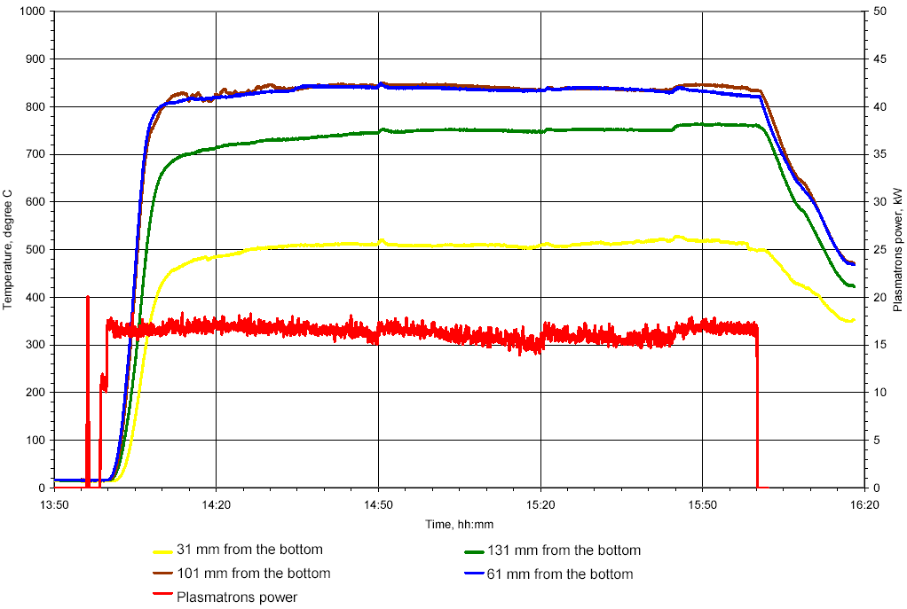

Fig. 38 Temperature history in different points of inner vessel wall

Fig. 39 presents the temperature field in the corium (it should be noted that thermocouples positions in corium are some different from test TOP-2).

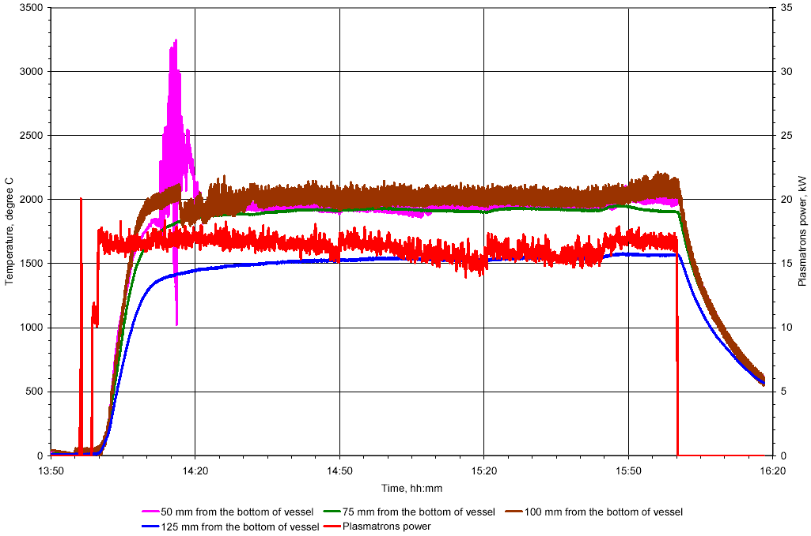

Fig. 39 Temperature history in the corium

It was found during the test that electric power of plasmatrons depends of gas pressure in the experimental facility.

**3.3 Results of post-test research**

Outside view of experimental cell after test was similar to test TOP-2. Nevertheless, it was solved to cut the inner vessel for more clear observation of heating results. Stages of experimental cell disassemble are shown in fig. 40.

|  |  |  |
| --- | --- | --- |
|  |  |  |
| a) Top screen was removed | b) Plasmatrons view without bottom (removable) part of outer electrode | c) Inner vessel wrapped with glass fabric |
|  |  |  |
| d) Inner vessel without glass fabric | e) Top view of inner vessel after non-caked loading removal |  |

Fig. 40 Sequence of experimental cell disassemble

Inner vessel with corium preliminary filled with molten sulfur was cut in the vertical direction /fig. 41/.

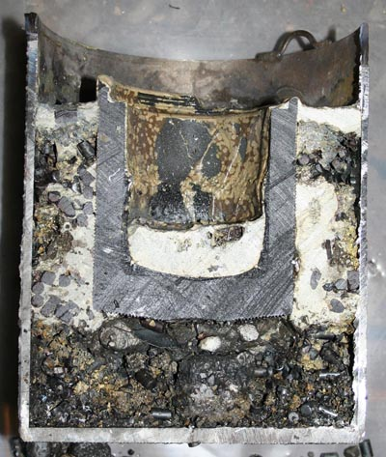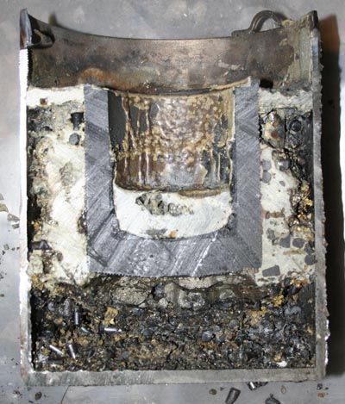

Fig. 41 Section plane of inner vessel

Solidified corium ingot under electrode face end was very fragile and cracked partly during the cutting process.

Phase analysis of solidified corium melt is in progress.

**3.4 Conclusion on TOP-3**

1) Slightly changed test condition did not lead to some progress in corium melting.

2) Usage of nitrogen for test facility filling caused the high fragility of solidified corium melt.

3) Protective Zr-coating on the electrode nozzle surface kept integrity and prevented graphite erosion durin the test.

Other conclusions will be finally formulated after post-test research finishing.

**4. Summary**

It is necessary to increase the electric power of plasmatrons to 18 kW at least. One limitation of power increase is the upper limit by maximum current of rectifiers used for plasmatrons power supply. Plasmatrons electrical power may be increased via search of optimal plasmatrons nozzles design.

It is necessary to find the way to reduce the influence of pressure in the test facility pressure vessel on the electrical power of plasmatrons.

Other conclusions will be finally formulated after post-test research finishing.