**Information letter**

**Experiment PARAMETER-SF2**

Second stage of the work under ISTC Project # 3194

“Preparation and conduct of the model of a 19-fuel element FA of VVER-1000 under simulated conditions of a severe accident including high rate combined flooding of the model assembly from the top and bottom”

According to the Work Plan for ISTC Project # 3194 the test of VVER-1000 model FA made up of 19 fuel rods was performed on 03.04.2007 under simulated conditions of a severe accident including high rate combined flooding of the model assembly from the top and bottom (PARAMETER-SF2).

Experiment PARAMETER-SF2 included the preliminary and main stages.

1) During the preliminary stage the assigned parameters were set up for the steam and argon flow rate at the inlet of the test section: steam flow rate (Gst in) was about 3.5±0.1 g/s at temperature (Tst in) - about 500±25 °С, argon flow rate (Garg in) was about 2.0±0.1 g/s at temperature (Targ in) - about 400±20 °С (see Fig. 1).

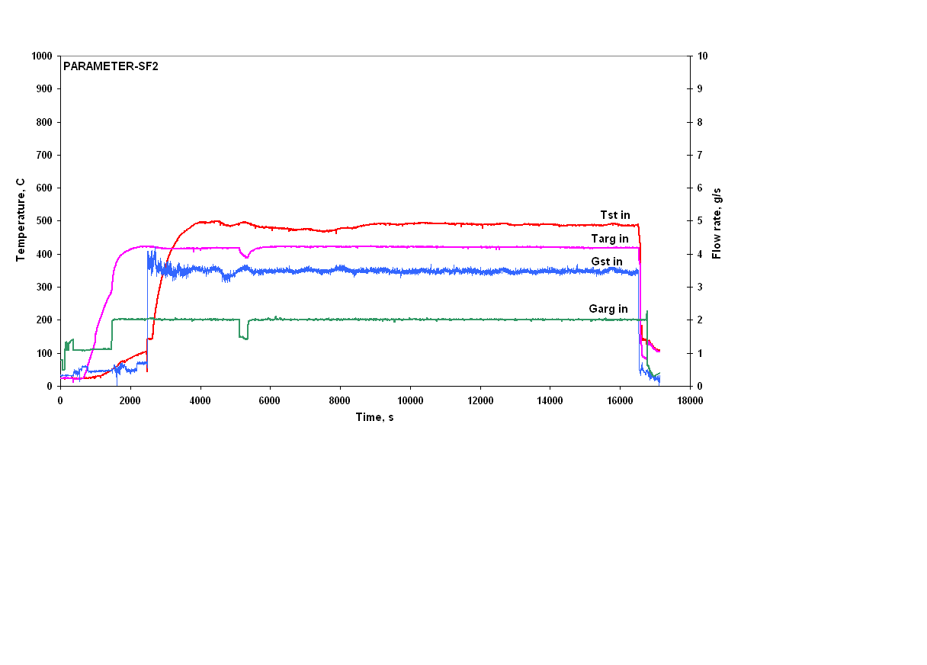

Fig. 1.

2) After stabilization of the fuel rods claddings temperatures at 500°С the supplied electric power (Р) had been increased to ~ 8.2 kW (Fig.2), temperatures of fuel rods claddings have reached values of 12001250 °С (according to thermocouples readings) in the hottest cross-section of the assembly (at the elevation of Z=1250 mm). The preoxidation phase began.

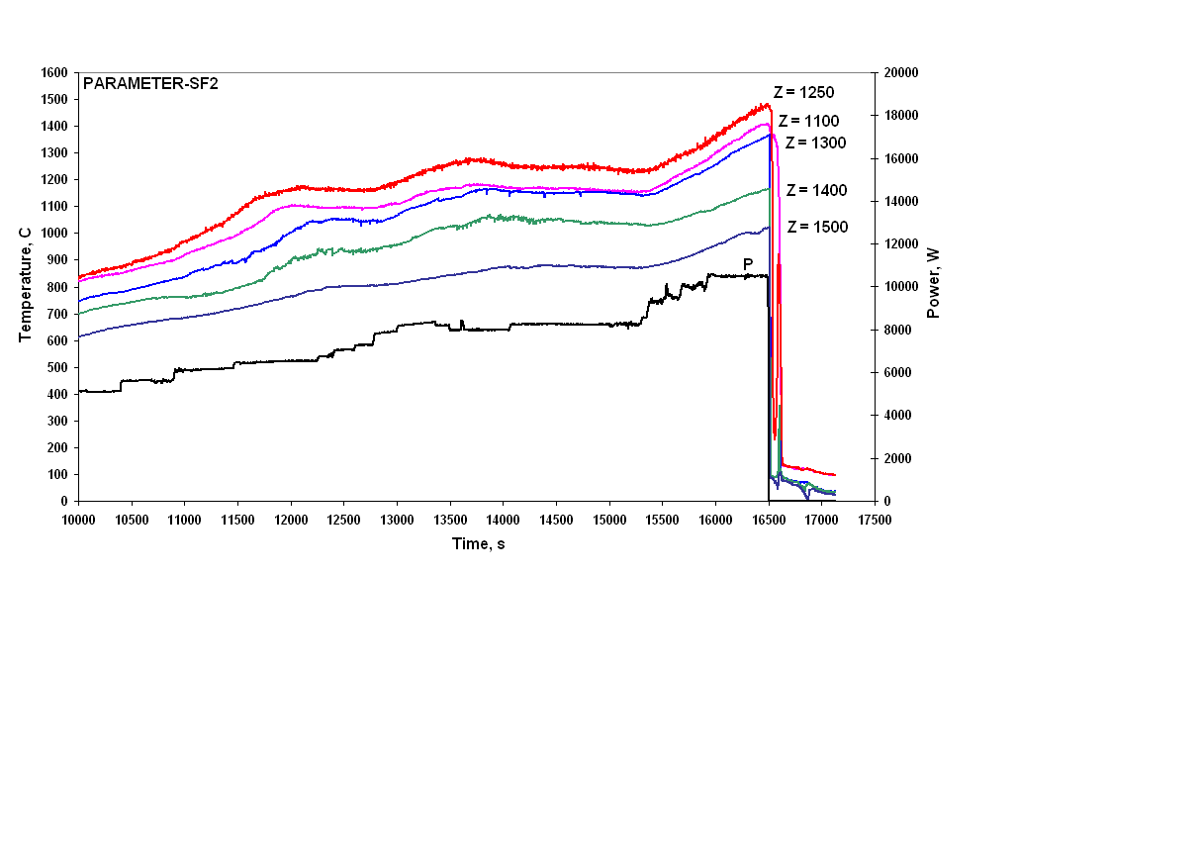

Fig. 2.

After annealing of the bundle at the temperature of ~1200 °С for ~ 3500 s, at the end of the pre-oxidization phase the electric power of the assembly was increased to ~ 10.5 kW to start the transient phase. The heat up rate during the transient phase was ~ 0.2 K/s   
(Fig. 2).

After the assigned fuel rods claddings temperatures of ~1500°С in the hottest cross-section was reached, the electrical power was switched off and steam supply was stopped. Then the system of top flooding was switched on at the average water flow rate of ~ 41 g/s. The indications of the flowmeter R3 – Gtf(R3) are presented in Fig 3. When the fuel rods claddings temperatures at the elevation of Z = 1250 mm decreased below ~ 700°С (in ~ 26 s) the bottom flooding system was switched on, at the average water flow rate of ~ 130 g/s according to the flowmeter readings R2 – Gbf(R2) (Fig. 3-6).

|  |
| --- |
|  |
| Fig. 3. Z = 1500 – 1300 mm. |
|  |
| Fig. 4. Z = 1250 mm. |
|  |
| Fig. 5. Z = 1100 mm. |
|  |
| Fig. 6. Z = 0 – 900 mm. |

Water injection into the assembly during top flooding (before starting of bottom quenching) resulted in

- quick (within the first 10 s of the beginning of flooding) cooling of the claddings to the temperature ~100°С at the elevations of Z = 1500 –1300 mm (Fig. 3);

- cooling the fuel rods claddings to the temperature of ~ 200 - 700 °С at the elevation of Z = 1250 mm for~ 40 s (Fig. 4).

No effect of the top flooding on temperature behaviour of the claddings of the fuel rods of the second and third rings at the elevation of Z = 1100 mm was recorded by the thermocouples (Fig. 5).

Water supply into the assembly during combined top and bottom flooding resulted in successive cooling of the claddings at the elevations of Z = 0 - 1100 mm. The front of cooling to temperature ~150°С moved up from the elevation of Z = 0 mm to the elevation of Z = 700 mm at the rate of ~ 90 mm/s, and from the elevation of Z = 700 mm to the elevation of Z = 900 mm at ~ 5 mm/s (Fig. 6).

In the course of the experiment the pressure jumps (Pbnl) in the assembly, caused by steam generation process, were recorded:

- to ~ 0.4 MPa within~ 20 s, in ~ 2 s after starting of the top flooding (Fig. 7);

- to ~ 0.6 MPa within~ 50 s, in ~ 50 s after starting of the bottom flooding (Fig. 7).

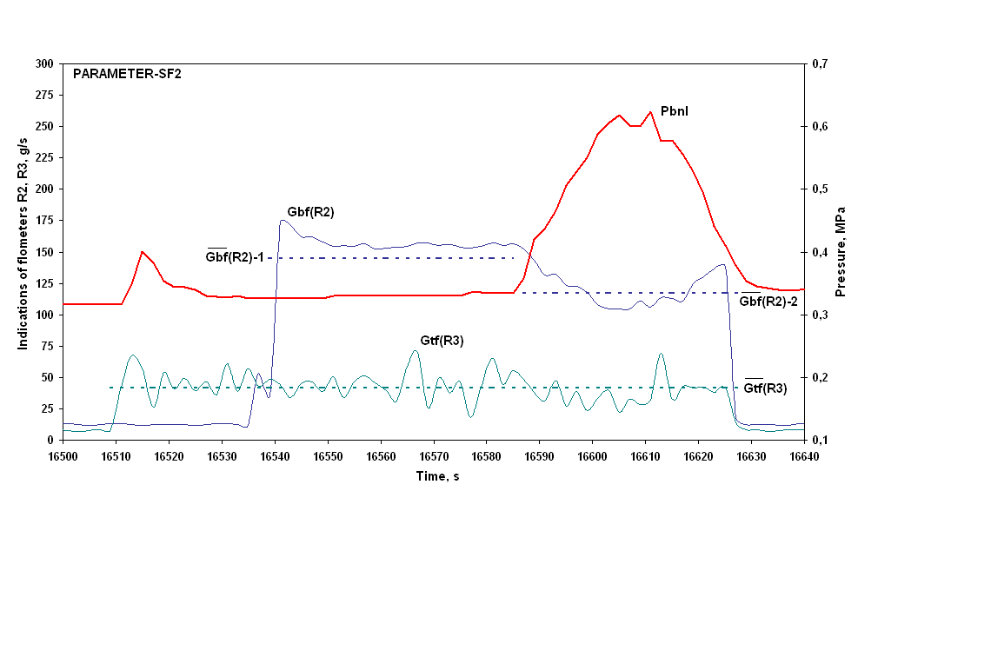

Fig. 7.

Bottom flooding resulted in steam had been generated intensively in the lower part of the assembly and the top flooding water have been ejected through off-pipe, and finally repeated temperature increasing have followed in the upper part of the test section:

- to ~500°С at the elevation of Z = 1300 mm (Fig. 8);

- to ~1000°С at the elevation of Z = 1250 mm (Fig. 9).

|  |
| --- |
|  |
| Fig. 8. Z = 1500 - 1300 mm. |
|  |
| Fig. 9. Z = 1250 mm. |

In the course of the experiment two hydrogen content measuring systems were used (Fig. 10): continuous – SOV-3 and discrete - sampling system (8 test samples), which recorded the hydrogen generation at the preoxidization phase (6 test samples) and at the transient phase (2 test samples).

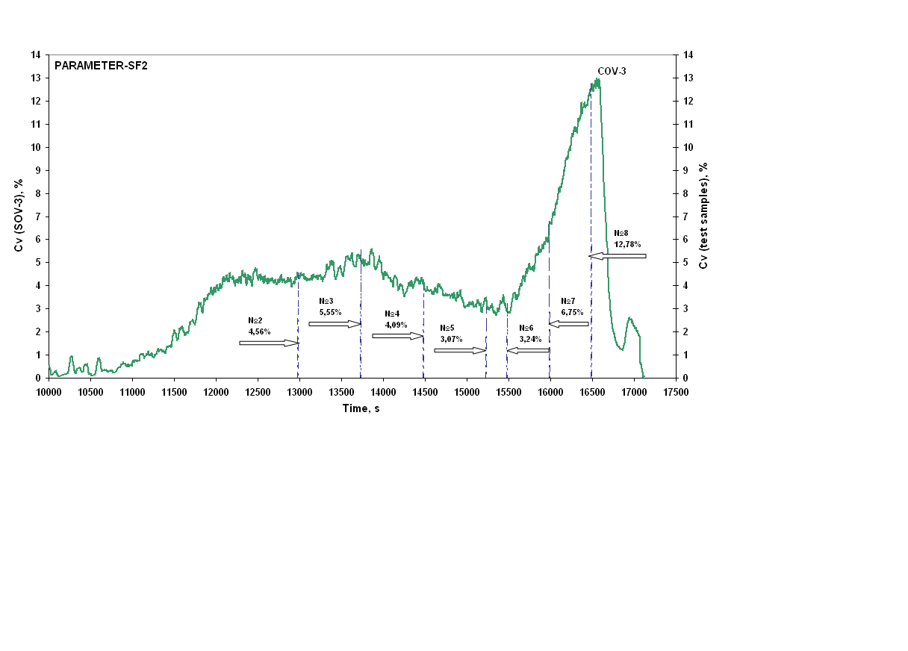

Fig. 10.

Results of preliminary processing of the indications of hydrogen content measuring system SOV-3, considering the analysis of test samples, showed that the total amount of the generated hydrogen did not exceed ~28 g.

At present the assembly SF2 is under preservation for the subsequent material study.