

|  |  |
| --- | --- |
| FSUE SRI SIA "LUCH"  IBRAE RAS  OKB "GIDROPRESS" | I S T c |

Study of Fuel Assemblies with Boron Carbide

Absorber Rods under Severe Accident Conditions

in PARAMETER-SF Test Series

Proposal on the ISTC Project



**The proposal under Project #3936 has been considered at:**

* **14th International QUENCH-Workshop 4-6 November, 2008, FZK, Karlsruhe, Germany;**
* **15th CEG-SAM Meeting, Villigen, Switzerland 10-12 March, 2009**



Objective:

The study of behaviour of two 18-rod VVER-1000 simulative fuel assemblies (FA) completed with standard reactor materials (constructional, fuel, and absorber elements on the basis of B4C) under severe accident conditions at the top flooding

material interaction



**Formation of low-temperature eutectics**

* **Zr+Fe → 950оC**

**Beginning of FA melting at T ≥ 1250oC**

* **B + Fe →1130-1150оC**
* **Zr + 42XHM → 1227оС**

**Formation of chemical compounds**

**An example for mixture: 80%В4С+10%Н2О+10%Fe, ΣР = 3 atm.**

|  |  |  |
| --- | --- | --- |
| **1500оС** | **1000оС** | **cladding embrittlement** |
| **=2.7 atm.** | **=2.9 atm.** |
| **В2О3 - 11 mass %** | **В2О3 - 13 mass %** |
| **Fe3C - 10 mass %** | **Fe3C - 10 mass %** |
| **В4С - 75 mass %** | **В4С - 74 mass %** |

**Interaction in UO2-H2O-Zr system**

|  |  |
| --- | --- |
| **3UO2 +2H2O = U3O8 + H2(T < 700oC)** | **UO2 lattice parameter change** |
| **U3O8 ⇒ UO2.2 (T > 700oC)** |
| **yUO2 +xZr = xZrOy + yUO2-x** | **liquid UxZr1-x at Т ≥ 1000оС** |
| **(2+x)UO2 + (1-x)Zr = UxZr1-x + 2UO2+x** |



Main project tasks

**Task 1. The first year of the project**

**The study of a change in the structure of the materials of VVER-1000 fuel assembly with an absorber element, heated up to a temperature of less than 1250oC at the initial stage of a severe accident at the top flooding of the assembly (PARAMETER-SF5):**

* **Preparation and carrying out of PARAMETER-SF5 experiment**
* **Post-test material-scientific analysis**
* **Processing of PARAMETER-SF5 experiment results**

**Task 2. The second year of the project**

**The study of a change in the structure of the materials of VVER-1000 fuel assembly with an absorber element, heated up to a temperature of less than 1450oC at the initial stage of a severe accident at the top flooding of the assembly (PARAMETER-SF6):**

* **Preparation and carrying out of PARAMETER-SF6 experiment**
* **Post-test material-scientific analysis**
* **Processing of PARAMETER-SF6 experiment results**
* **Preparation and release of a final report**



technical approach and methodology, codes

**The methodology of realizing the project tasks includes the following main stages:**

**Preparation and carrying out of the experiment:**

* **Developing the program of experiment and its principal tasks;**
* **Developing a computational model and performing calculations of modes and parameters of the experiment tests on the basis of computational codes (SOCRAT/B1, PARAM-TG, ТЕЧЬ-М, RELAP/SCADSIM, ICARE-CATHARE);**
* **Fuel assembly installation and erection and preparation of technological systems of a rig for carrying out the experiment;**
* **comprehensive starting-adjustment works;**
* **Carrying out the experiment**

**Post-test material-scientific analysis:**

* **Cutting of the fuel assembly subjected to the tests during the experiment to fragments, and template preparation;**
* **Optical and electronic microscopy;**
* **X-ray analysis**

**Processing of experimental results and release of reports with the following results:**

* **Measurements of the fuel assembly parameters controlled during the experiments;**
* **Post-test metallographic investigations of fuel assemblies**

**Preparation and release of a final report**



Main characteristics of bundle with absorber rod

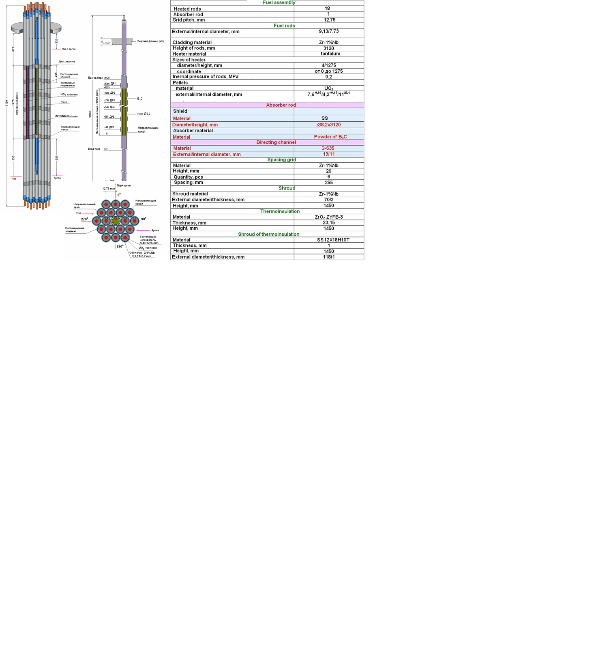

Suggested scenarios of experiments

1. The scenario of SF5 experiment

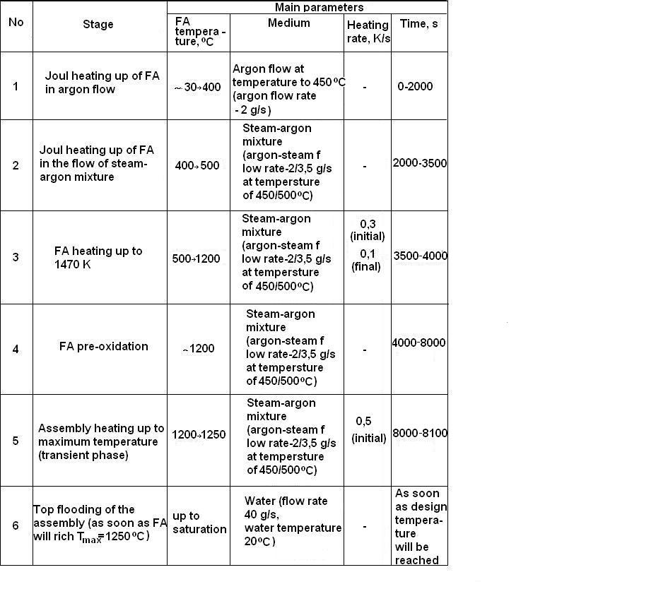

1. The scenario of SF6 experiment

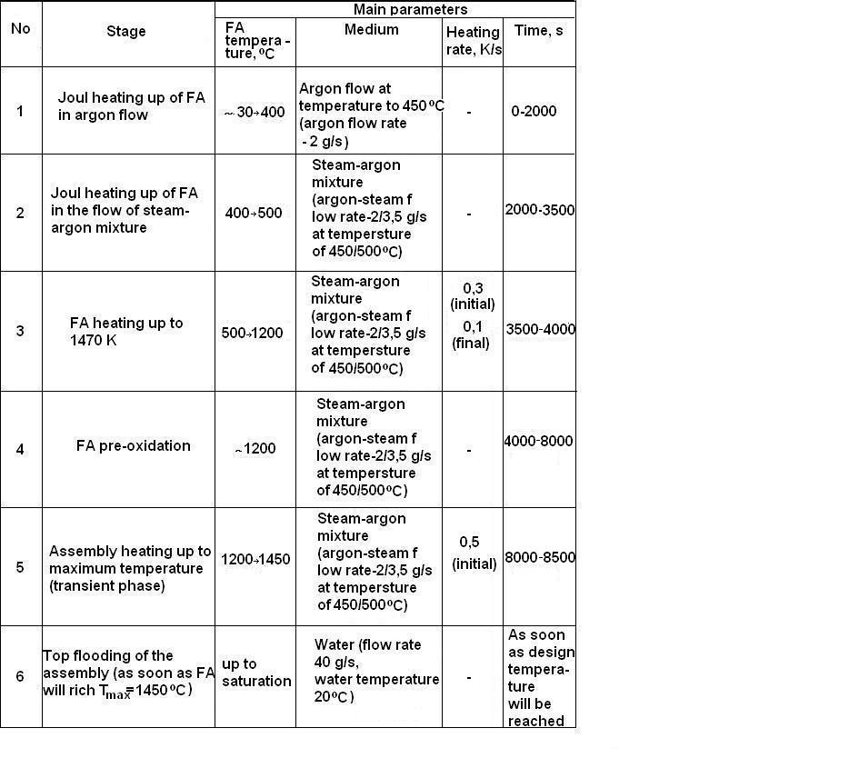

Expected project results



**While implementing the project, the following results are expected to be achieved:**

* **Information of the behaviour of a model FA with absorber rods (AR) based on boron carbide under conditions of a severe accident with top flooding will be gained and systematized.**
* **The degree of the cladding oxidation along the length of a AR depending on temperature and the degree of melting the metal of the cladding, guiding tube, and AR materials will be studied.**
* **The composition of solidified mixtures after flowing down the melt will be determined.**
* **The database for verifying the codes of a severe accident (SOСRAT/B1, ATLET, ICARE-CATARE, etc.) will be extended.**

**The obtained results can be used for justifying the safety of   
VVER (PWR) type reactors.**



Participants of project

**The Main participants**

**FSUE SRI SIA "LUCH" - carrying out of experiments, a post-test calculational and material-scientific analysis;**

**IBRAE RAS - development of program of tests, a pre-test and post-test calculational analysis;**

**JSC OKB "GIDROPRESS" - development of program of tests, an analysis of the degree of conformity of experiments, pre-test and post-test calculations**



Participants of project

**Extra participants**

**A.A. Bochvar FSUE VNIINM,**

**A.I. Leipunsky SRC RF-IPPE,**

**RRC "Kurchatov institute",**

**Open Society "Moscow factory of polymetals"**